UNIT TEST DOCUMENT |  | Module Name |  | LANDING PAGE MODULE
Test Cycle No. | 1
Test Cycle No. | 1 | Component Name |  | LANDING PAGE
Date Tested |  | Type of System |  | Web Application
Pre-conditions | Desktop browser is open and the AgriX client web portal is available. User is signed out.
Action Description | Navigate to the AgriX landing page. Review the hero section, header navigation, calls to action, and footer. Click the available navigation links and confirm they open the expected pages or sections.
Verification Steps | Confirm the landing page loads without errors; the hero content, header, and footer are visible and readable; and each navigation link or call to action routes to the correct destination.
Test Scenario | Data  (Input Values) |  | Expected Results |  | Actual Results | Remarks
1 | Open the AgriX landing page. |  | The hero displays “AgriX Coffee Monitoring,” its storage-monitoring description, feature bullets, and the “Start Monitoring” and “Sign in” buttons. |  | 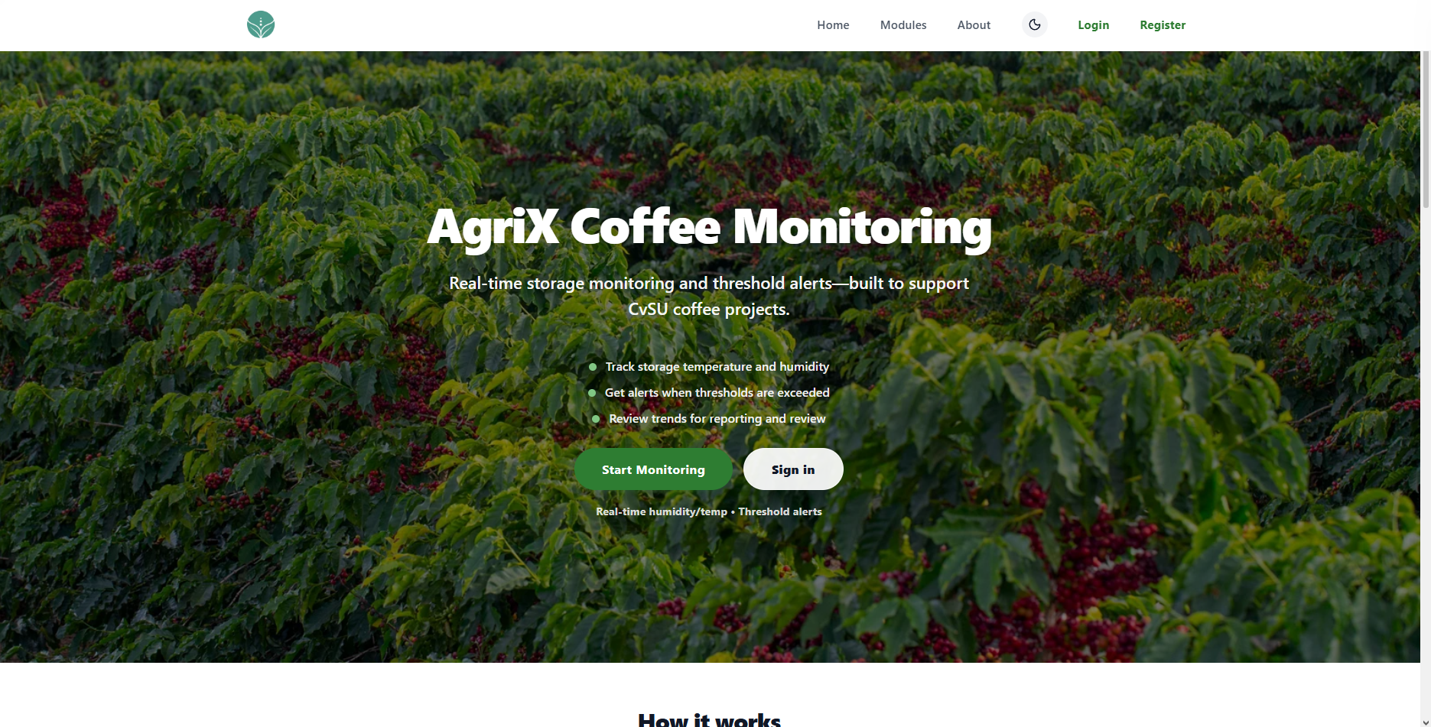 | PASSED
2 | Click Home, Modules, and About one at a time. |  | Each link navigates to the matching landing-page section. The header remains visible and usable. |  |  | Choose an item.
3 | Click Modules or scroll to the Modules section. |  | Module cards appear for the ESP32 Microcontroller Node, OV2640 Camera Module, Humidity and Temperature Sensing (DHT11), and Bean Moisture Monitoring. Each card shows its icon, title, and description. |  | 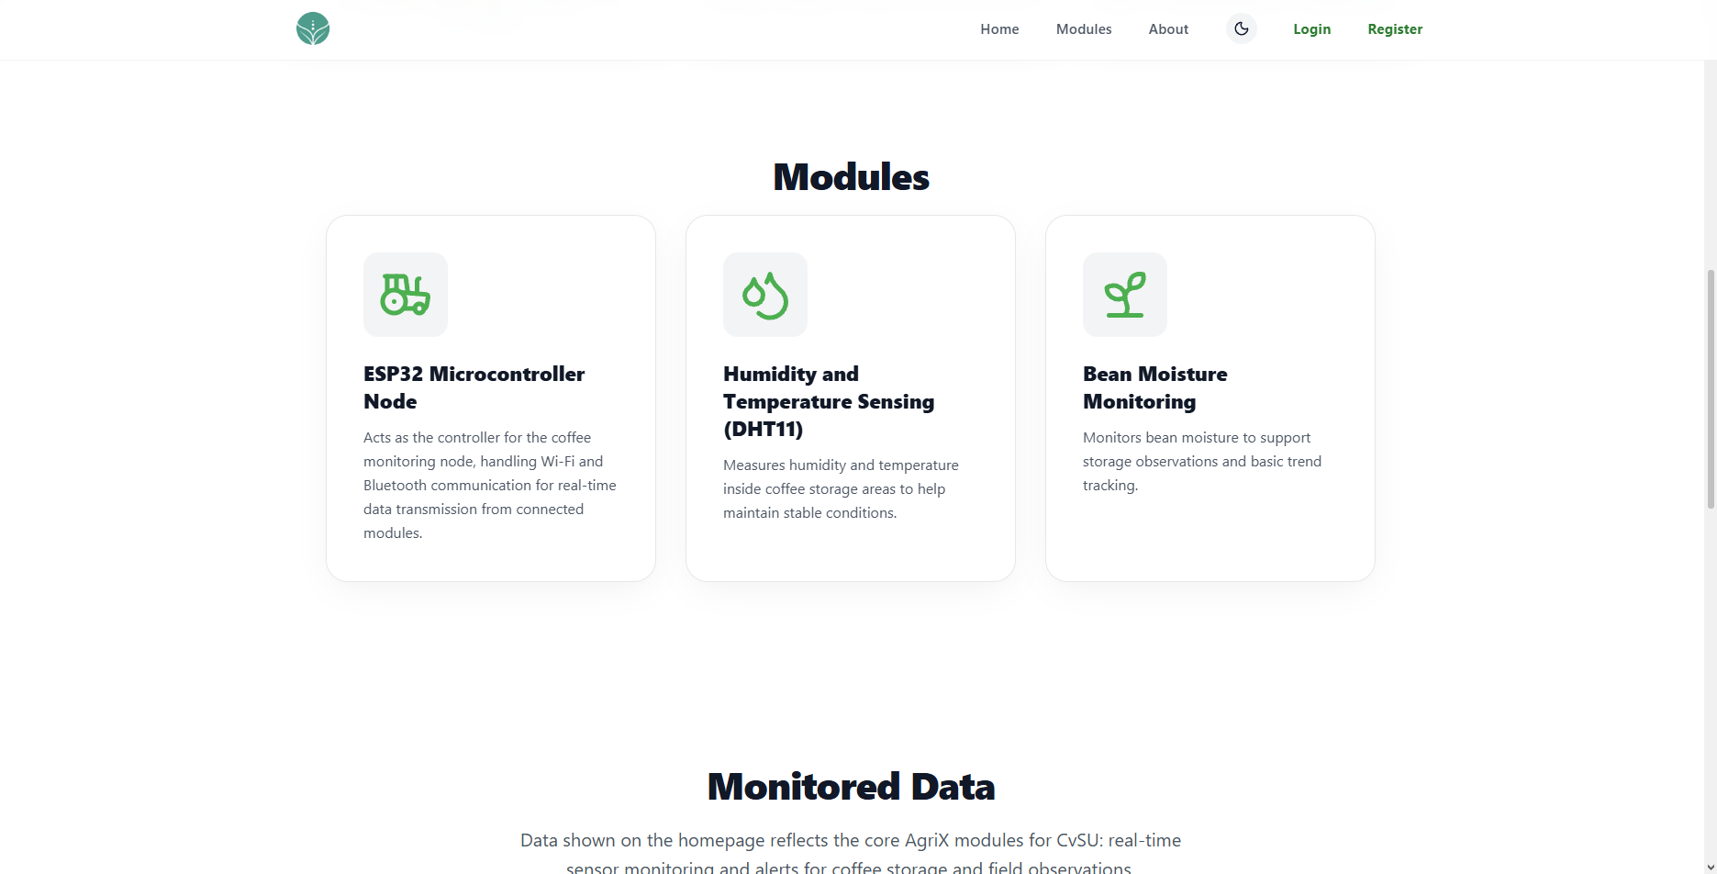 | Choose an item.
4 | Click About, then click Create an Account. |  | The About section shows the project description and goal. Create an Account opens the registration page. |  | 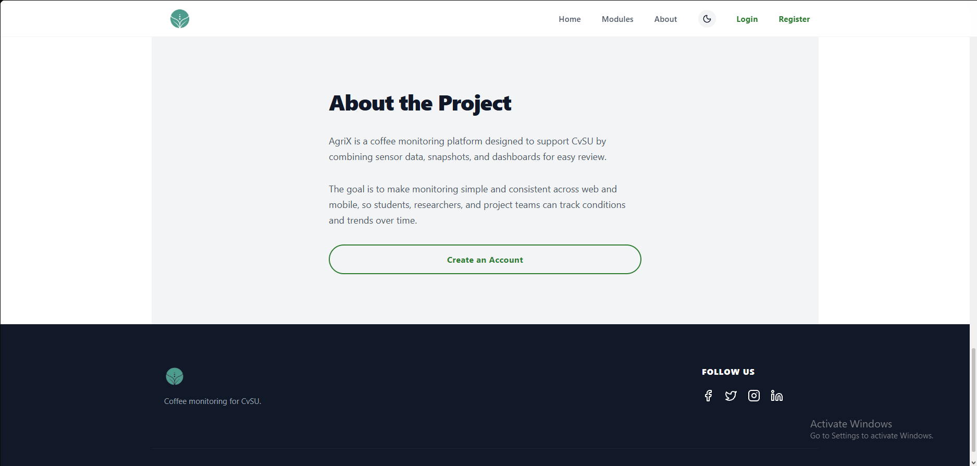 | Choose an item.
5 | Click Login from the header or hero. |  | Login open the login page. |  | 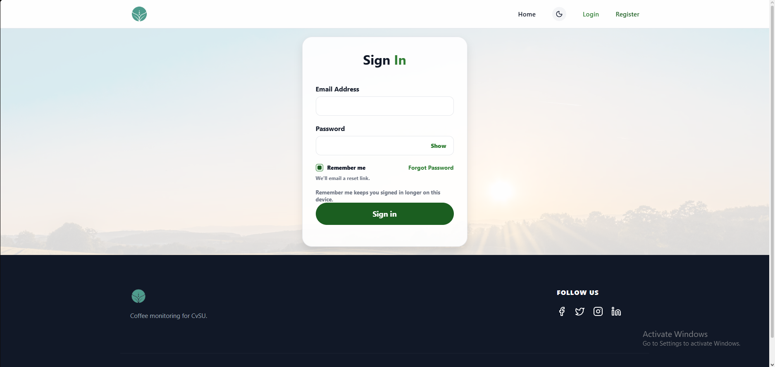 | Choose an item.
6 | Click Register from the header or hero. |  | Register opens the registration page. |  | 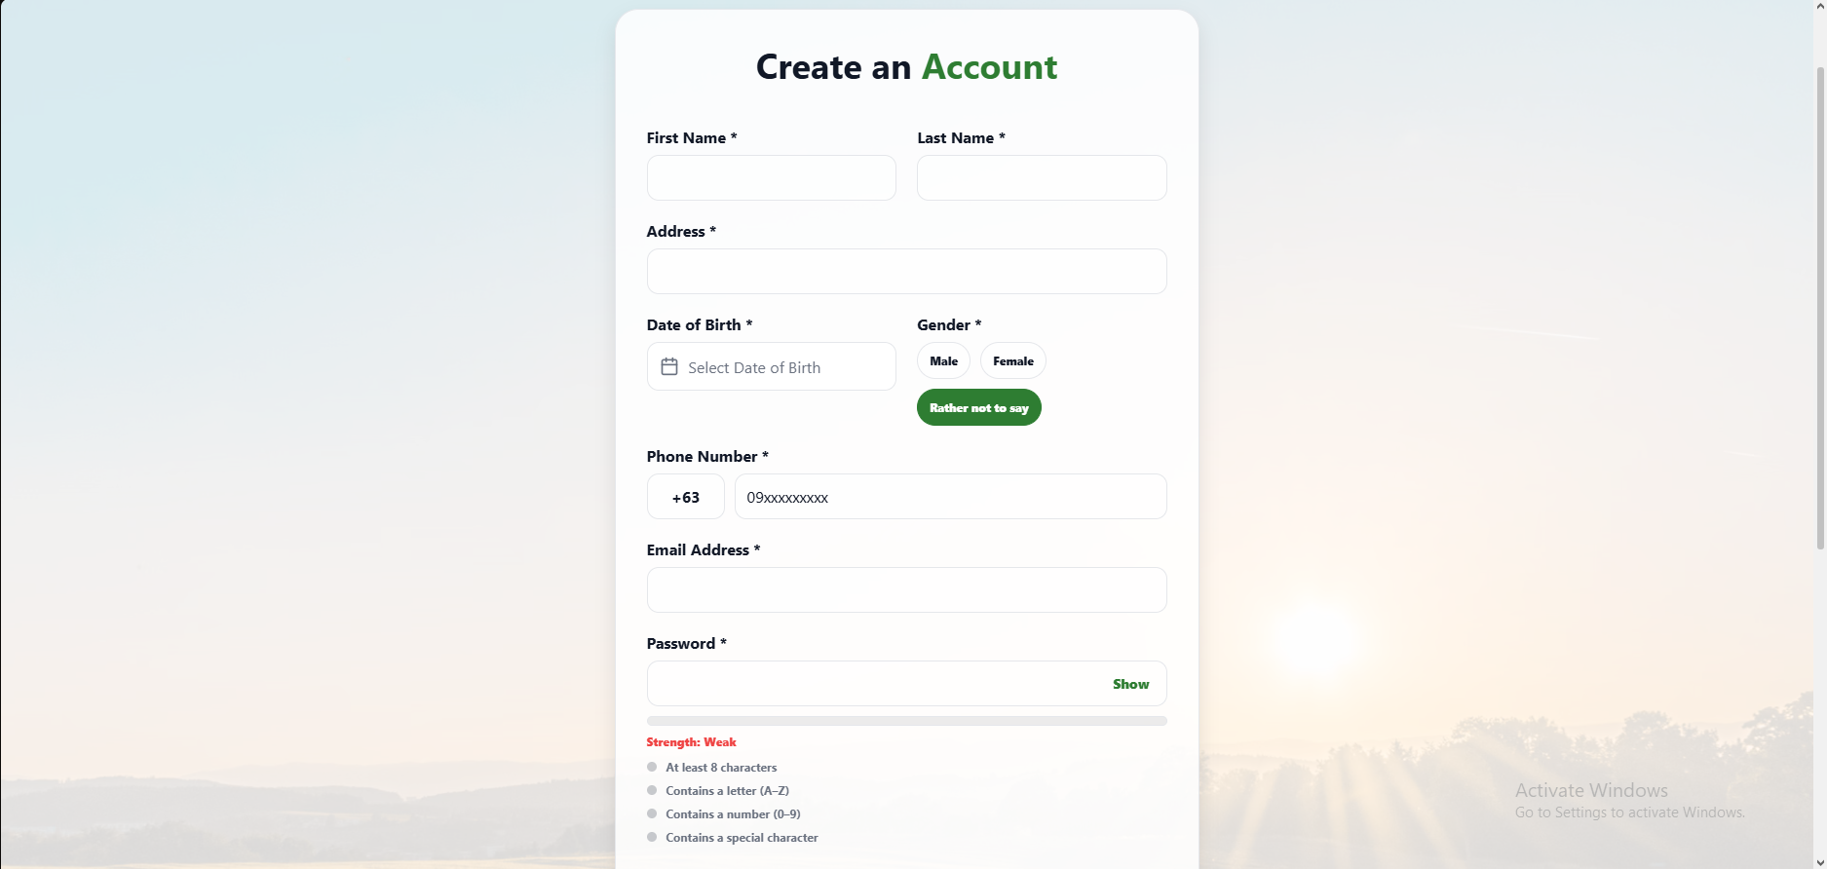
7 | Click Start Monitoring on the hero section. |  | The button opens the intended monitoring page or prompts the visitor to sign in if monitoring requires an account. |  | 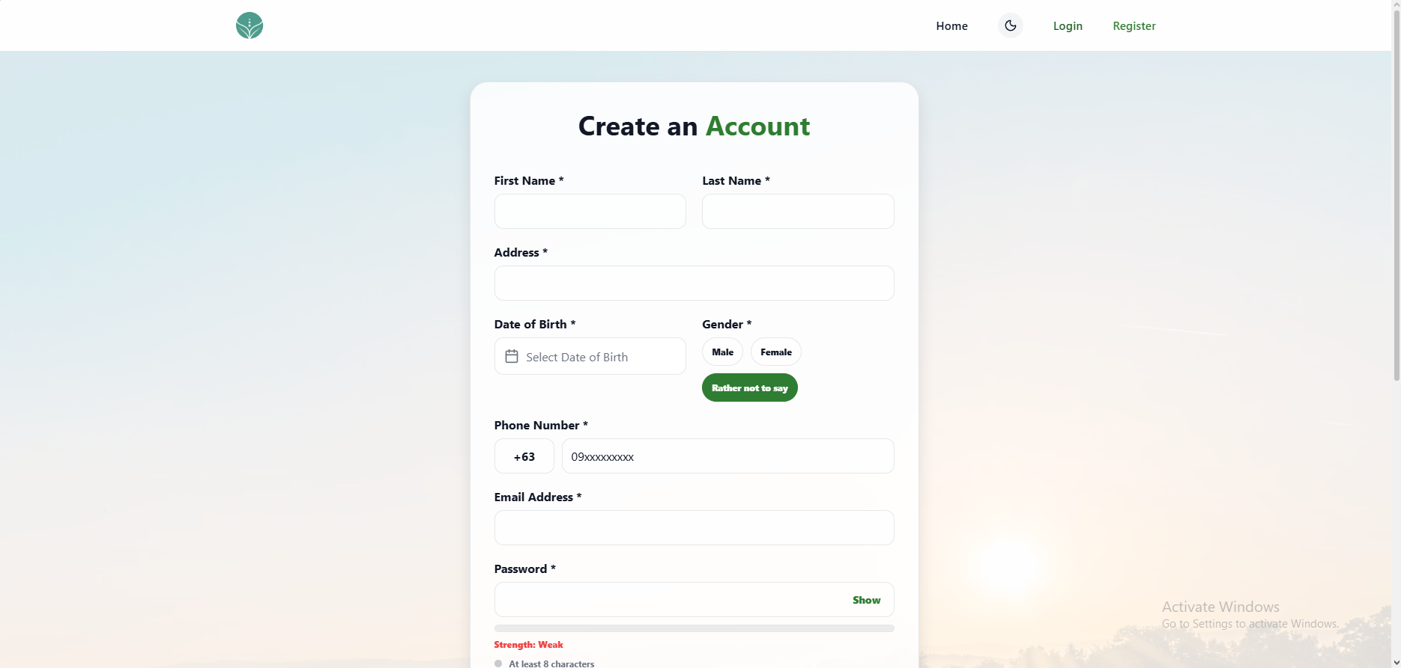
8 | Review the four feature bullets on the landing page. |  | The page lists storage temperature and humidity tracking, threshold alerts, and trend review. |  | 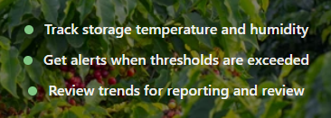
9 | Click the moon icon in the header. |  | The page switch’s theme while keeping text, links, cards, and controls readable. |  | 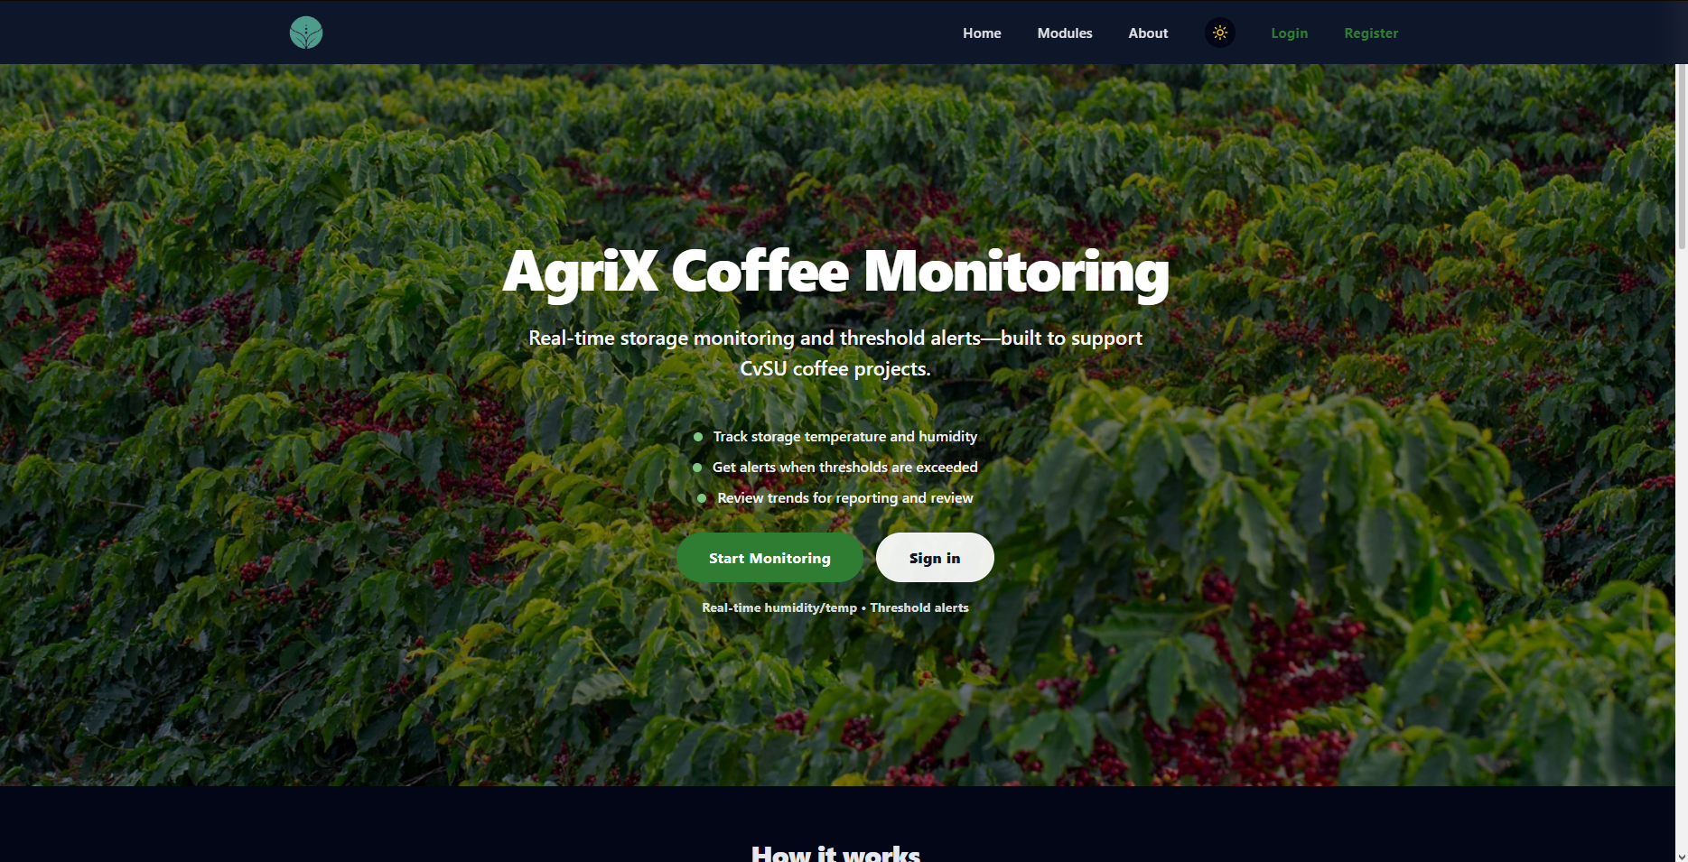
10 | Scroll to the bottom of the page. |  | The footer displays the AgriX branding, “Coffee monitoring for CvSU,” and the Follow Us social icons. |  | 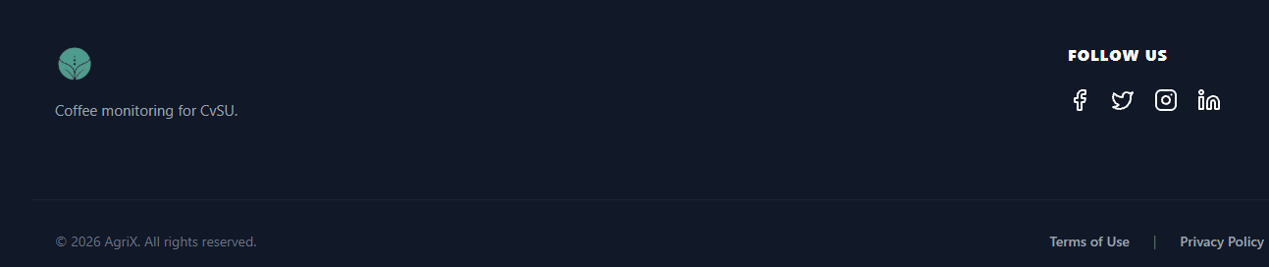
15 | Click the AgriX logo in the header. |  | The browser returns to the landing page’s Home section. |  | 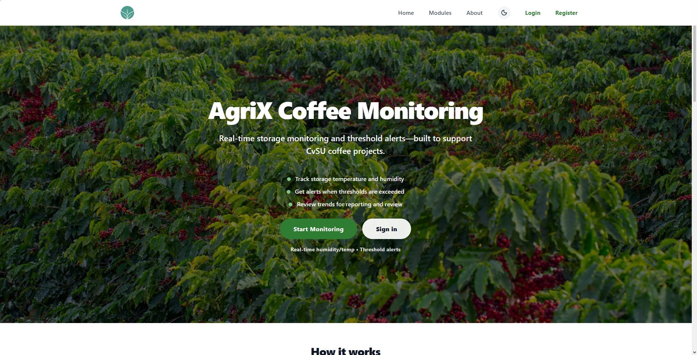

UNIT TEST DOCUMENT |  | Module Name |  | LOGIN MODULE
Test Cycle No. | 1
Test Cycle No. | 1 | Component Name |  | LOGIN PAGE
Date Tested |  | Type of System |  | Web Application
Pre-conditions | Desktop browser is open and the AgriX client web portal is available. User is signed out.
Action Description | Open the AgriX sign-in page. Review the login form, password controls, account links, header, and footer. Exercise the visible controls and check their feedback and navigation.
Verification Steps | Confirm the sign-in page loads without errors; the form and controls are visible, readable, and keyboard accessible; validation and feedback are clear; and navigation links open their intended destinations.
Test Scenario | Data  (Input Values) |  | Expected Results |  | Actual Results | Remarks
1 | Open the AgriX sign-in page. |  | The Sign In form appears with Email Address and Password fields, a Show control, remember me checkbox, Forgot Password link, and Sign in button. |  | 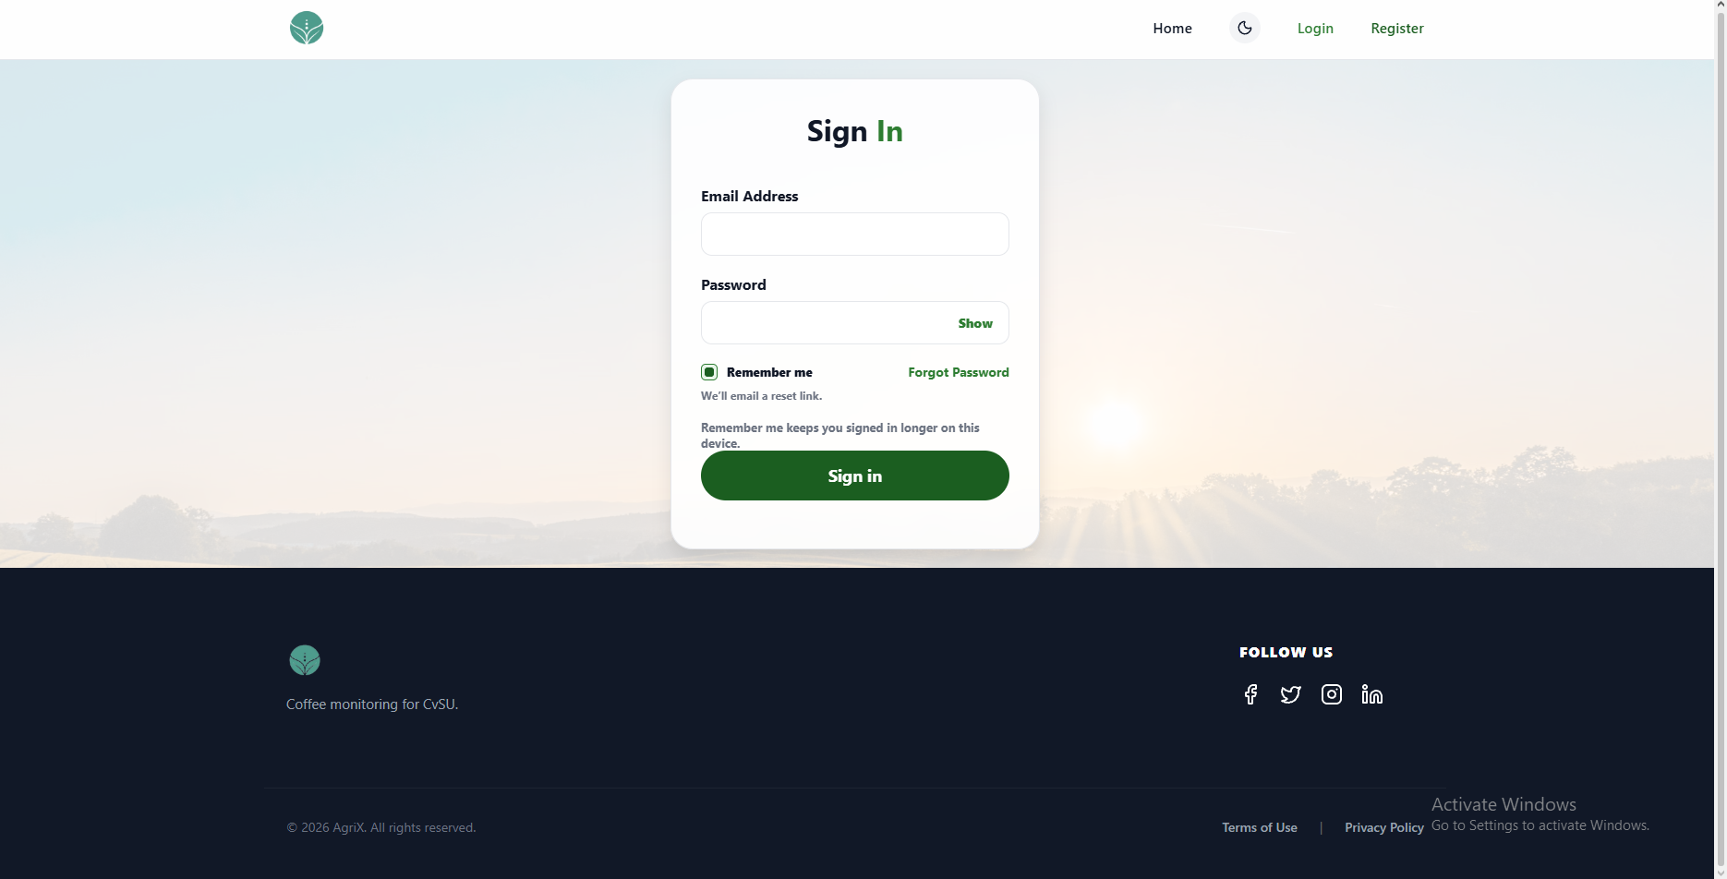 | PASSED
2 | Submit the form with both fields empty. |  | The form prevents submission and clearly identifies the required fields. |  | 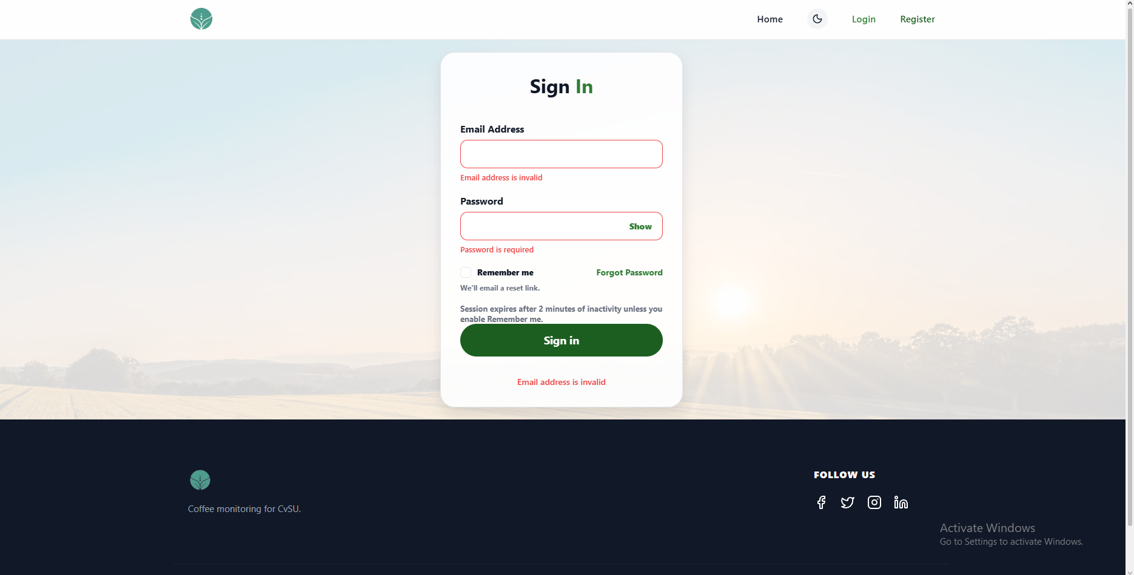
3 | Enter an invalid email format and a password, then submit. |  | The email field shows a clear validation message, and the form does not submit. |  | 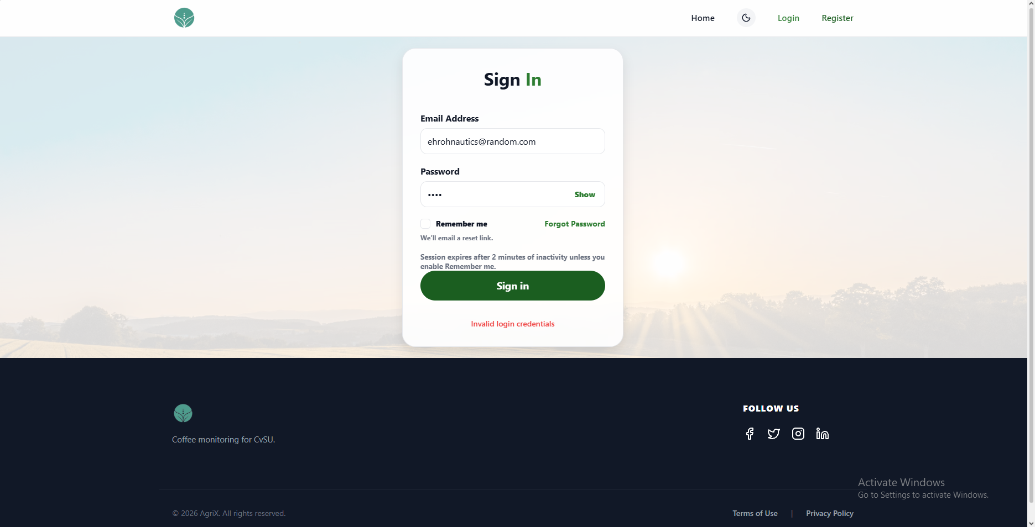
4 | Enter a validly formatted email and an incorrect password, then submit. |  | Sign-in is rejected and an understandable error message appears without exposing sensitive account details. |  | 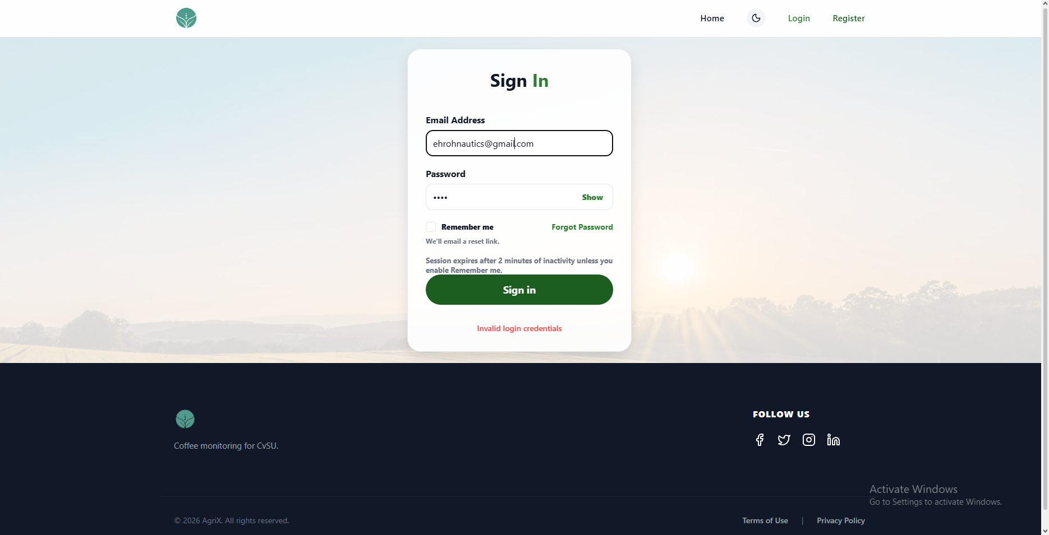
5 | Enter a password and click Show. Click it again to hide the password. |  | The password becomes readable while shown and is masked again when hidden; the control remains usable. |  | 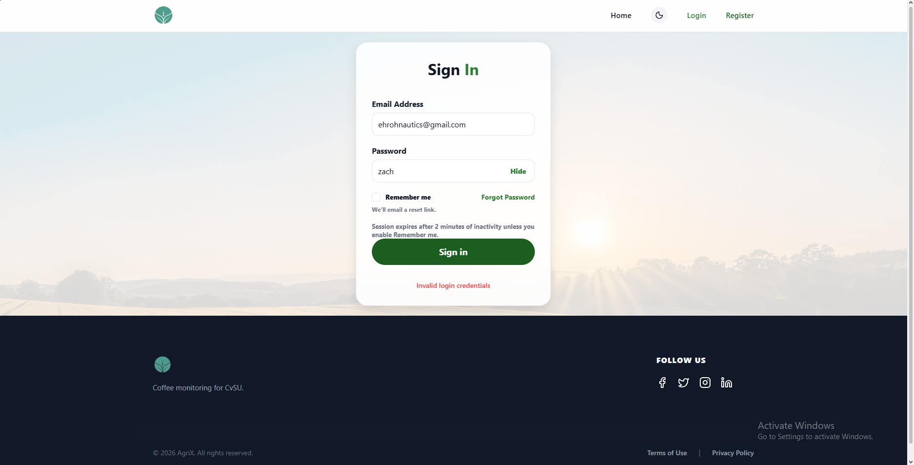
6 | Toggle Remember me off and on. |  | The checkbox state changes when selected and can be returned to its previous state. |  | 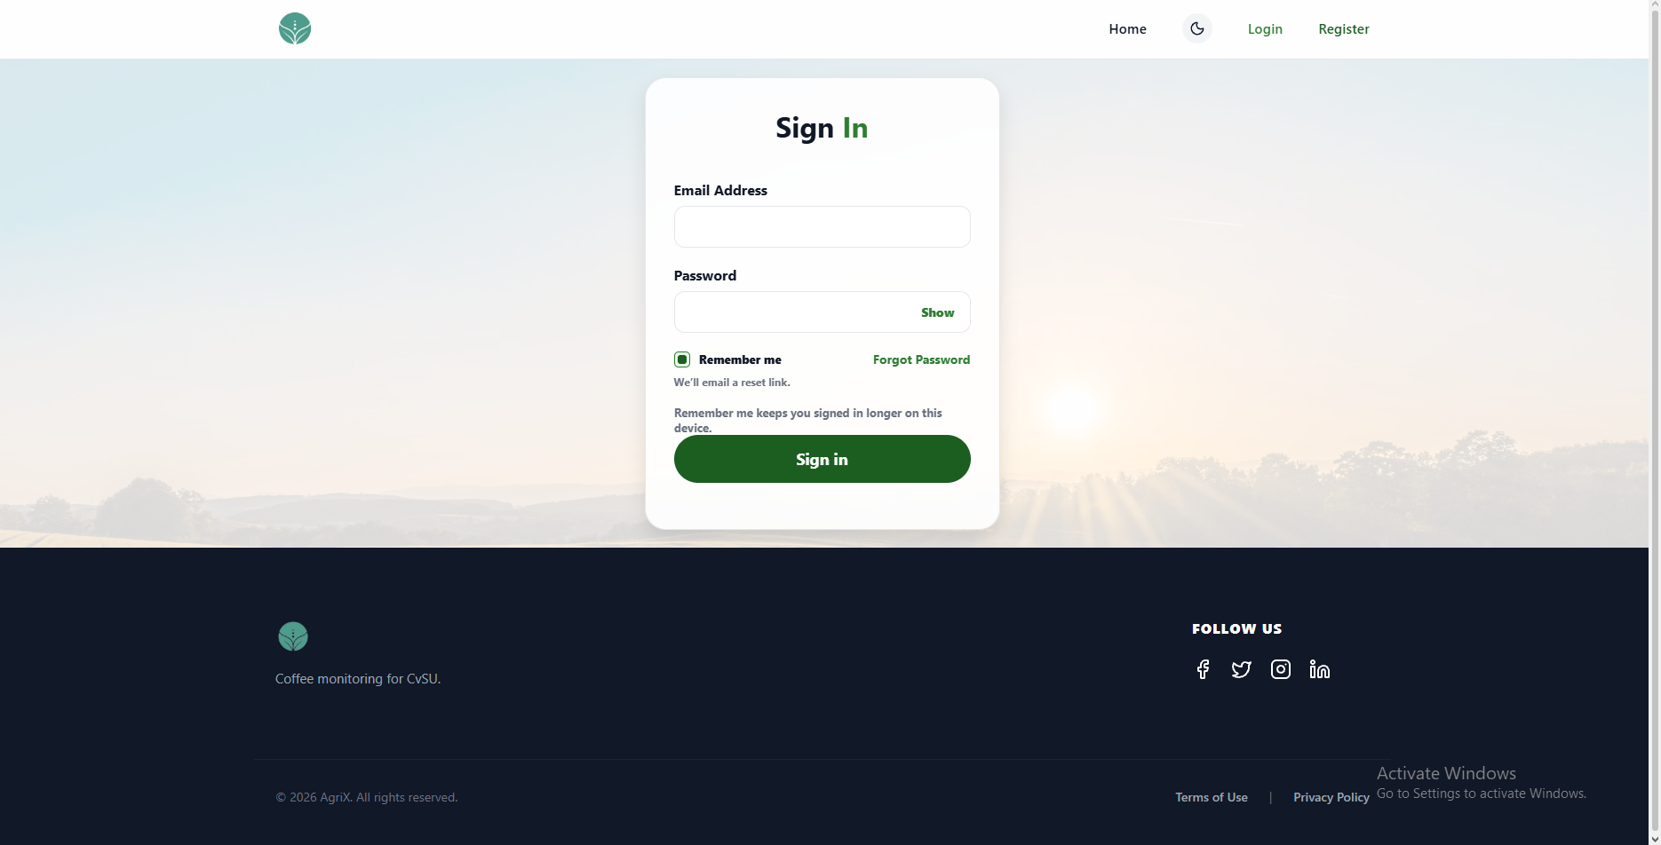
7 | Click Forgot Password. |  | The password recovery page or flow opens and explains how to request a reset link. |  | 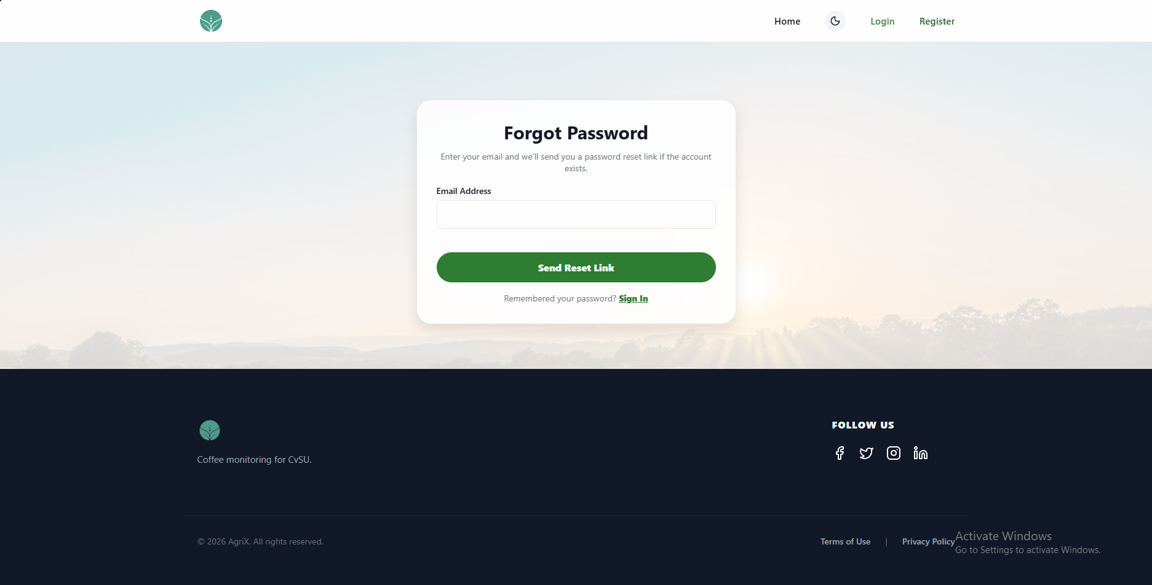
8 | Enter valid credentials for an active account and click Sign in. |  | The user is authenticated and taken to the intended post-login page. |  | 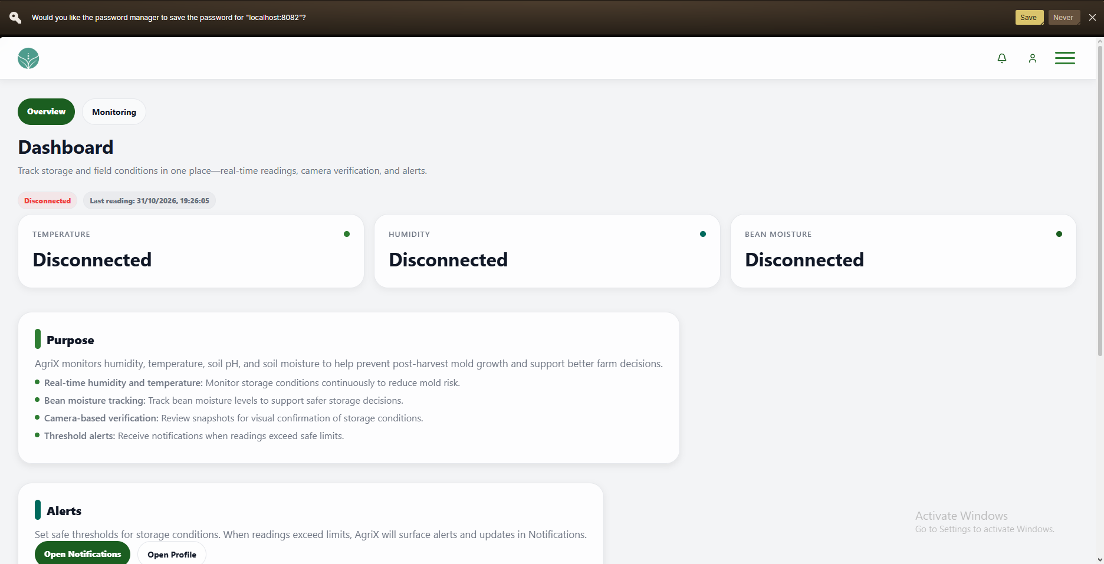
9 | Click Home in the header. |  | The browser returns to the AgriX home page. |  | 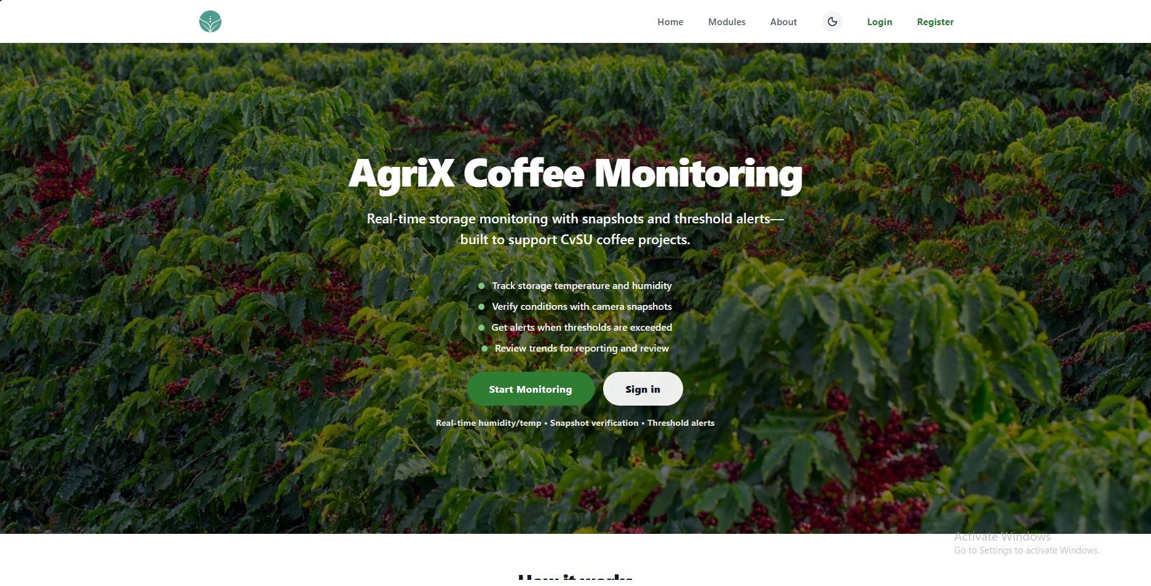
10 | Click the moon icon in the header. |  | The theme changes and all form text, links, fields, and controls remain readable. |  | 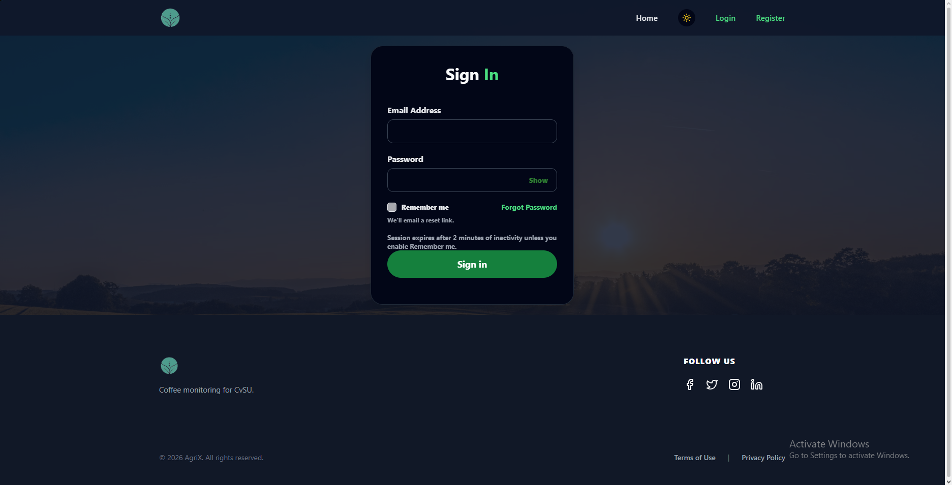
11 | Click Register in the header. |  | The registration page opens. |  | 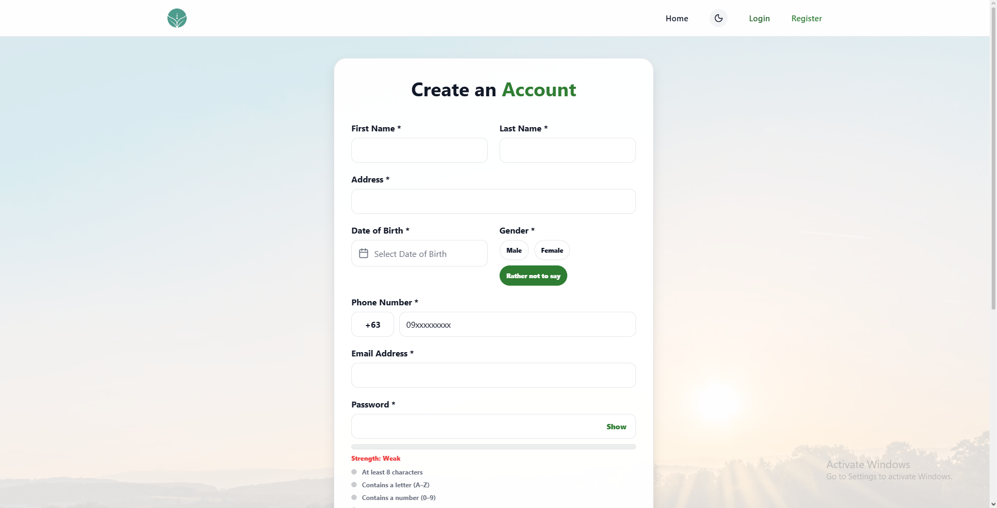
12 | Click the AgriX logo in the header. |  | The browser returns to the AgriX home page. |  | 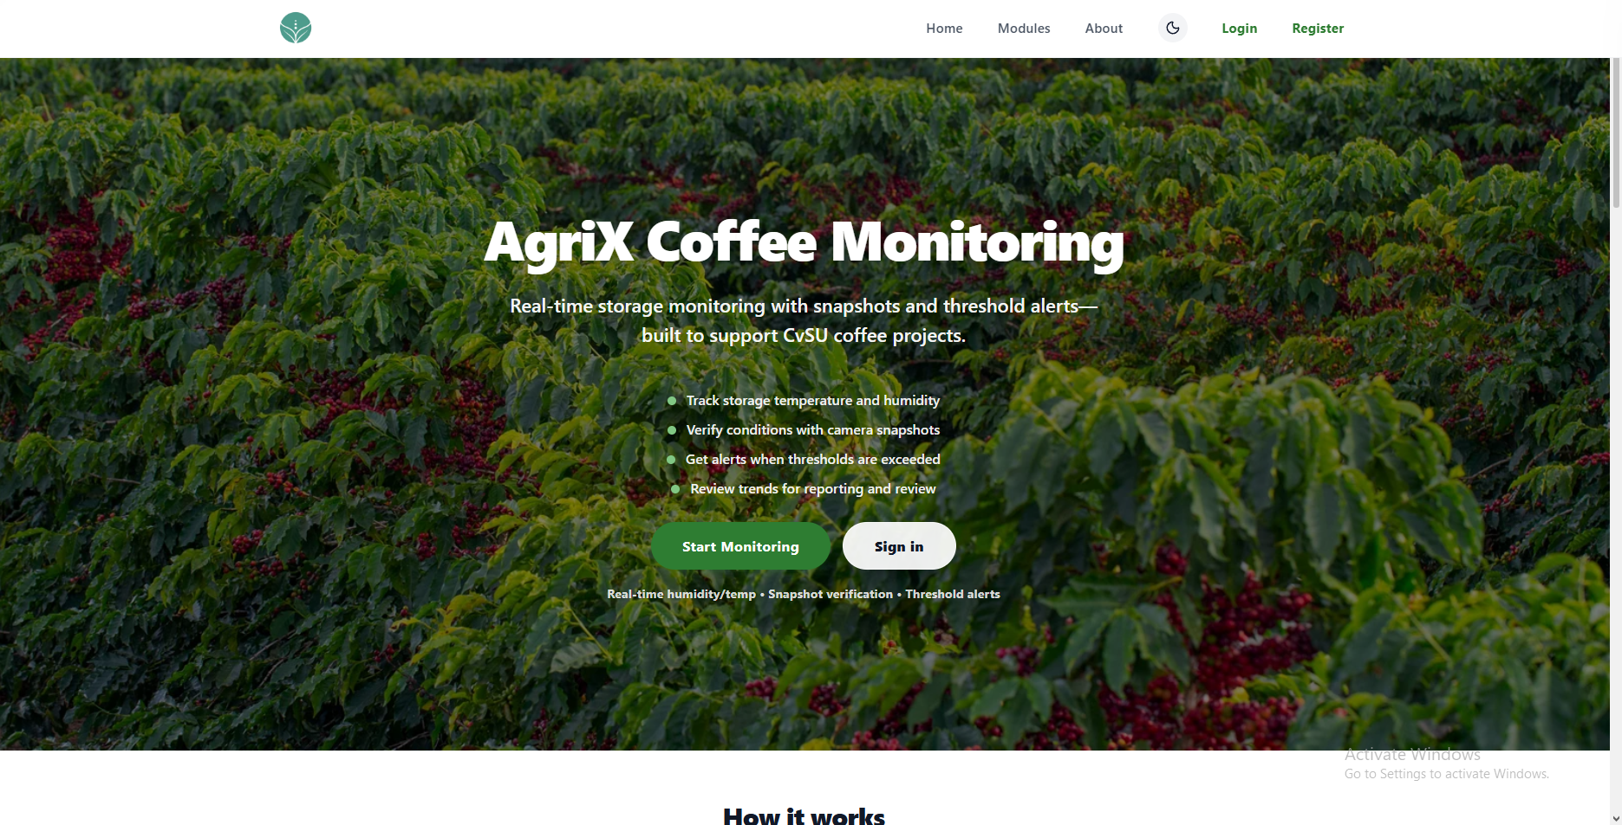

UNIT TEST DOCUMENT |  | Module Name |  | LOGIN-FORGOT PASSWORD MODULE
Test Cycle No. | 1
Test Cycle No. | 1 | Component Name |  | FORGOT PASSWORD FLOW
Date Tested |  | Type of System |  | Web Application
Pre-conditions | Desktop browser is open and the AgriX client web portal is available. User is signed out. A dedicated registered QA account and test mailbox are available.
Action Description | Open Forgot Password from the sign-in page. Submit reset-link requests with valid and invalid email inputs, then exercise the reset link and password update flow when available.
Verification Steps | Confirm the reset flow validates email input, gives clear and privacy-safe feedback, handles reset links securely, and allows the user to return to sign in.
Test Scenario | Data  (Input Values) |  | Expected Results |  | Actual Results | Remarks
1 | Open Forgot Password from the sign-in page. Input: none. |  | The recovery form appears with an email field, a reset request action, and a way back to sign in. |  | 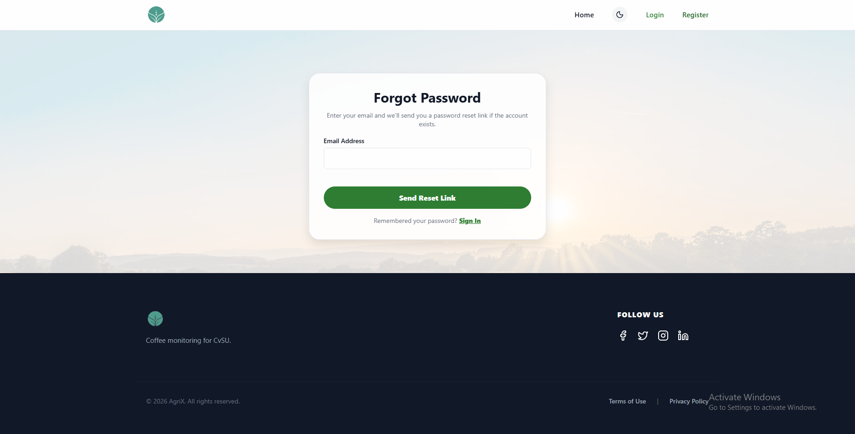 | PASSED
2 | Submit the form once with a blank email |  | blocked with clear validation; no reset email is sent. |  | 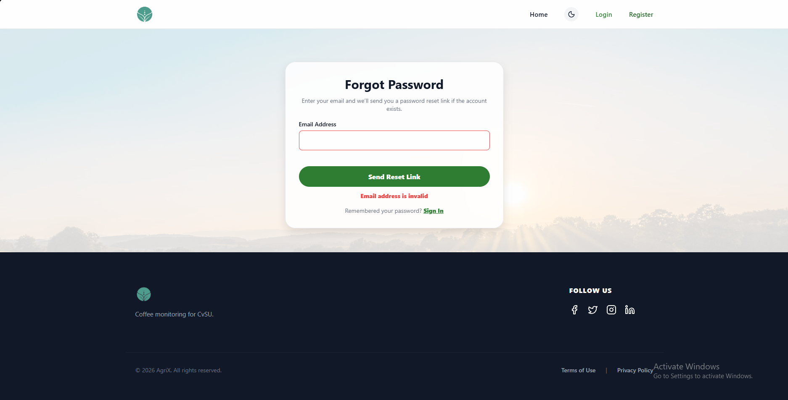 | PASSED
3 | Request a reset for the registered QA account. |  | A generic confirmation appears, and a usable reset link arrives at the registered QA mailbox. |  | 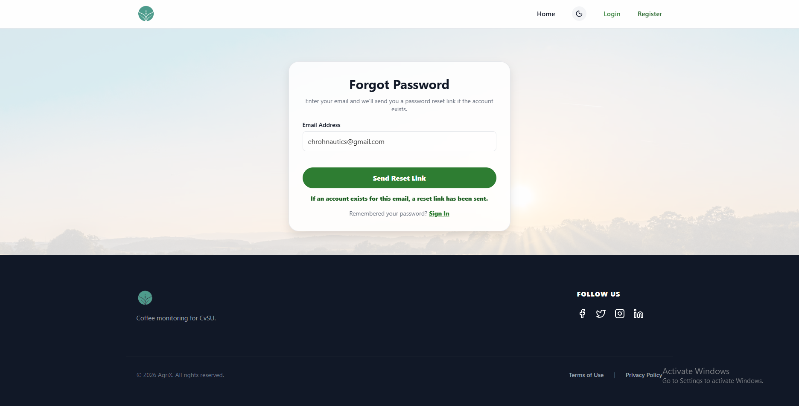 | PASSED
4 | Request a reset for an unregistered address. |  | The response matches the registered-address confirmation and does not reveal whether an account exists. |  | 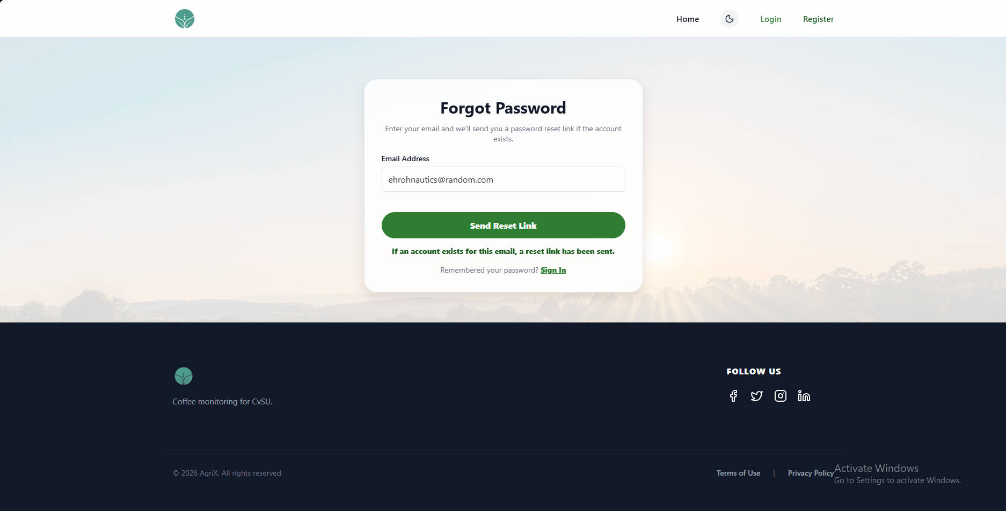 | PASSED
5 | Open the latest unused reset link. Input: valid reset link. |  | The link opens the password update form and accepts the valid token. |  | 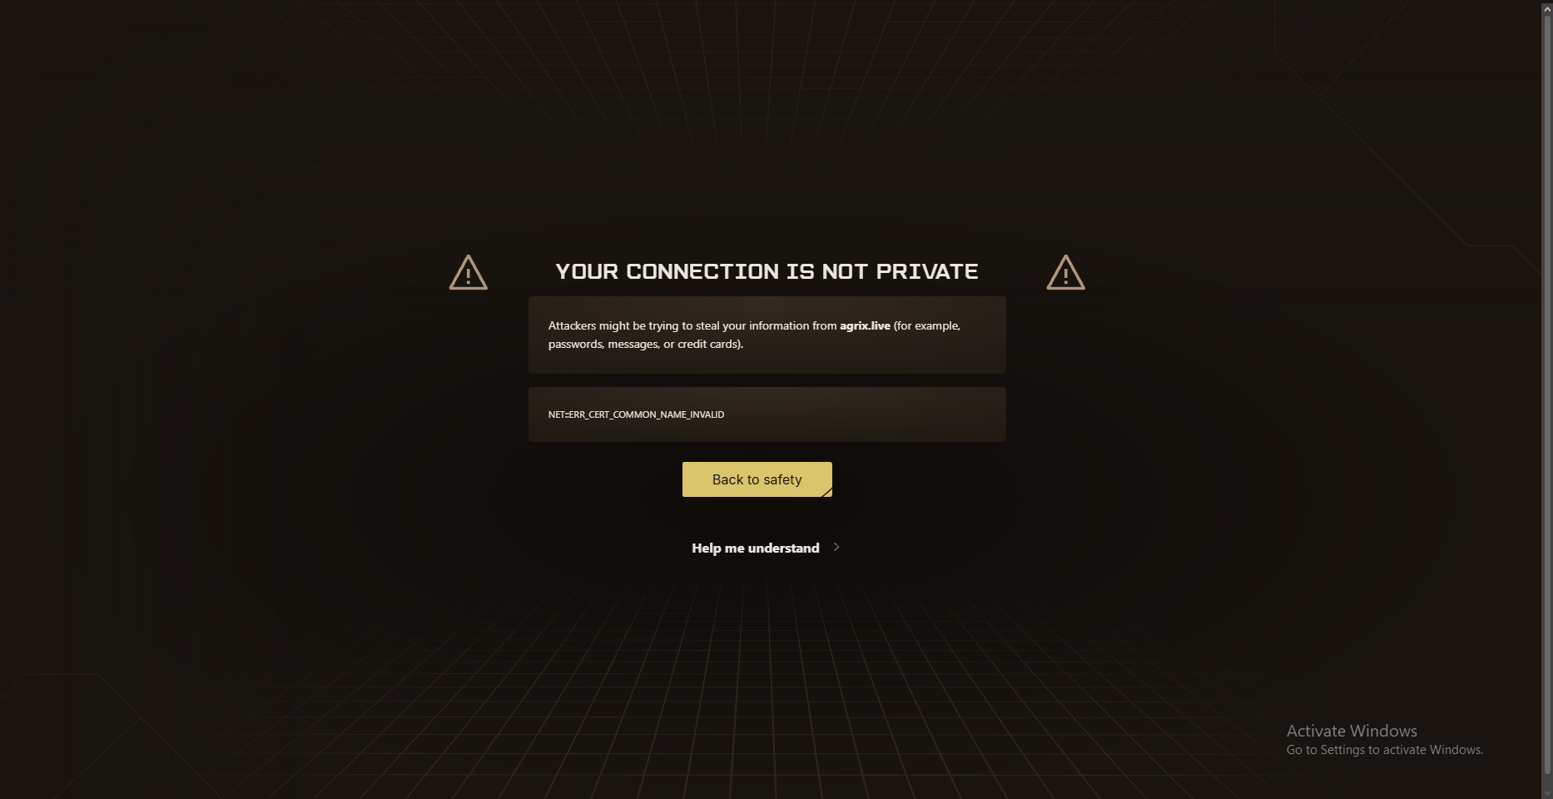 | FAILED
6 | Open an expired link and a previously used link. Inputs: expired link; used link. |  | Both links are rejected, and the user can request a new reset link. |  |  | FAILED
7 | Submit a new password with a different confirmation. Input: mismatched values. |  | The password is not changed and the mismatch is clearly identified. |  |  | FAILED
8 | Complete a reset with matching policy-compliant values, then try signing in. Inputs: new password and matching confirmation. |  | The reset succeeds; the link cannot be reused; the new password signs in successfully and the old password no longer works. |  |  | FAILED

UNIT TEST DOCUMENT |  | Module Name |  | REGISTRATION MODULE
Test Cycle No. | 1
Test Cycle No. | 1 | Component Name |  | REGISTRATION PAGE
Date Tested |  | Type of System |  | Web Application
Pre-conditions | Registration page is open. Email verification is enabled. Dedicated test email and phone values are available, including one existing account for duplicate checks.
Action Description | Review the AgriX logo, Home, theme toggle, Login, and Register controls in the page header. Check the available navigation and theme actions.
Verification Steps | Confirm each header item is visible and usable: the logo and Home return to the landing page, Login opens sign in, Register identifies the current page, and the theme toggle changes the theme.
Test Scenario | Data  (Input Values) |  | Expected Results |  | Actual Results | Remarks
1 | Open the Register page by clicking Register in the header from Home or Login. |  | The registration page opens with the Create an Account form, and Register is shown as the active page. |  | 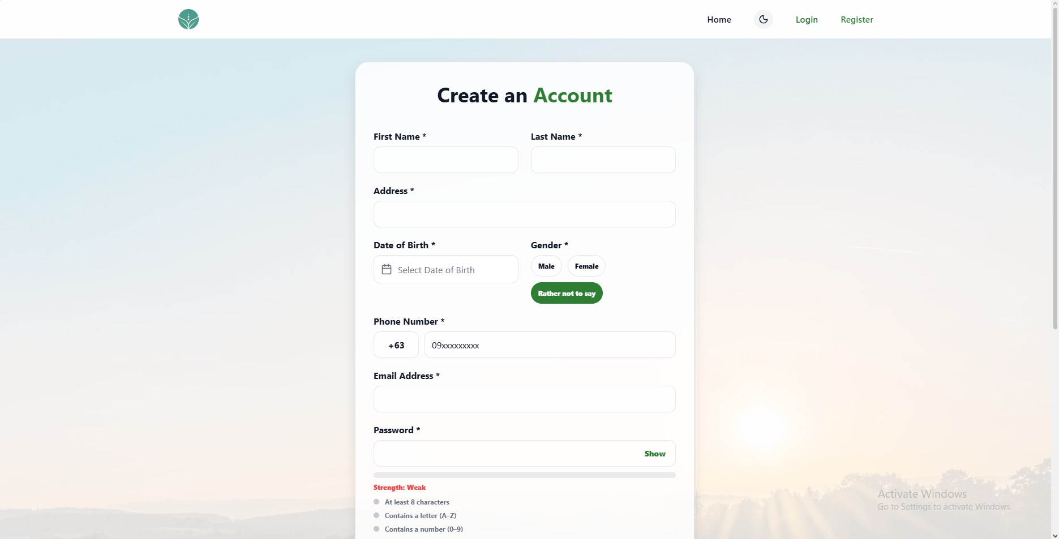 | PASSED
2 | Click Home in the header. |  | The landing page opens at its Home section. |  | 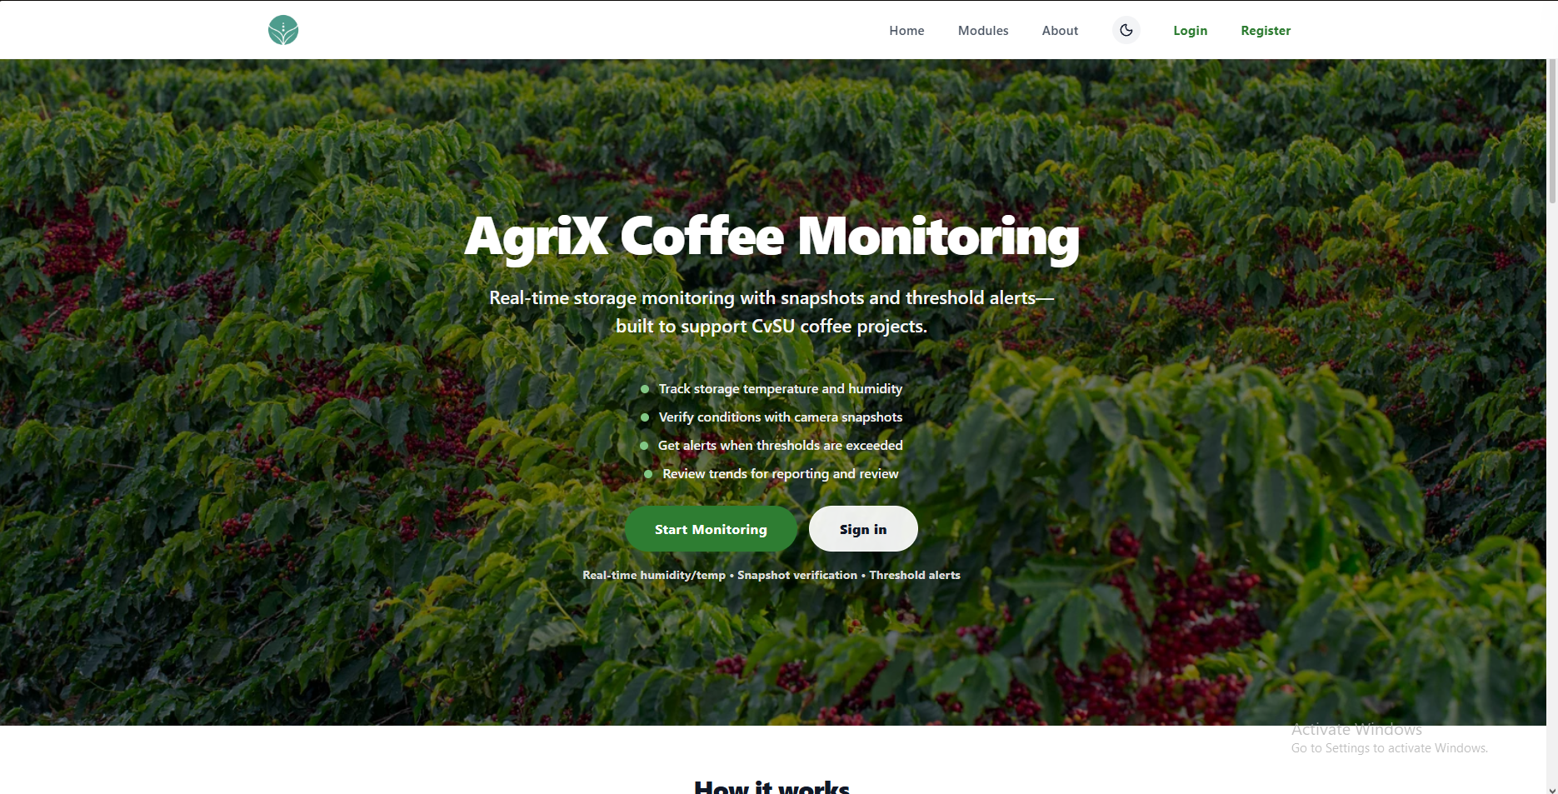 | PASSED
3 | Click the moon icon in the header. |  | The theme changes, and all registration page text, fields, and controls remain readable. |  | 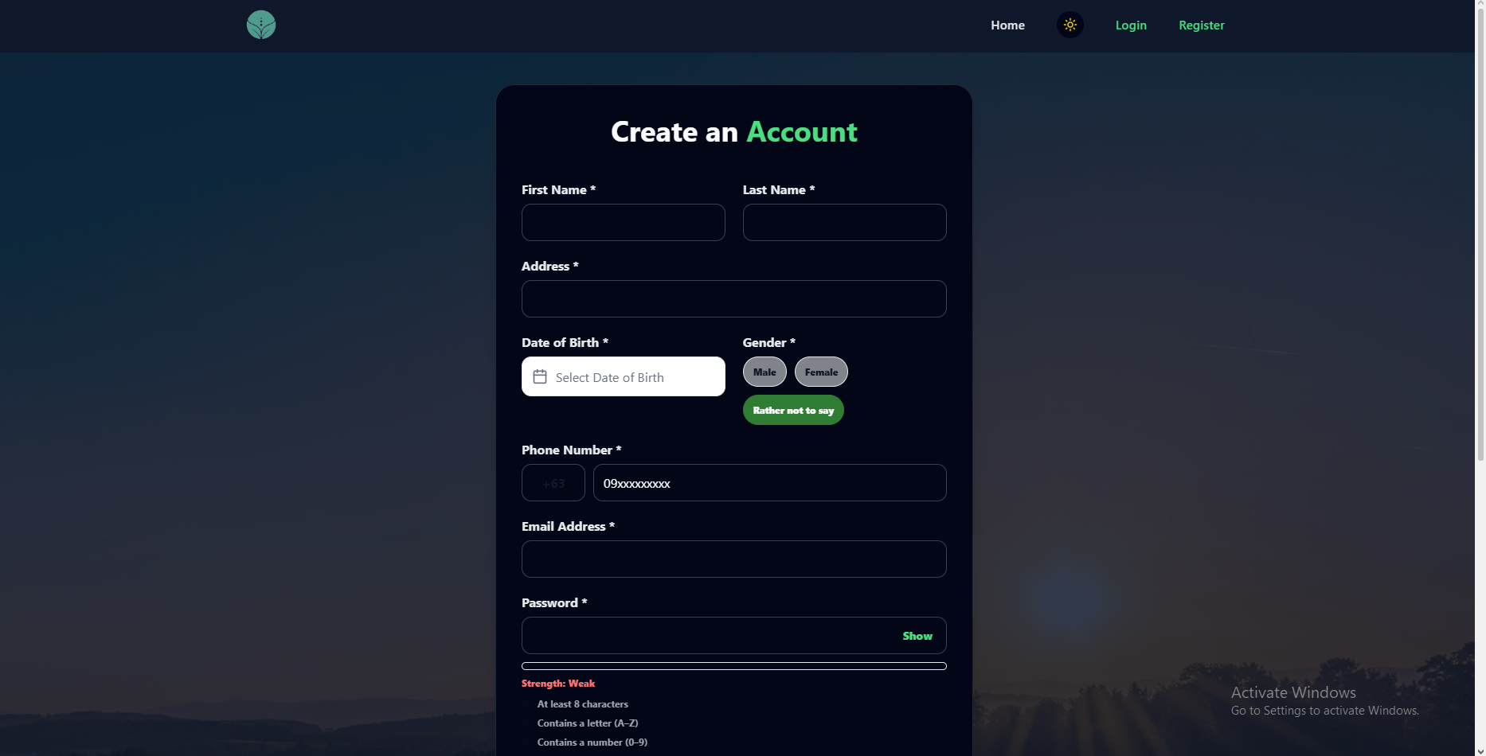 | PASSED
4 | Leave the First Name field blank. |  | Blank is rejected with a required-field message. |  | 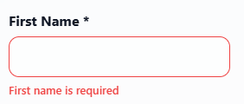 | PASSED
5 | Enter a one-character value in the First Name field. |  | A one-character name is rejected; minimum length is 2. |  | 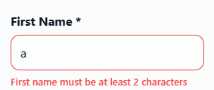 | PASSED
6 | Enter a value longer than 36 characters in the First Name field. |  | A name longer than 35 characters is rejected. |  | 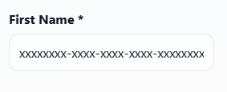 | FAILED
7 | Enter a value containing digits in the First Name field. |  | Digits are removed from the field. |  | 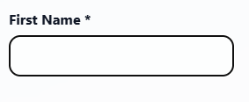 | PASSED
8 | Leave the Last Name field blank. |  | Blank is rejected with a required-field message. |  | 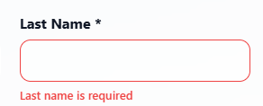 | PASSED
9 | Enter a one-character value in the Last Name field. |  | A one-character name is rejected; minimum length is 2. |  | 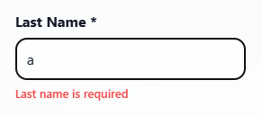 | PASSED
10 | Enter a value longer than 36 characters in the Last Name field. |  | A name longer than 35 characters is rejected. |  | 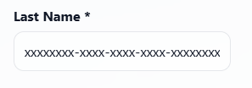 | FAILED
11 | Enter a value containing digits in the Last Name field. |  | Digits are removed from the field. |  | 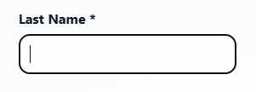 | PASSED
12 | Leave the Address field blank. |  | Blank is rejected with a required-field message. |  | 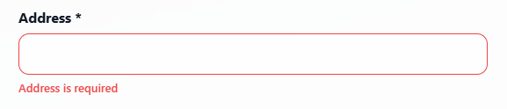 | PASSED
13 | Enter a 4-character value in the Address field. |  | A 4-character address is rejected. |  | 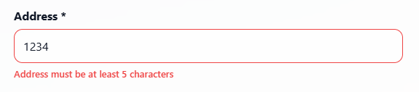 | PASSED
14 | Enter a 5-character value in the Address field. |  | A 5-character address is accepted. |  | 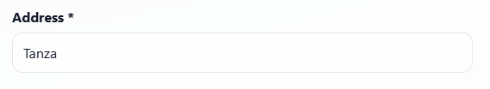 | PASSED
15 | Enter a 160-character value in the Address field. |  | A 160-character address is accepted. |  | 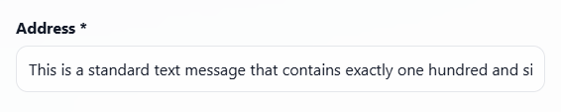 | PASSED
16 | Enter a 161-character value in the Address field. |  | A 161-character address is rejected. |  | 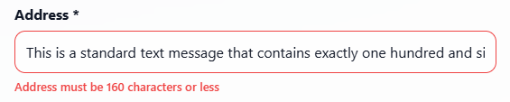 | PASSED
17 | Leave the Date of Birth field blank. |  | Blank is rejected with a required-field message. |  | 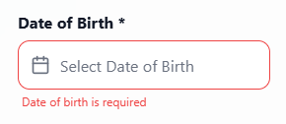 | PASSED
18 | Enter 2015-01-01 in the Date of Birth field. |  | A date that makes the user under 18 is rejected. |  | 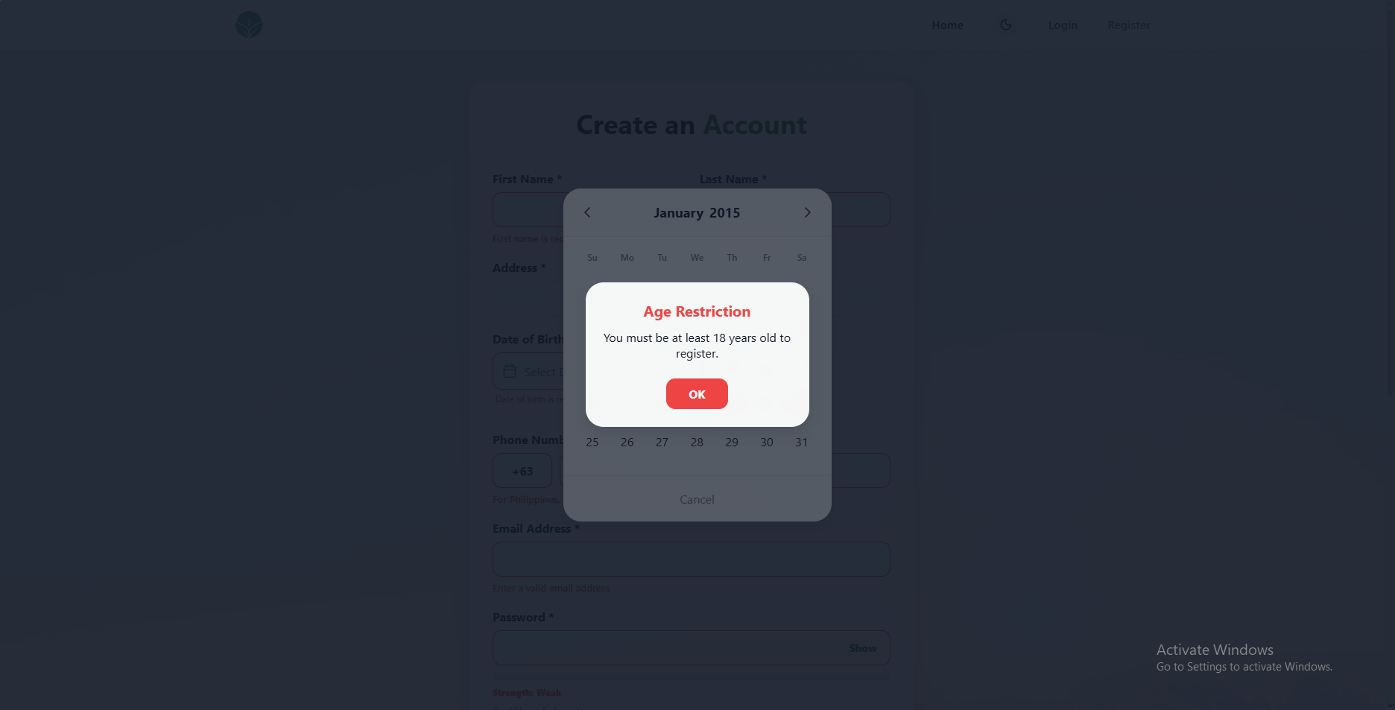 | PASSED
19 | Enter a future date in the Date of Birth field. |  | A future date is rejected. |  | 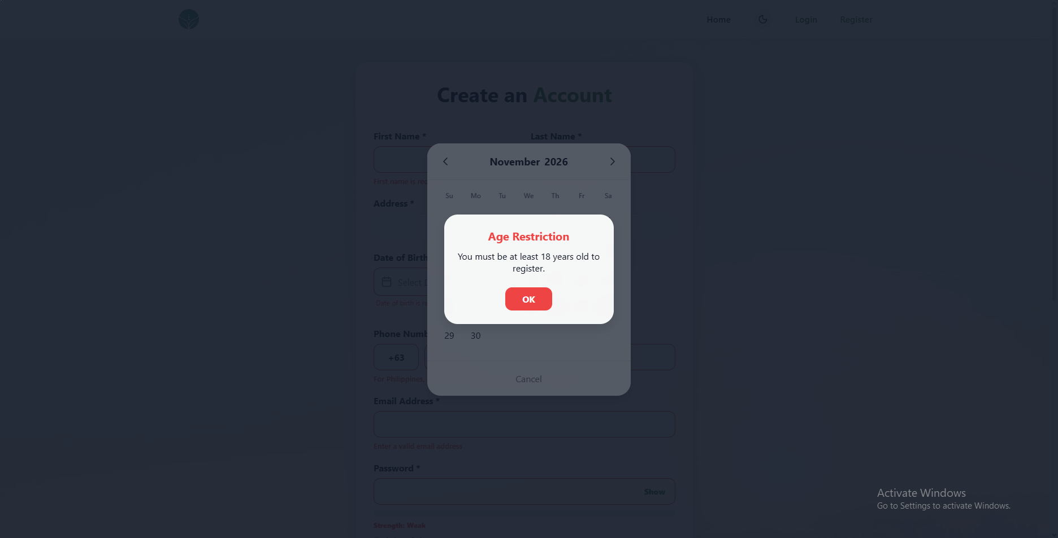 | FAILED
20 | Enter 2000-01-01 in the Date of Birth field. |  | A valid adult date is accepted. |  | 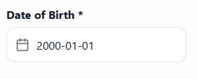 | PASSED
21 | Leave the default Gender option selected. |  | Rather not to say is selected by default. |  | 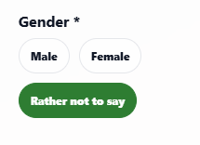 | PASSED
22 | Select Male in the Gender field. |  | Male can be selected. |  | 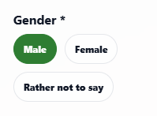 | PASSED
23 | Select Female in the Gender field. |  | Female can be selected. |  | 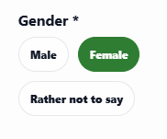 | PASSED
24 | Select Rather not to say in the Gender field. |  | Rather not to say can be selected. |  | 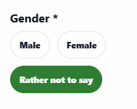 | PASSED
25 | Leave the Phone Number field blank. |  | Blank is rejected with a required-field message. |  | 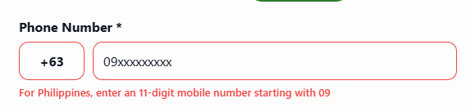 | PASSED
26 | Select +63 and enter fewer than 11 digits in the Phone Number field. |  | The number is rejected, and the message explains the minimum length. |  | 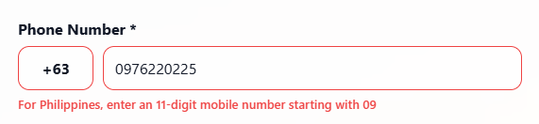 | FAILED
27 | Enter a phone number that is already registered. |  | An already registered phone number is rejected. |  | 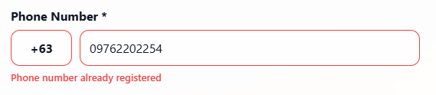 | PASSED
28 | Select +63 and enter the remaining digits to complete an 11-digit number. |  | The valid 11-digit number is accepted. |  | 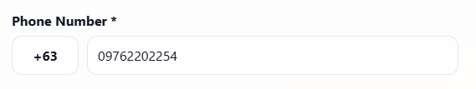 | PASSED
29 | Select +1 and check that the starting digits update for that country code. |  | The phone field updates its starting digits for +1. |  | 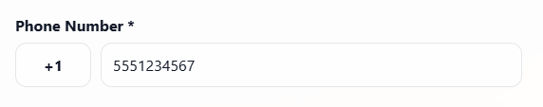 | PASSED
30 | Leave the Email Address field blank. |  | Blank is rejected with a required-field message. |  | 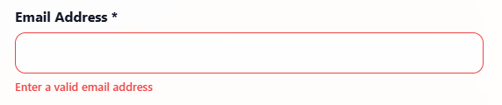 | PASSED
31 | Enter an invalid email address in the Email Address field. |  | Invalid email is rejected. |  | 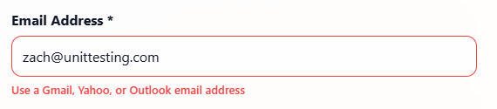 | PASSED
32 | Enter an email address that is already registered. |  | An already registered email is rejected. |  | 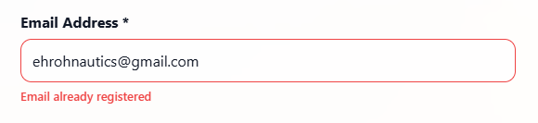 | PASSED
33 | Leave the Password field blank. |  | Blank is rejected with a required-field message. |  | 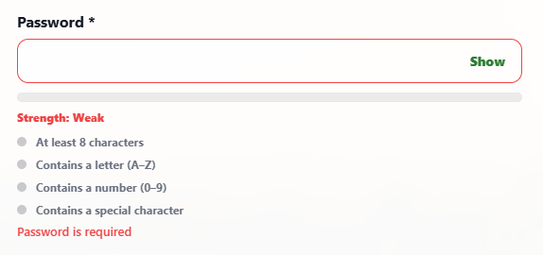 | PASSED
34 | Enter a password shorter than 8 characters. |  | A password shorter than 8 characters is rejected. |  | 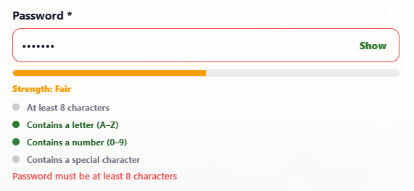 | PASSED
35 | Enter a password without a letter. |  | A password without a letter is rejected. |  | 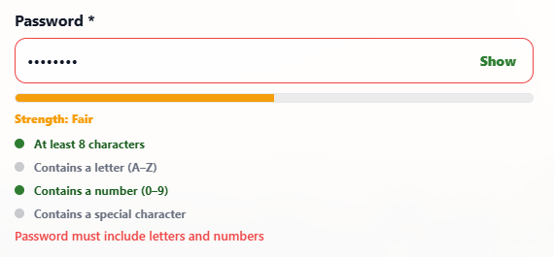 | PASSED
36 | Enter a password without a number. |  | A password without a number is rejected. |  | 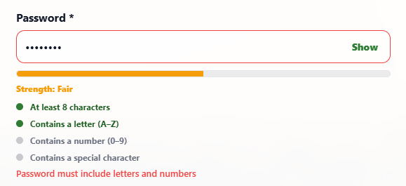 | PASSED
37 | Enter a password without a special character. |  | A password without a special character is rejected. |  | 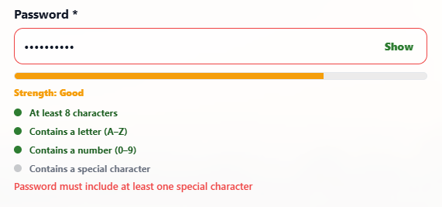 | PASSED
38 | Enter a password longer than 72 characters. |  | A password longer than 72 characters is rejected. |  | 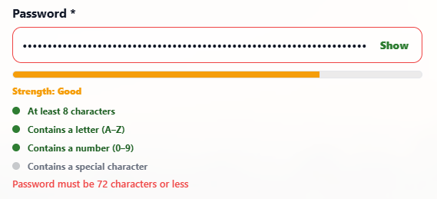 | PASSED
39 | Enter Abc123!x in the Password field. |  | The compliant password is accepted and strength feedback updates. |  | 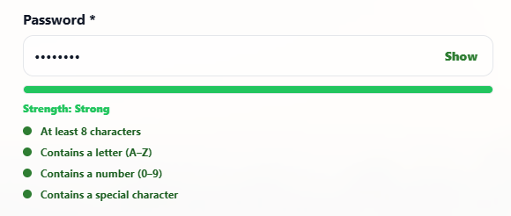 | PASSED
40 | Select the Show/Hide control for the Password field. |  | The control toggles password visibility. |  | 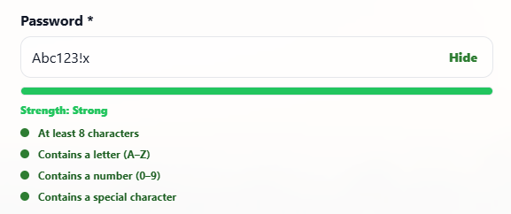 | PASSED
41 | Leave the Confirm Password field blank. |  | Blank confirmation is rejected. |  | 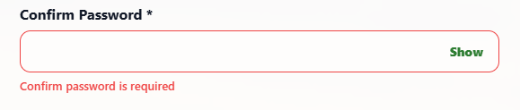 | PASSED
42 | Enter a value that differs from the Password field. |  | A mismatch is rejected. |  | 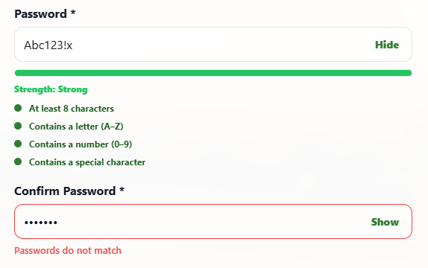 | PASSED
43 | Enter the same value as the Password field. |  | Matching values are accepted. |  | 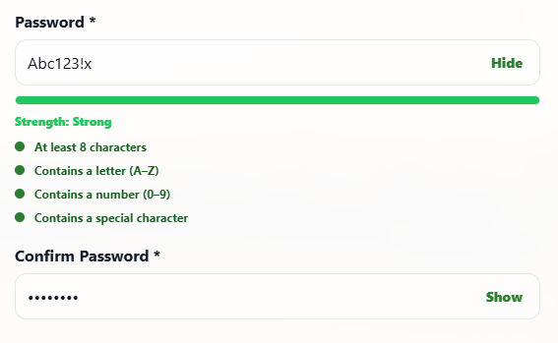 | PASSED
44 | Enter valid, unique registration details in all fields and submit the form. |  | Registration succeeds, opens email verification, and sends a 6-digit code. |  | 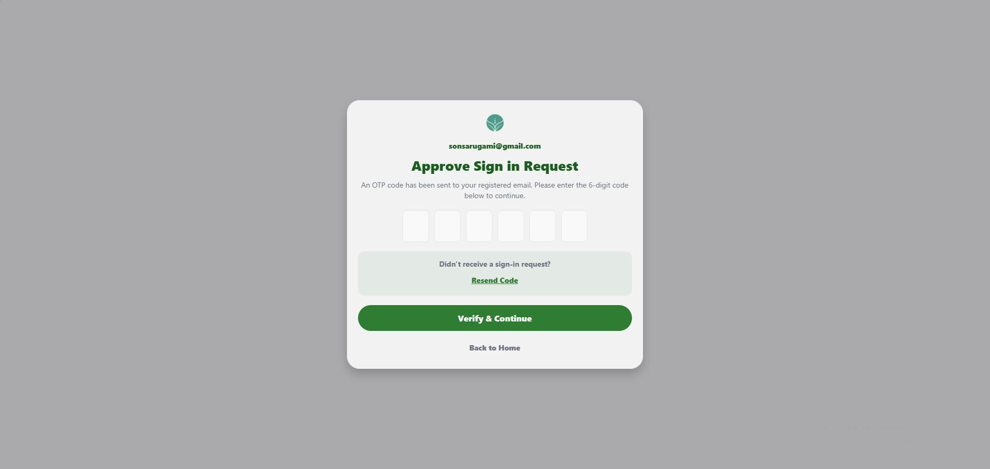 | PASSED

UNIT TEST DOCUMENT |  | Module Name |  | REGISTRATION – OTP VERIFICATION MODULE
Test Cycle No. | 1
Test Cycle No. | 1 | Component Name |  | REGISTRATION – OTP VERIFICATION FLOW
Date Tested |  | Type of System |  | Web Application
Pre-conditions | A registered account with an unverified email is available. Valid sign-in credentials and access to the test email inbox are available. The tester can use valid, invalid, expired, and resend OTP test cases.
Action Description | Open the sign-in OTP verification page after signing in with valid credentials for an account whose email is not yet verified. Check the six-digit code entry, Resend Code, Verify & Continue, and Back to Home controls.
Verification Steps | Confirm the OTP page shows the registered email and six code boxes, accepts only numeric code digits, gives clear feedback for incomplete, invalid, expired, or locked attempts, resends codes with clear status, verifies a valid code, and returns to the correct page when Back to Home is selected.
Test Scenario | Data  (Input Values) |  | Expected Results |  | Actual Results | Remarks
1 | OTP page after signing in with valid credentials for an account that needs email verification. |  | The Approve Sign in Request page opens, displays the account email, and shows six code boxes. |  | 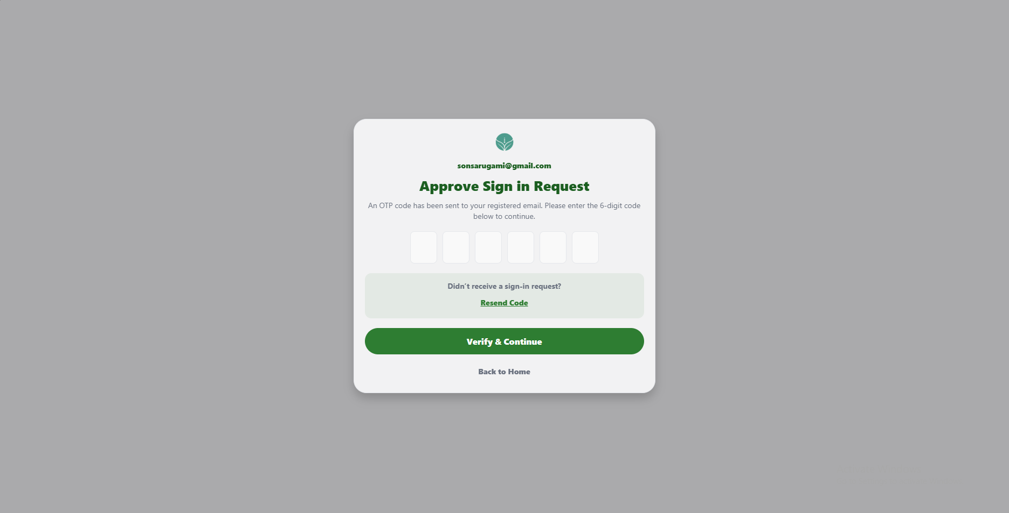 | PASSED
2 | Submit the form without entering a code. |  | A message asks for the 6-digit code, and verification does not continue. |  | 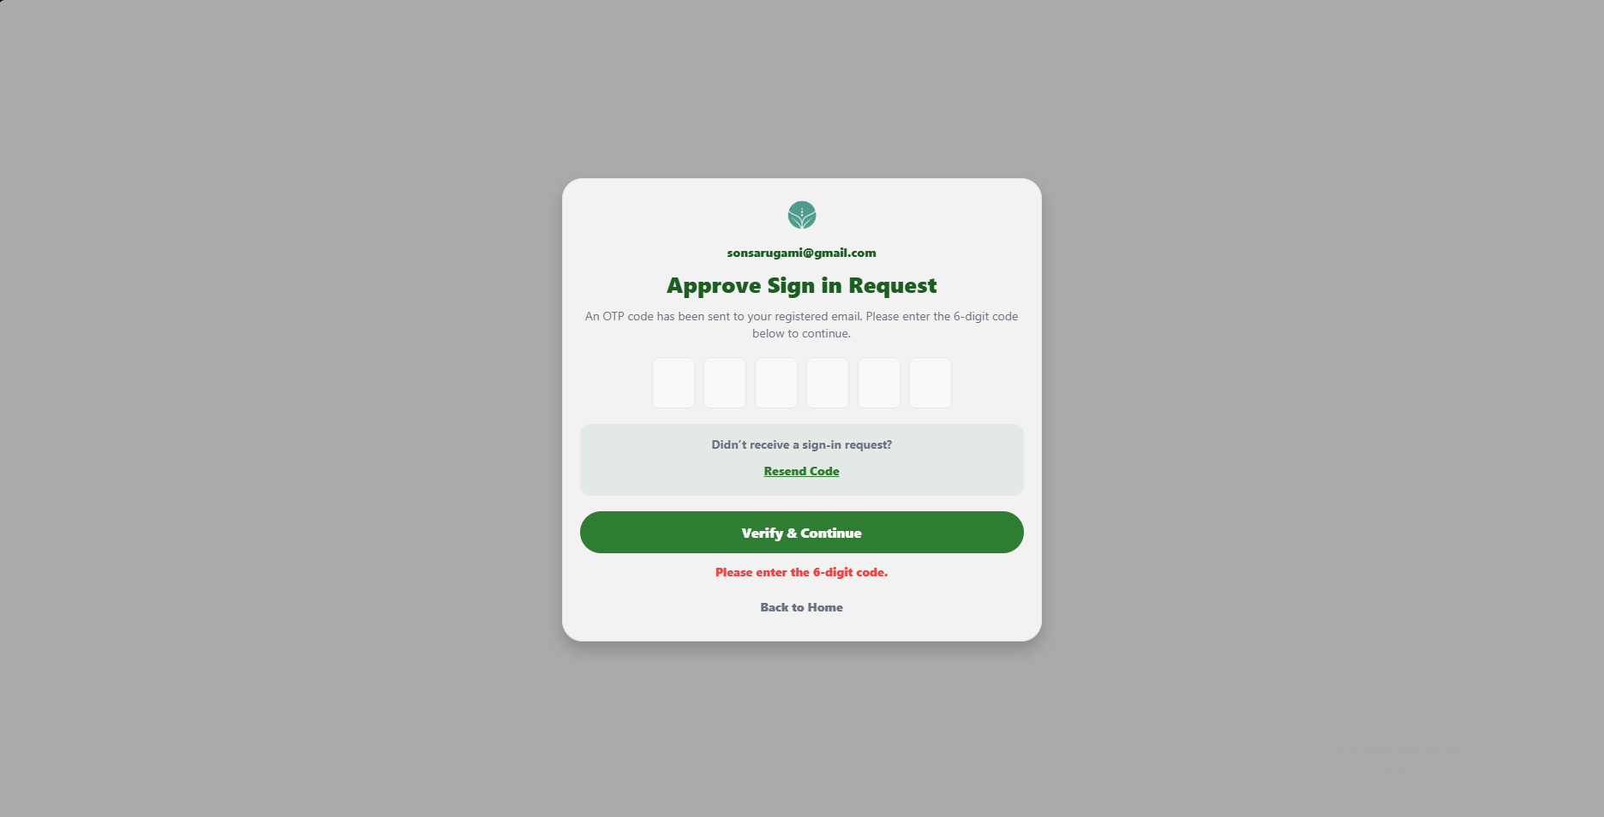 | PASSED
3 | Enter a code with fewer than six digits and select Verify & Continue. |  | The page asks for all six digits, and the code is not submitted. |  | 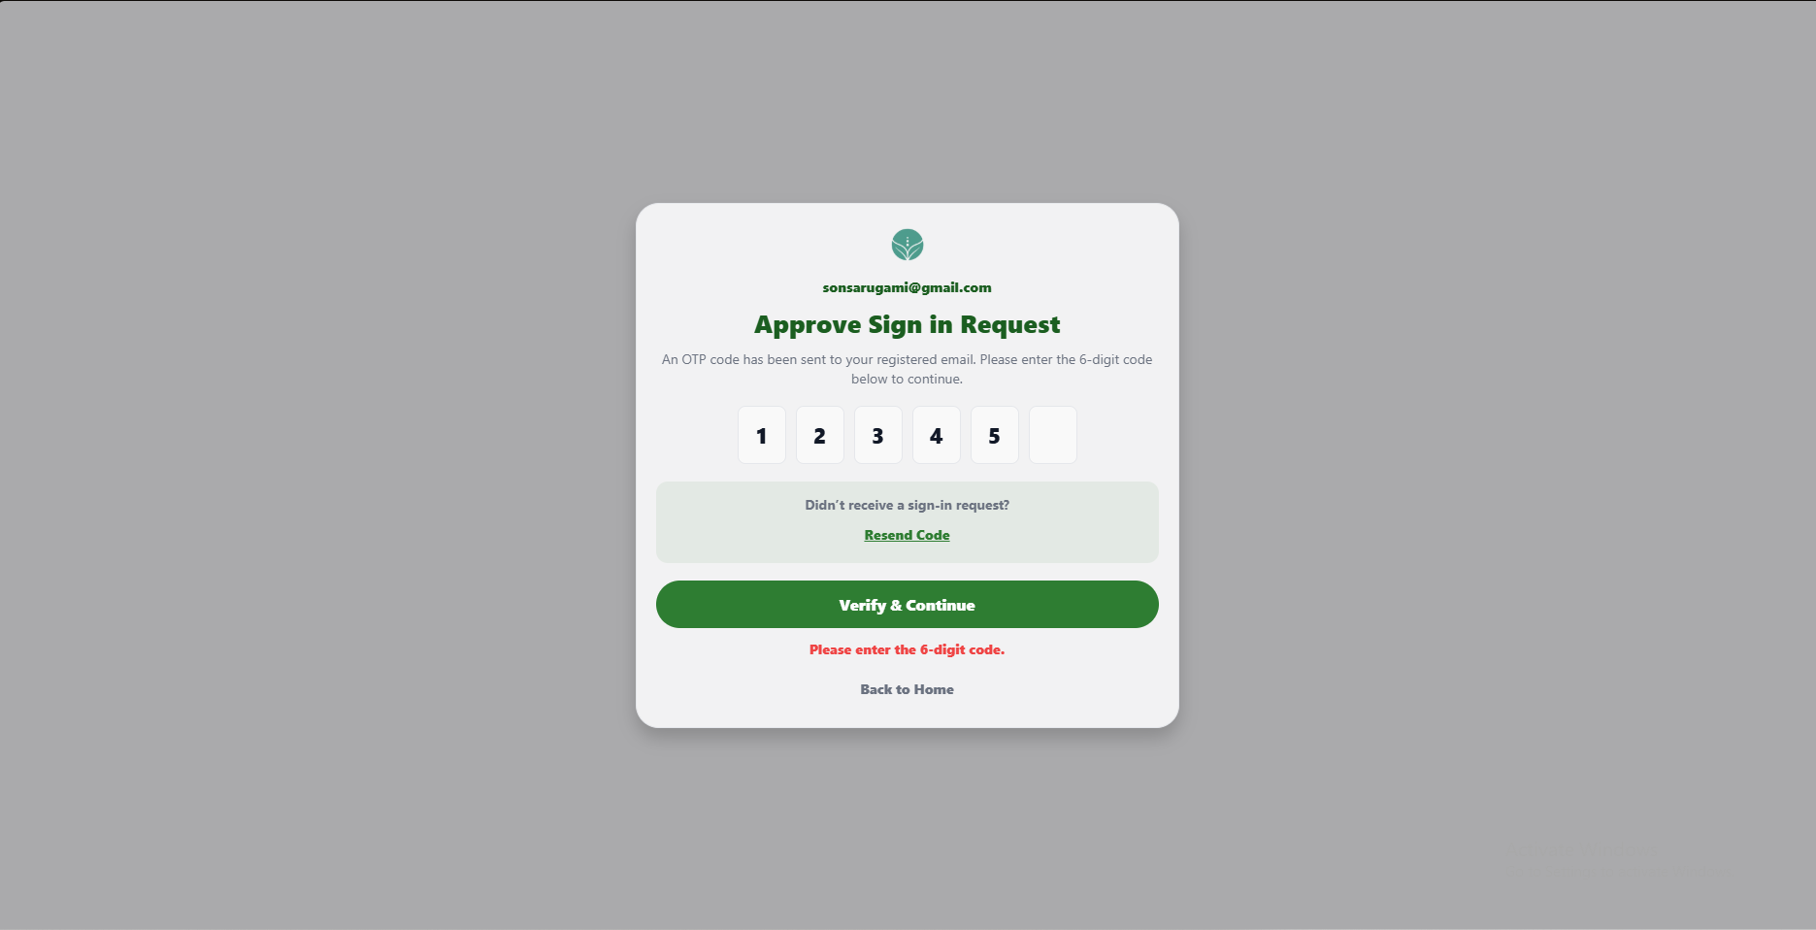 | PASSED
4 | Enter letters and symbols in the code field. |  | Only numeric digits appear in the code boxes. |  | 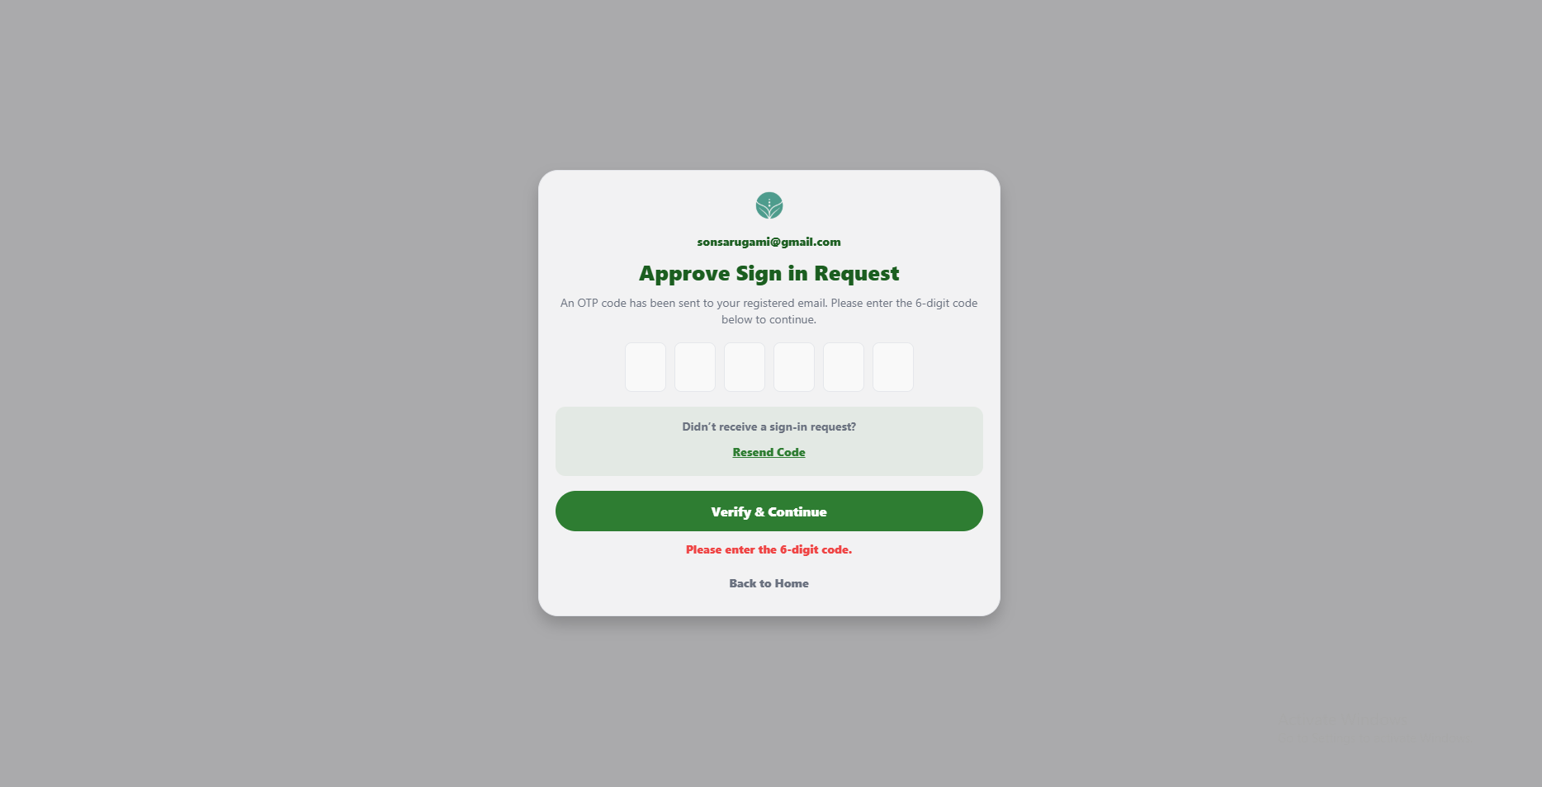 | PASSED
5 | Enter an incorrect six-digit code and select Verify & Continue. |  | The code is rejected, and a clear error message appears. |  | 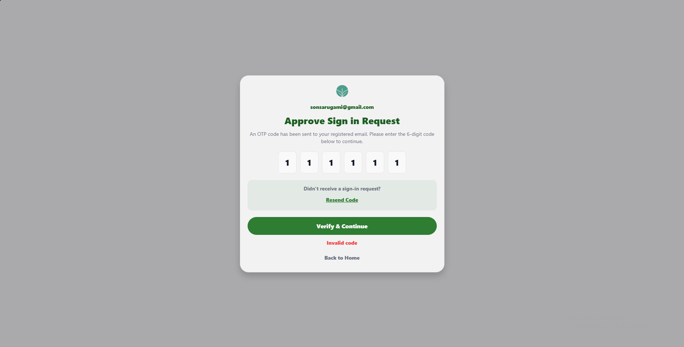 | PASSED
6 | Enter an expired six-digit code and select Verify & Continue. |  | The page explains that the code expired and asks the user to resend a code. |  | 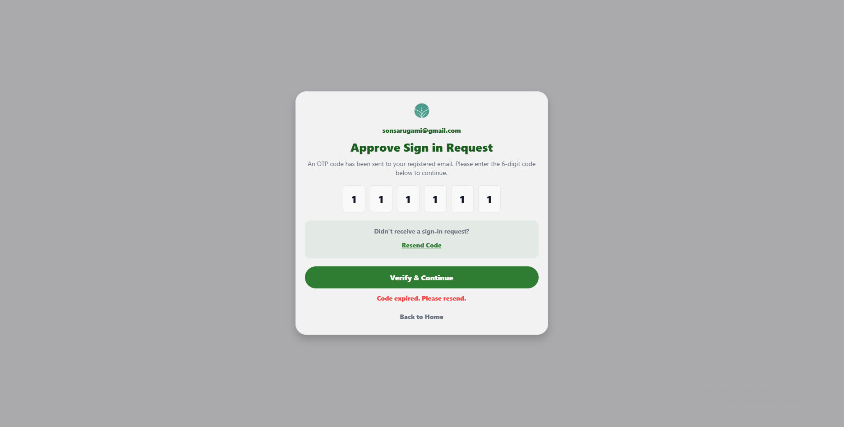 | PASSED
7 | Submit an incorrect code five times. |  | Further verification is blocked temporarily, and a try-again-later message appears. |  | 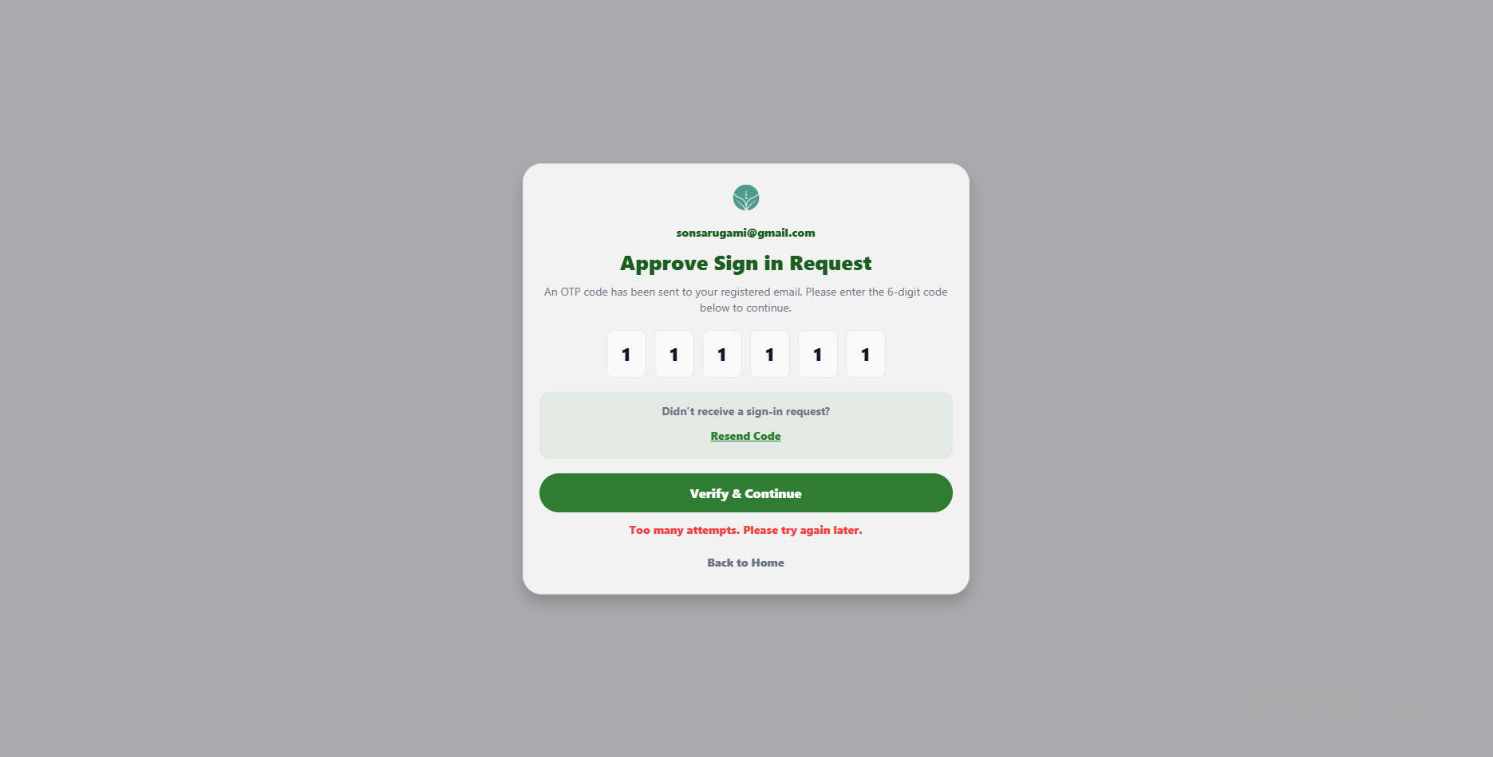 | PASSED
8 | Enter the current valid six-digit code from the test email and select Verify & Continue. |  | The email is verified, and the user is returned to Sign In to continue signing in. |  | 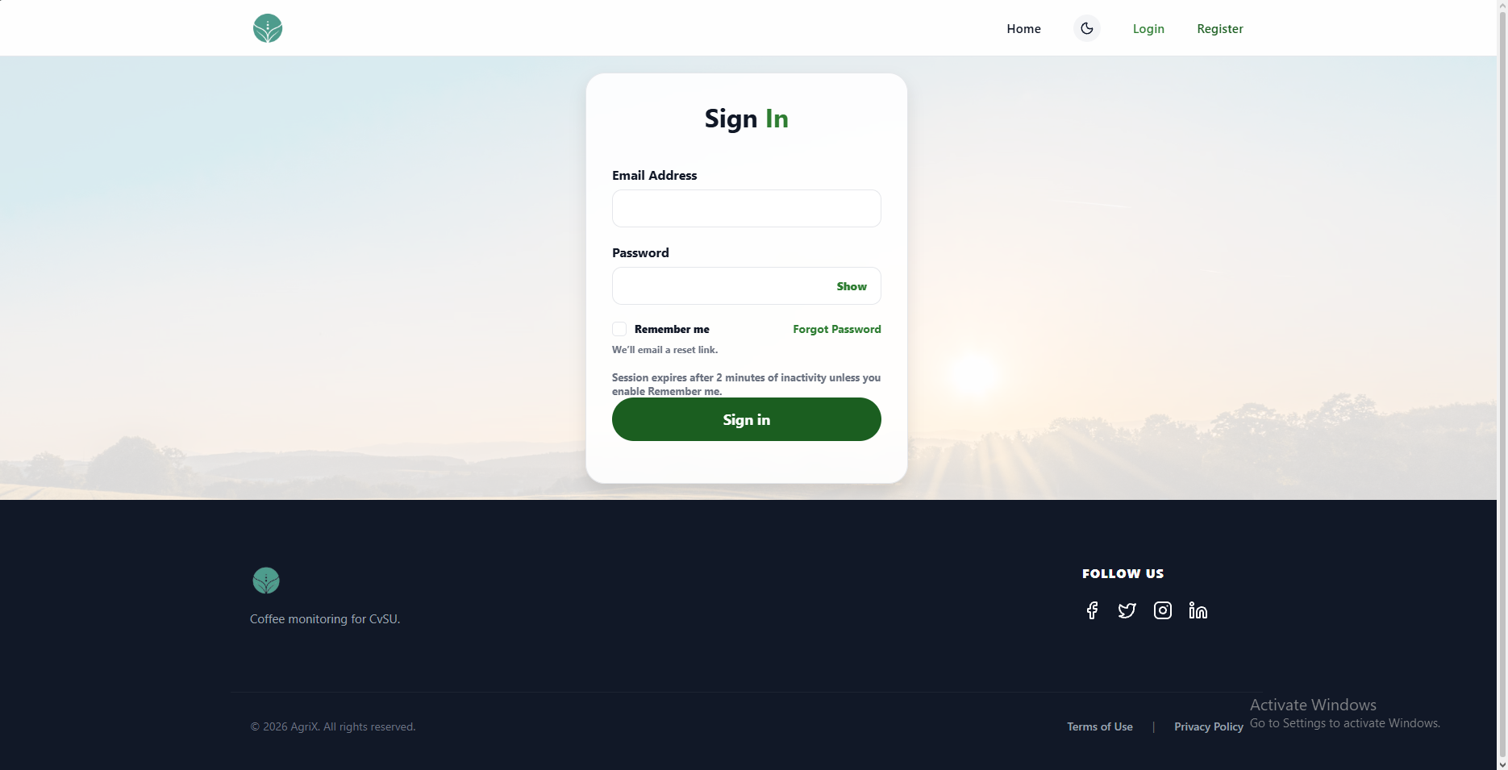 | PASSED
9 | Select Resend Code once. |  | A new code is sent to the registered email and a confirmation message appears. |  | 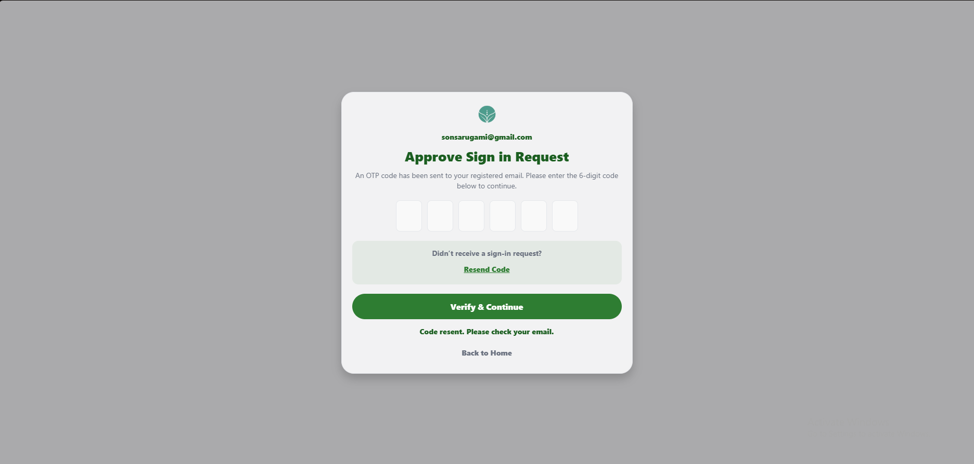 | PASSED
10 | Use the previous code after requesting a new code. |  | The old code is rejected; only the latest code can verify the account. |  | 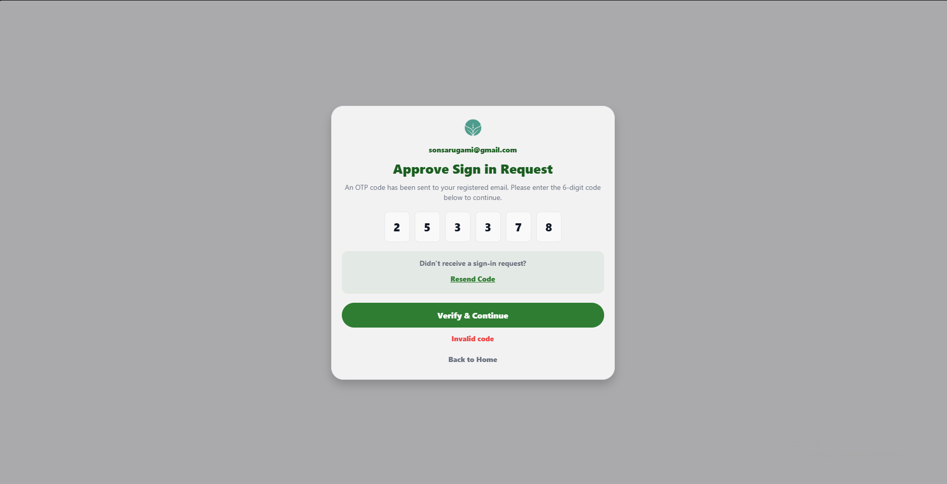 | PASSED
11 | Request more than three codes within ten minutes. |  | The page blocks further resend requests and asks the user to try again later. |  | 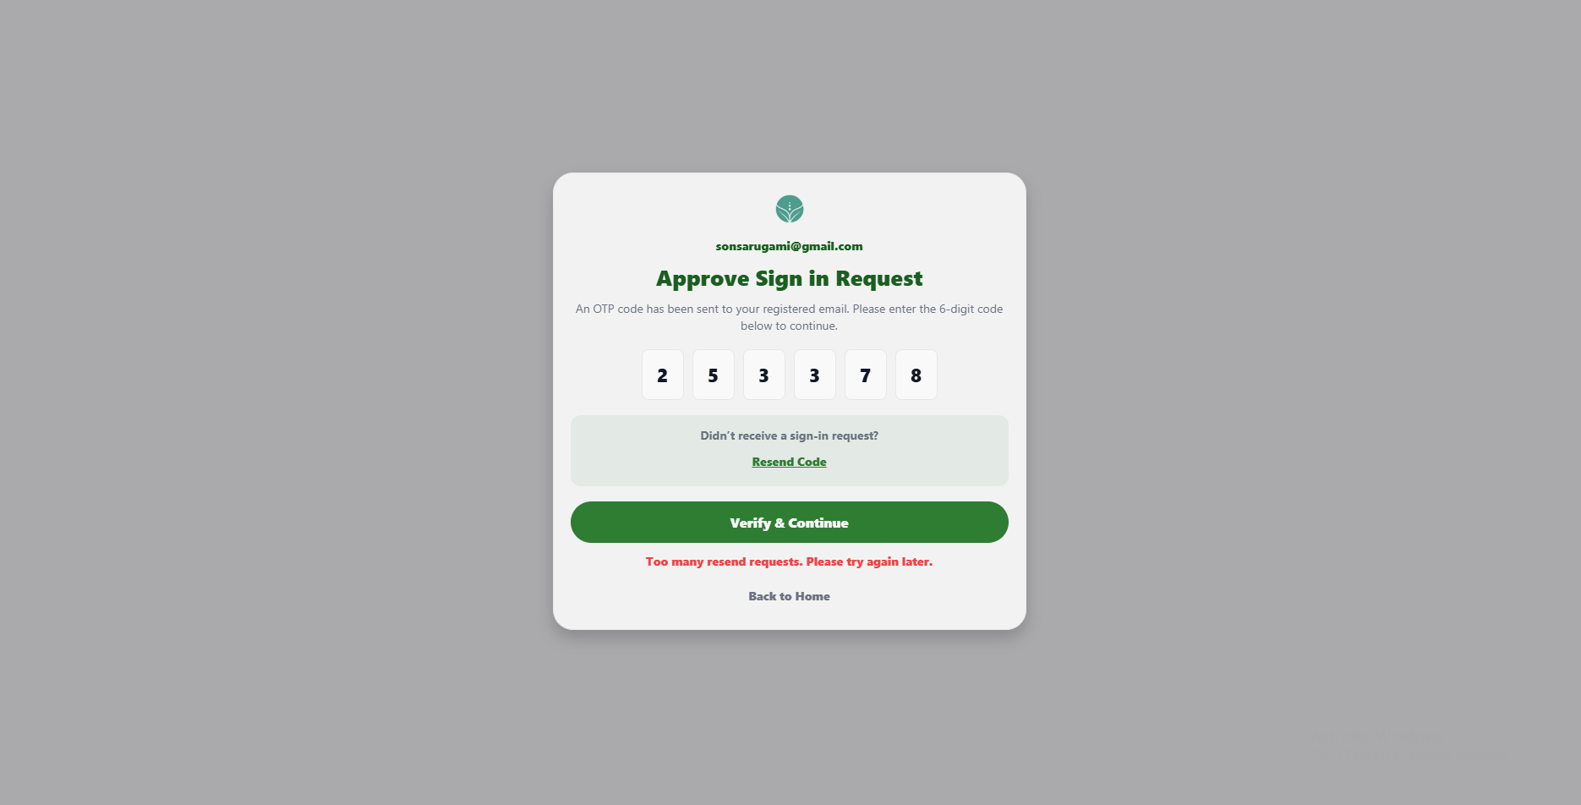 | PASSED
12 | Select Back to Home. |  | The landing page opens. |  | 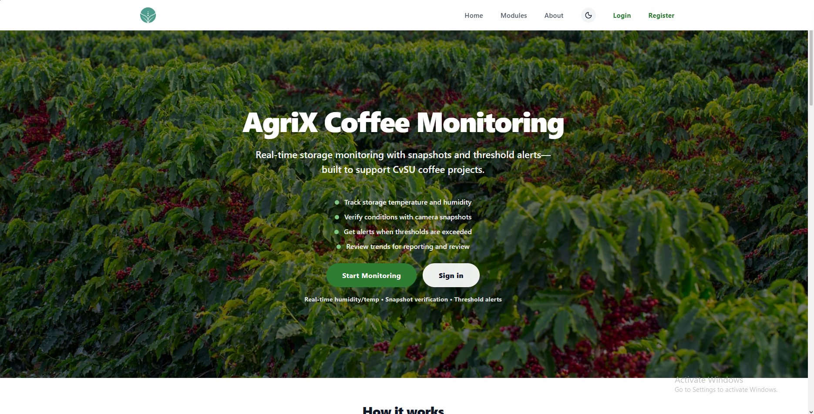 | PASSED

UNIT TEST DOCUMENT |  | Module Name |  | DASHBOARD MODULE
Test Cycle No. | 1
Test Cycle No. | 1 | Component Name |  | DASHBOARD PAGE
Date Tested |  | Type of System |  | Web Application
Pre-conditions | A signed-in standard user account is available. Sensor data may be live, disconnected, or unavailable. For Monitoring checks, a test image and permission to create test readings are available when needed.
Action Description | Open the AgriX Dashboard and review the Overview and Monitoring views, sensor status, alerts, navigation controls, threshold settings, trends, readings, and camera snapshots.
Verification Steps | Confirm the Dashboard opens, displays current sensor and system status accurately, and that each tab, header control, monitoring action, and navigation button responds as expected.
Test Scenario | Data  (Input Values) |  | Expected Results |  | Actual Results | Remarks
1 | Open the Dashboard after signing in. |  | The Dashboard opens with the Overview tab selected and the header controls visible. |  | 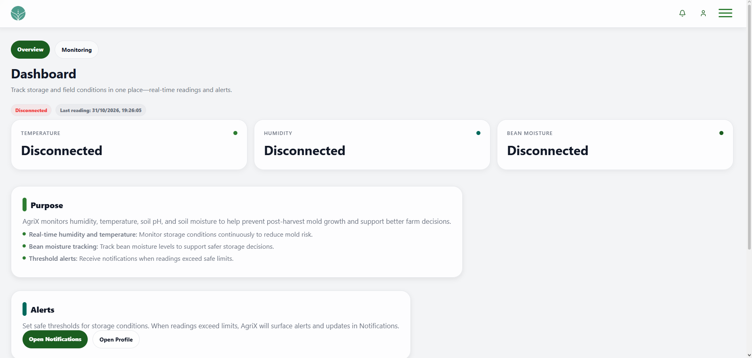 | PASSED
2 | Select the AgriX logo in the header. |  | The Dashboard opens at its default Overview view. |  | 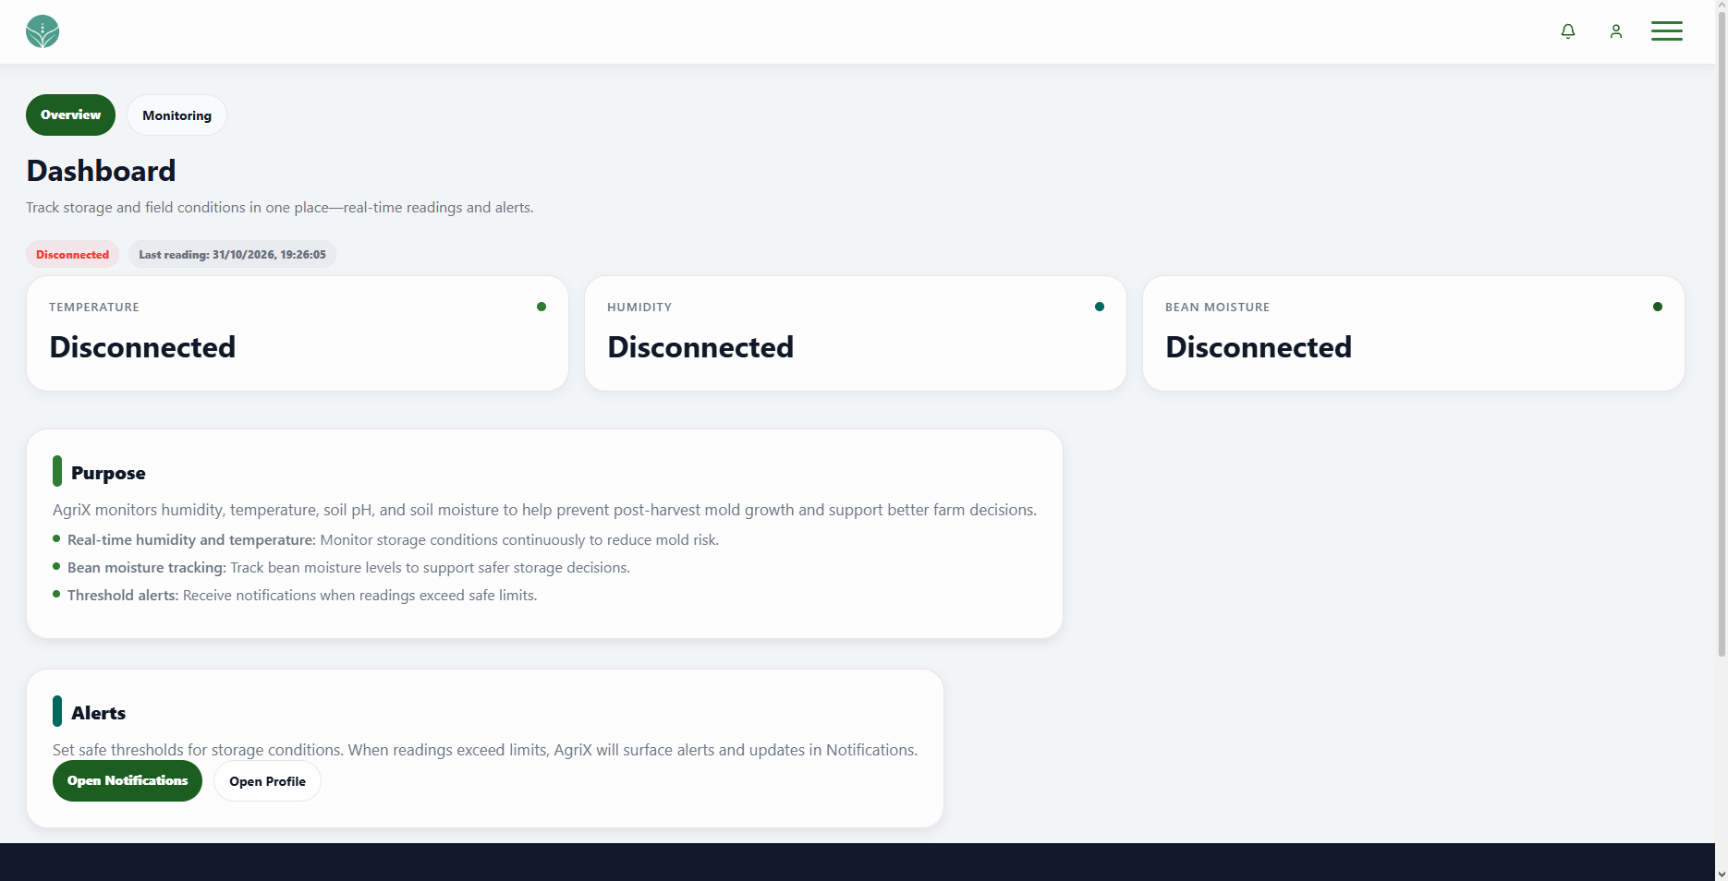 | PASSED
3 | Select the notification bell in the header. |  | The Notifications page opens, and any unread count is shown on the bell. |  | 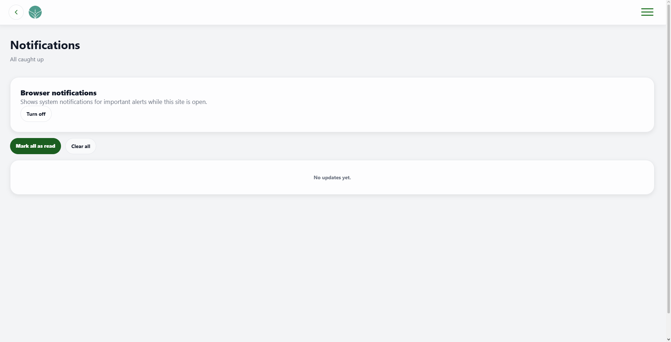 | PASSED
4 | Select the profile icon in the header. |  | The My Profile page opens. |  | 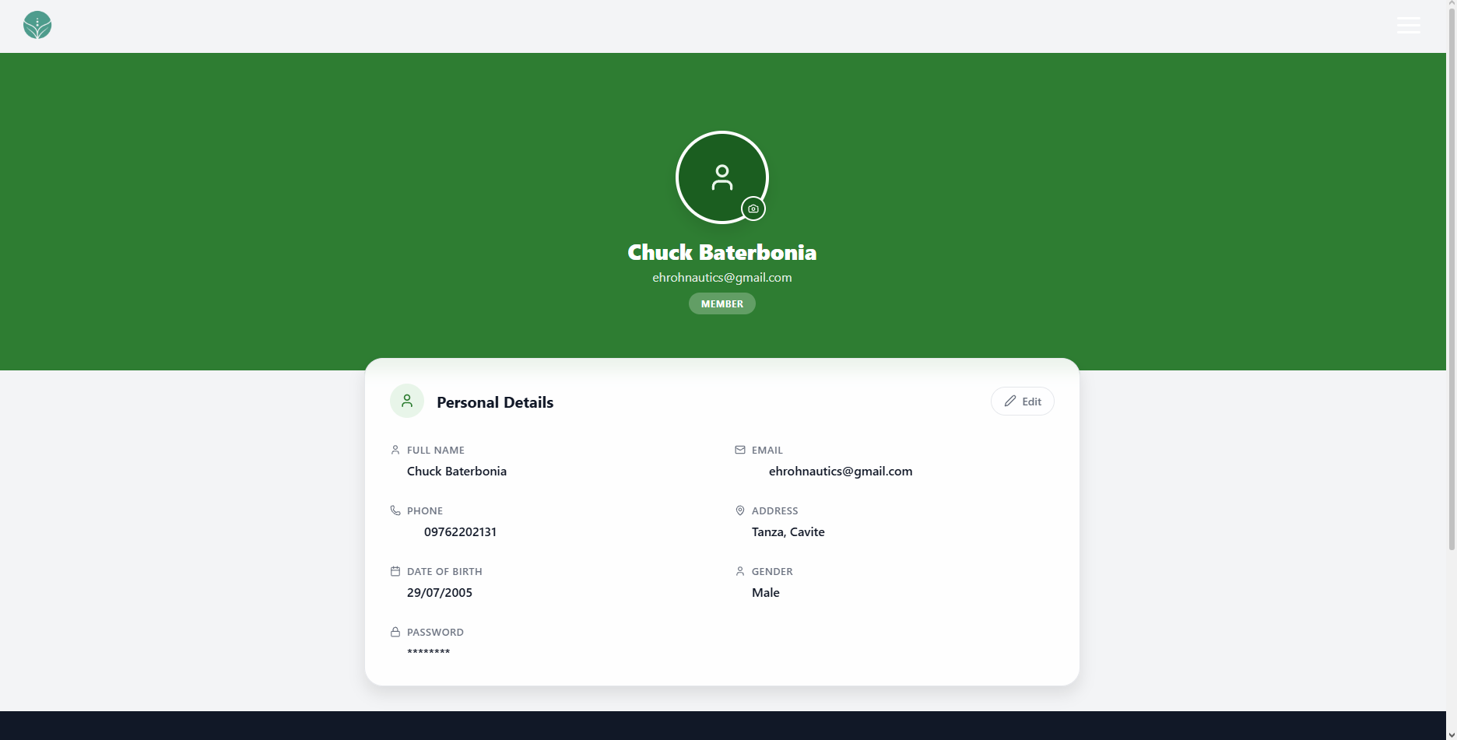 | PASSED
5 | Select the menu icon in the header. |  | The navigation menu opens with the available options. |  | 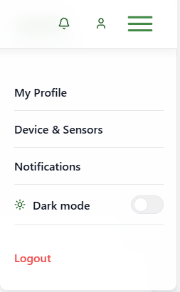 | PASSED
6 | Select Dark mode in the navigation menu. |  | The Dashboard changes to dark mode and its text and controls remain readable. |  | 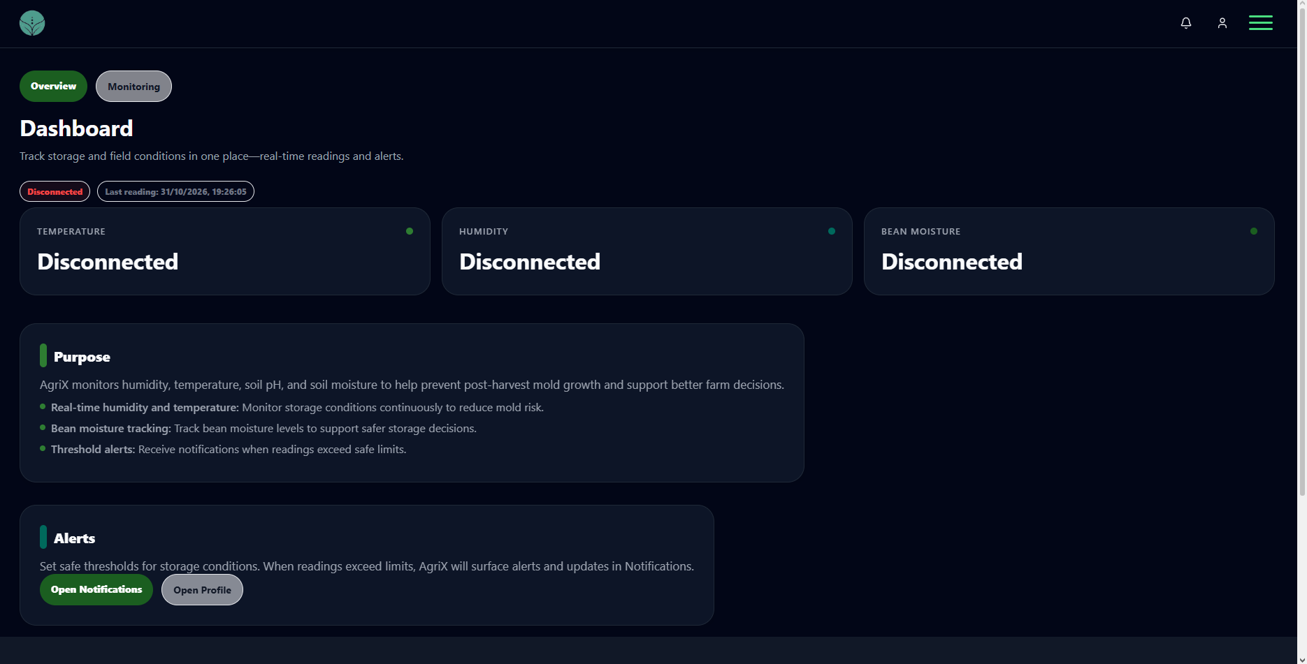 | PASSED
7 | View the Dashboard when sensor data is disconnected, stale, or not available. |  | The status and cards show Disconnected, Offline, or No data yet as appropriate; stale values are not presented as live. |  | 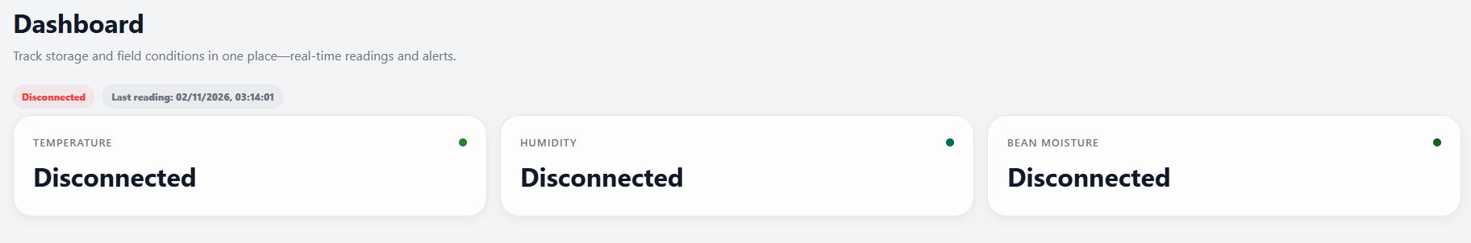 | PASSED
8 | Select the Monitoring tab. |  | The Monitoring view opens with system status, sensor summaries, trends, snapshots, and daily checklist. |  | 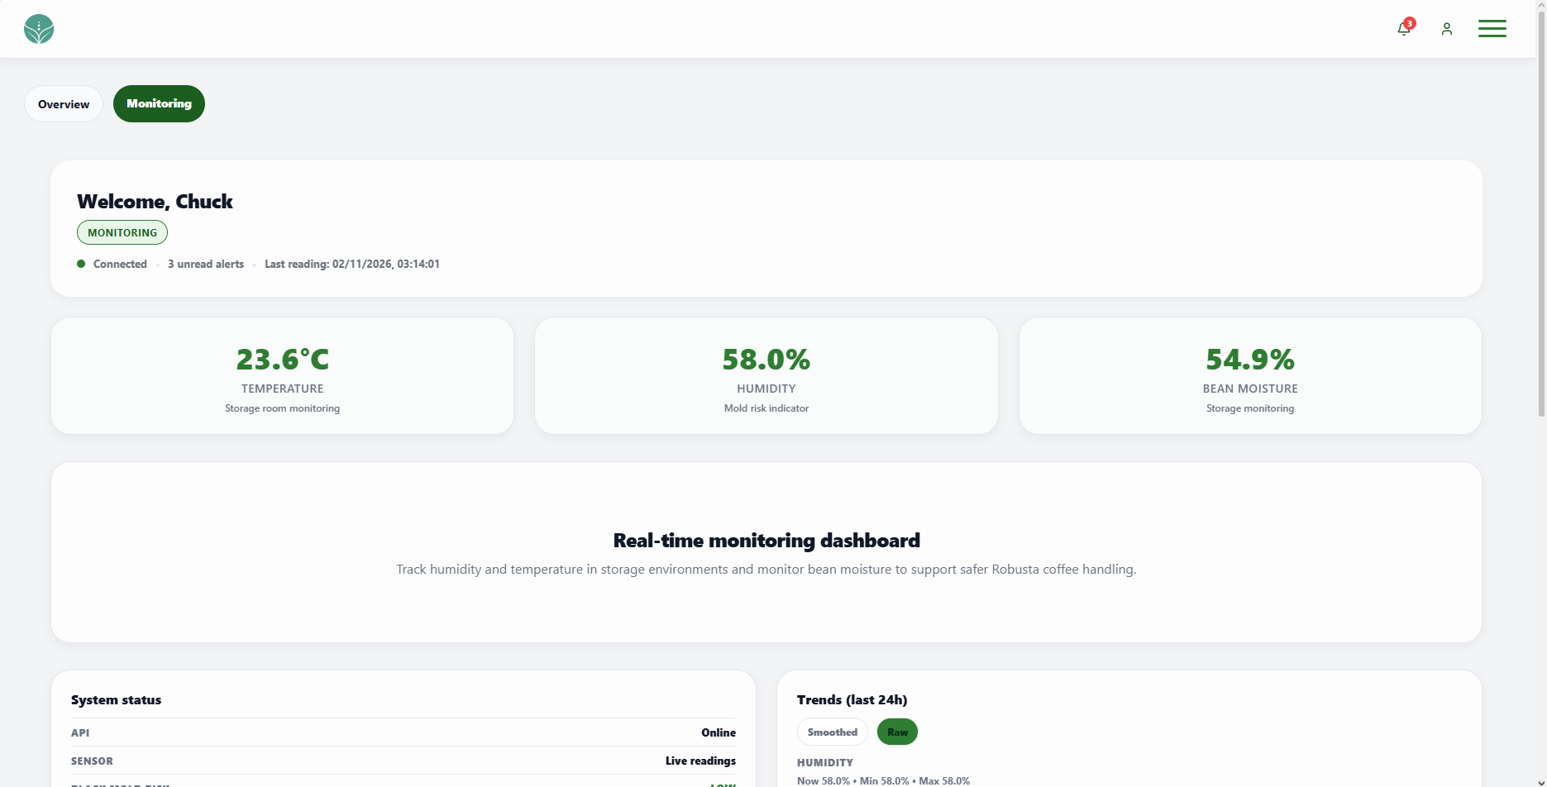 | PASSED
9 | Select Smoothed in the Trends section. |  | The trend charts switch between smoothed and raw readings. |  | 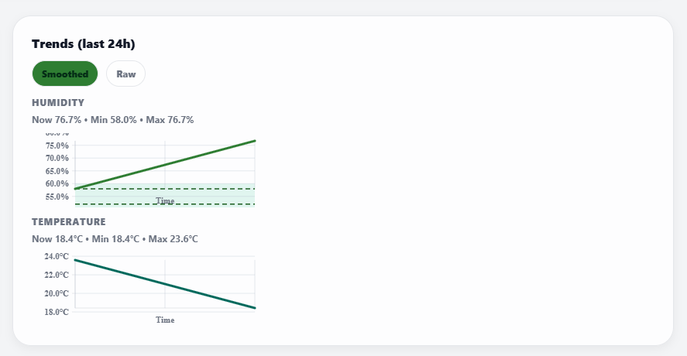 | PASSED
10 | Select Raw in the Trends Section |  | The trend charts switch between smoothed and raw readings. |  | 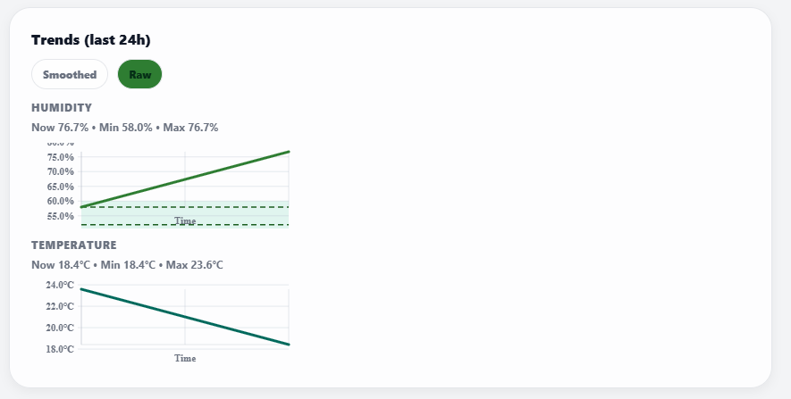 | PASSED
11 | Open Set thresholds, select Recommended, and save. |  | The recommended humidity and temperature thresholds are applied, and a settings update appears in Notifications. |  | 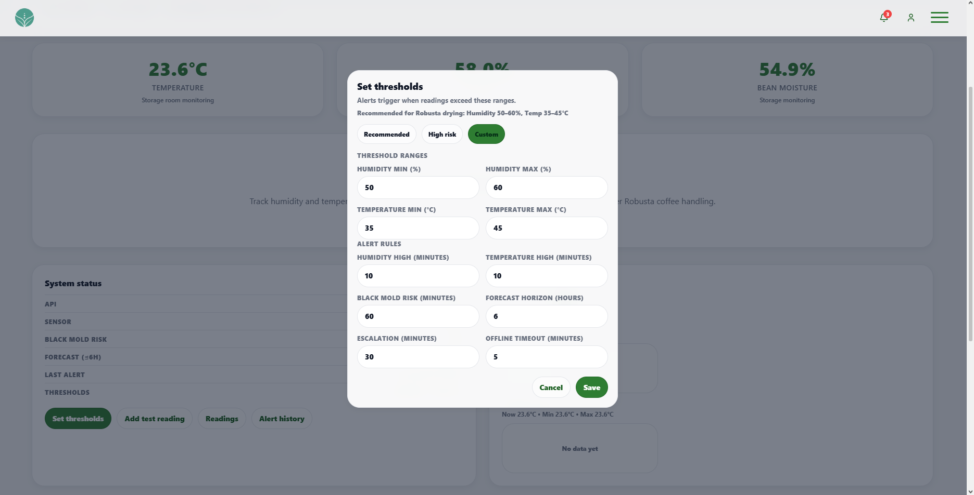 | PASSED
12 | Open Set thresholds, enter 52 and 58 for humidity and 36 and 42 for temperature, then save. |  | The custom threshold values are saved and shown in the Monitoring view. |  | 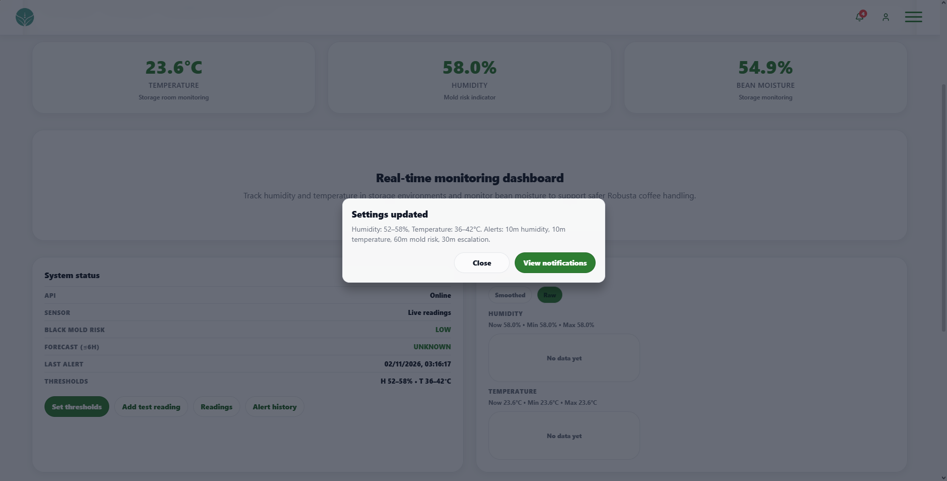 | PASSED
13 | Select Add test reading. |  | A new test reading is added and the dashboard reading data updates. |  | 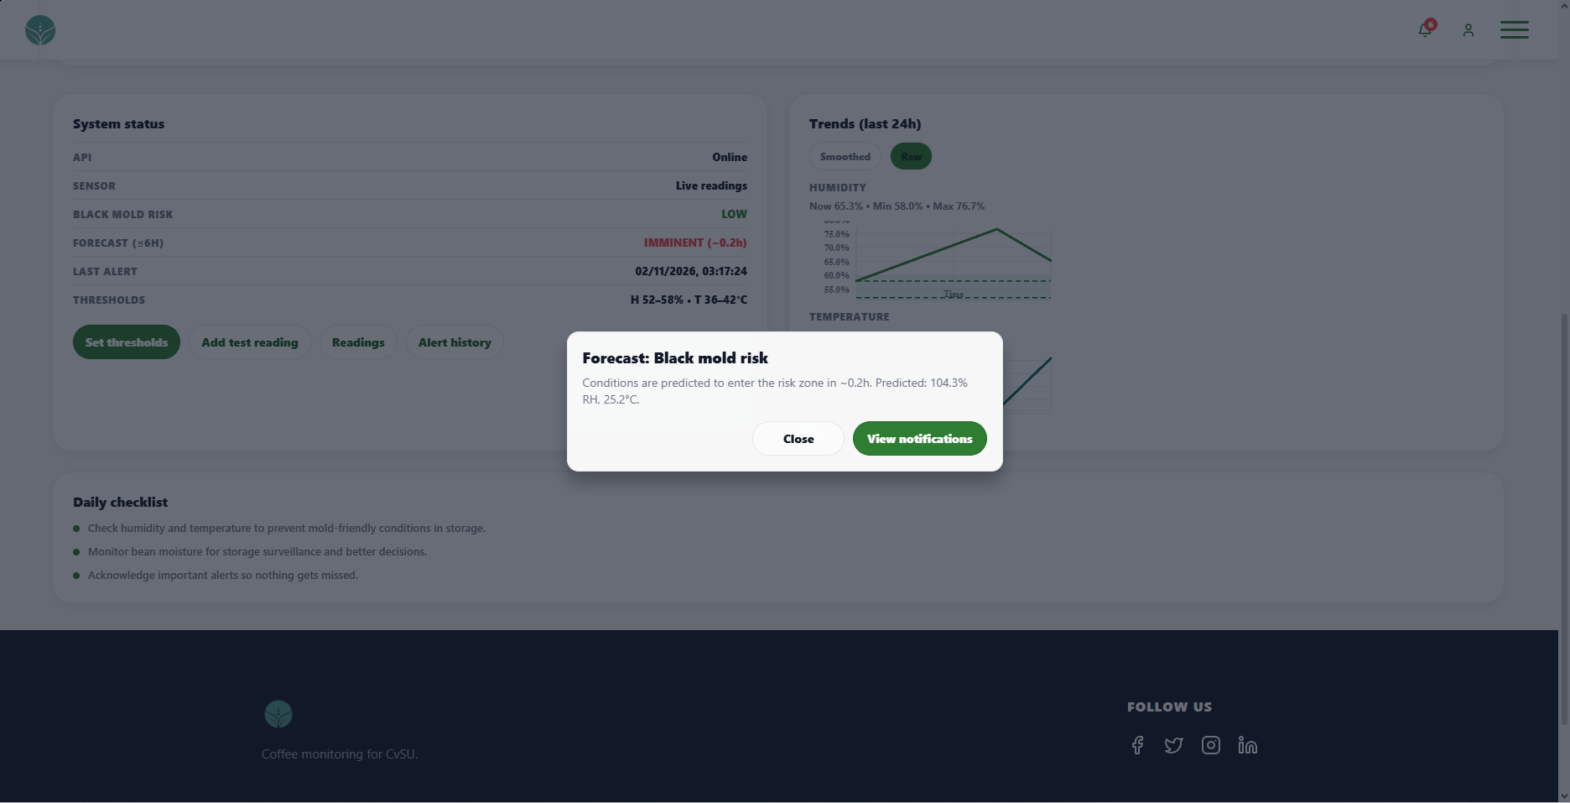 | PASSED
14 | Select Readings. |  | The readings timeline opens. |  | 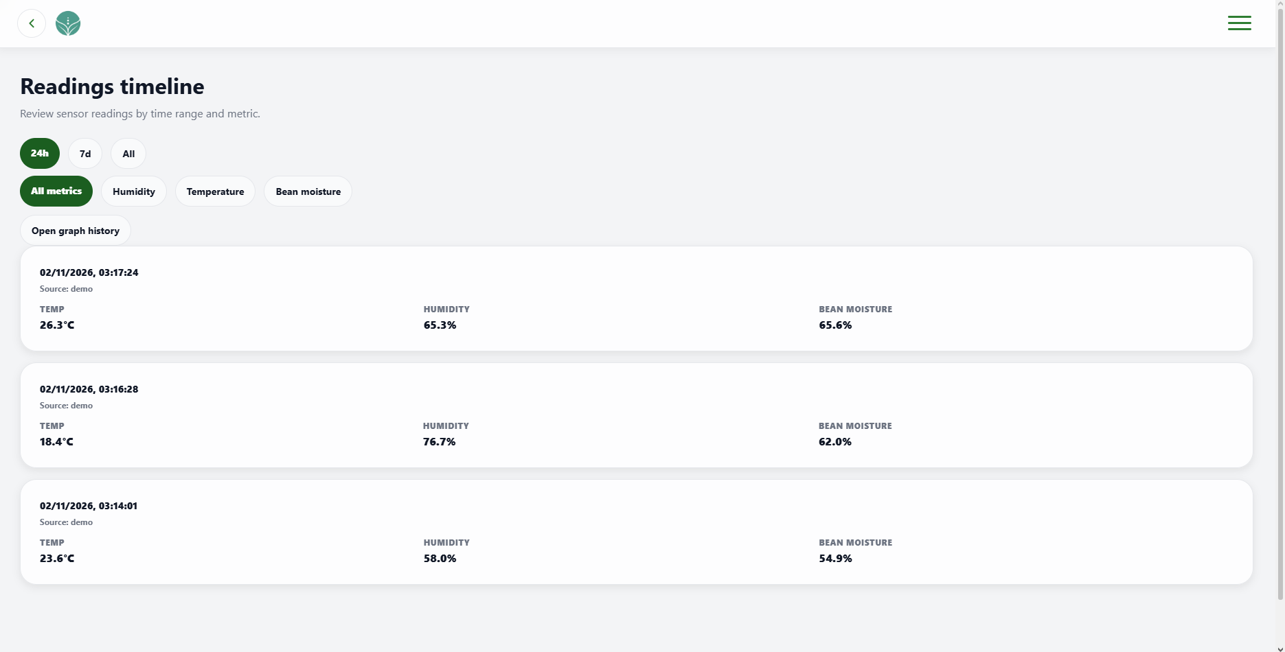 | PASSED
16 | Select Alert history. |  | The alert history page opens. |  | 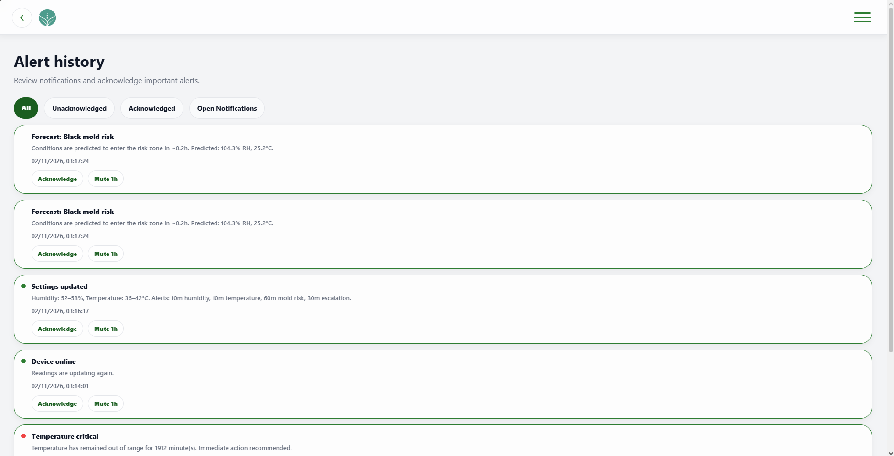 | PASSED

UNIT TEST DOCUMENT |  | Module Name |  | NOTIFICATION MODULE
Test Cycle No. | 1
Test Cycle No. | 1 | Component Name |  | NOTIFICATION PAGE
Date Tested |  | Type of System |  | Web Application
Pre-conditions | A signed-in client account is available. Test notifications are available with both read and unread items, different dates, and at least one repeated notification category. Browser notification tests require a web browser that supports system notifications.
Action Description | Open the client Notifications page and review its notification list, read and acknowledge actions, category mute controls, browser notification setting, and page navigation.
Verification Steps | Confirm the page shows current notifications and unread status, updates items after each action, handles browser notification permission correctly, and opens the intended destination for each navigation control.
Test Scenario | Data  (Input Values) |  | Expected Results |  | Actual Results | Remarks
1 | Open the Notifications page with read and unread test notifications available. |  | The page title and unread count appear, and notifications are listed from newest to oldest with readable dates. |  | 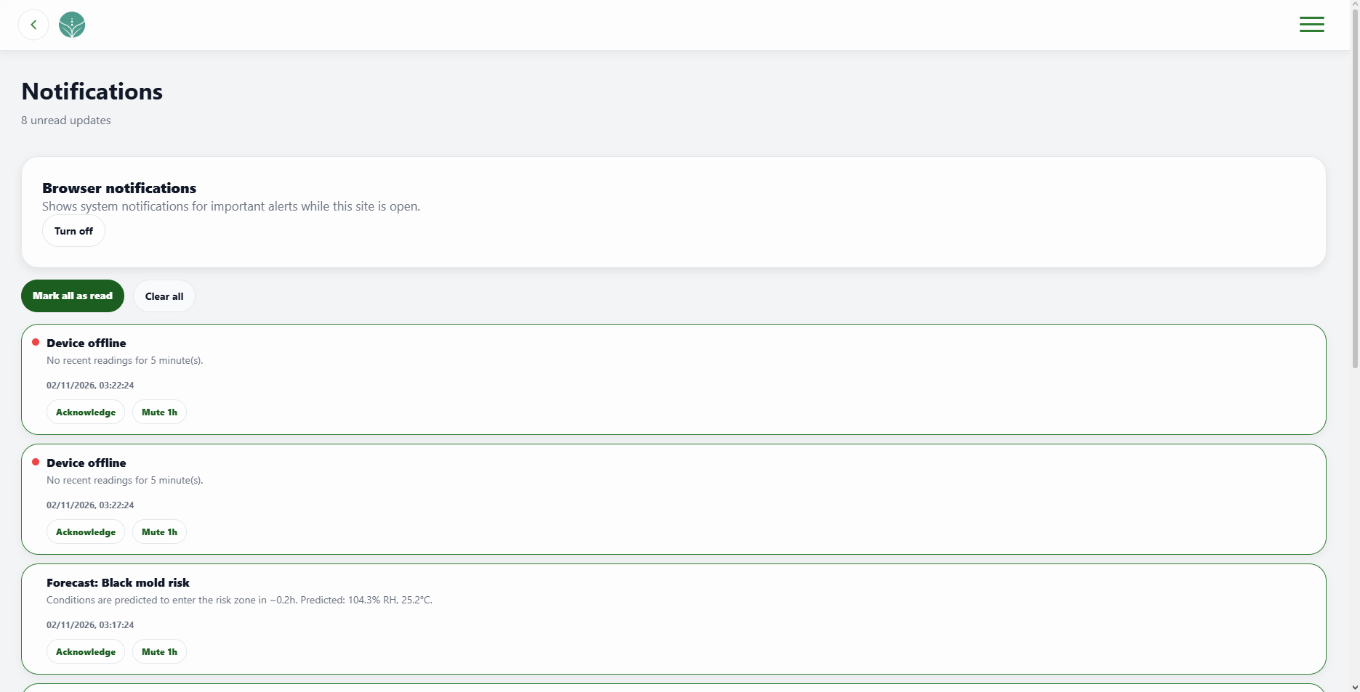 | PASSED
2 | Open the Notifications page when there are no notifications. |  | The subtitle shows All caught up and the page displays No updates yet. |  | 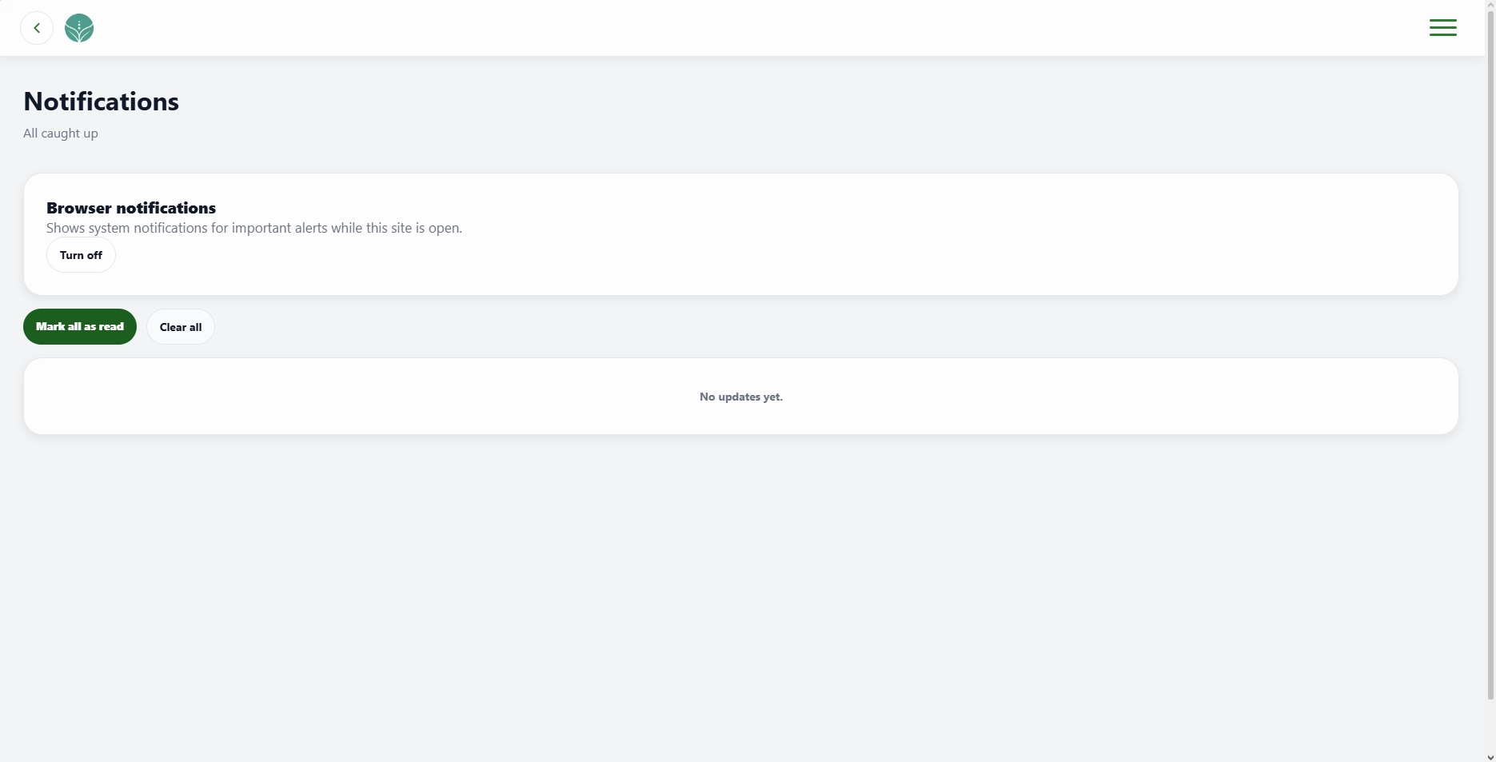 | PASSED
3 | Select one unread notification. |  | The notification is marked as read and the unread count decreases by one. |  | 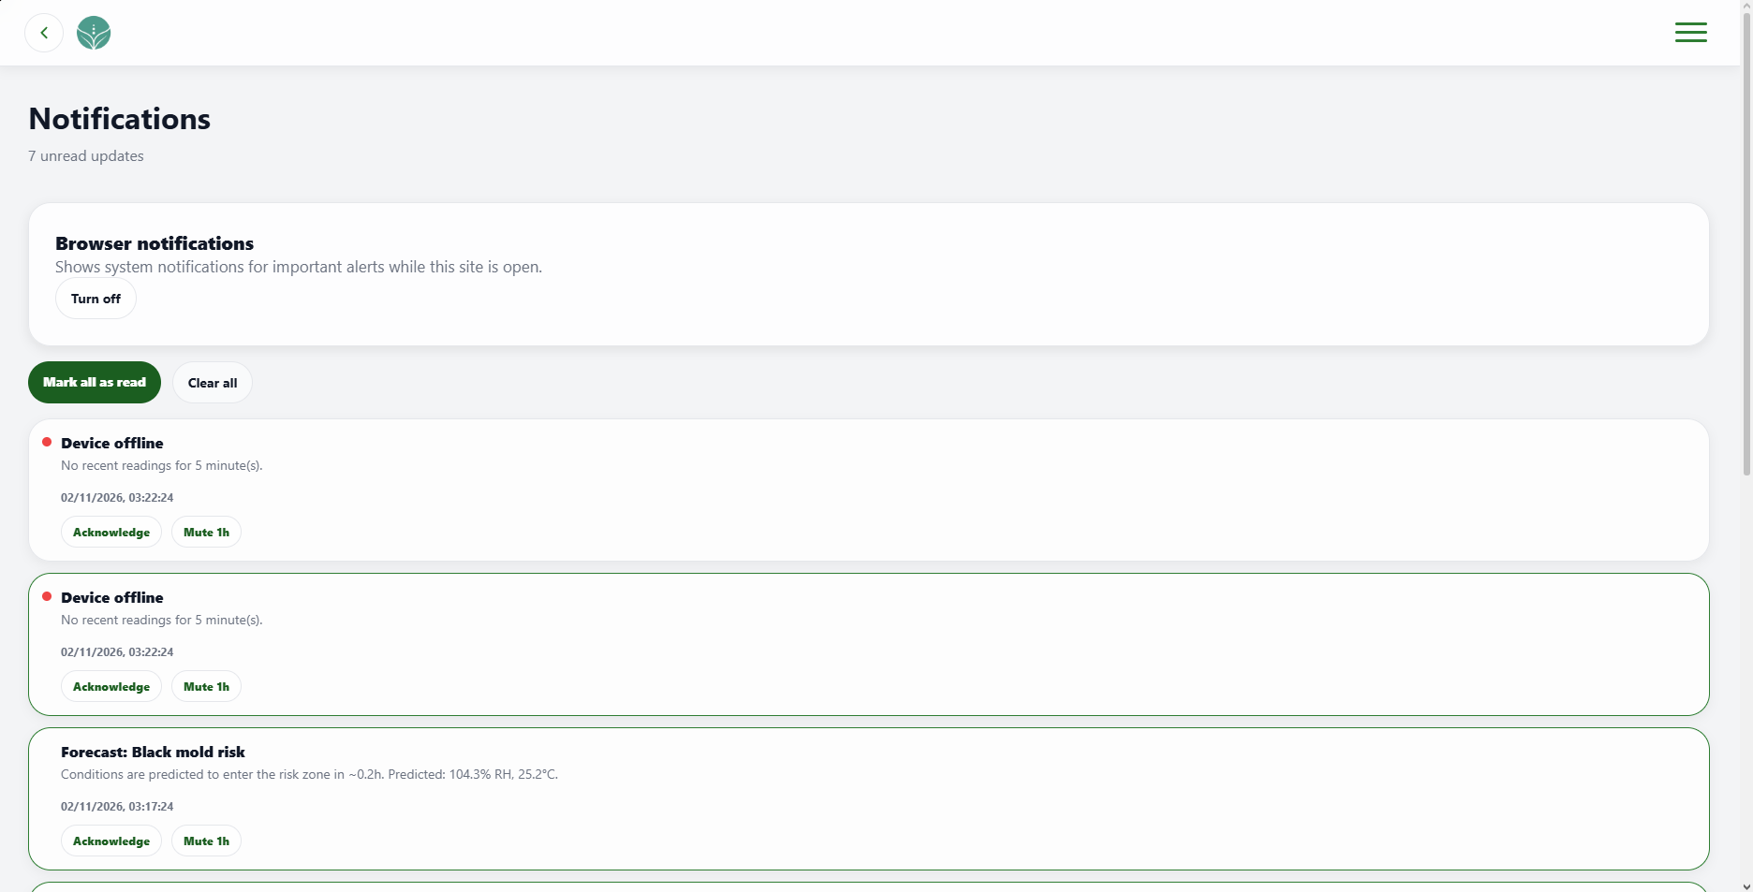 | PASSED
4 | Select Mark all as read. |  | All notifications are marked as read and the subtitle shows All caught up. |  | 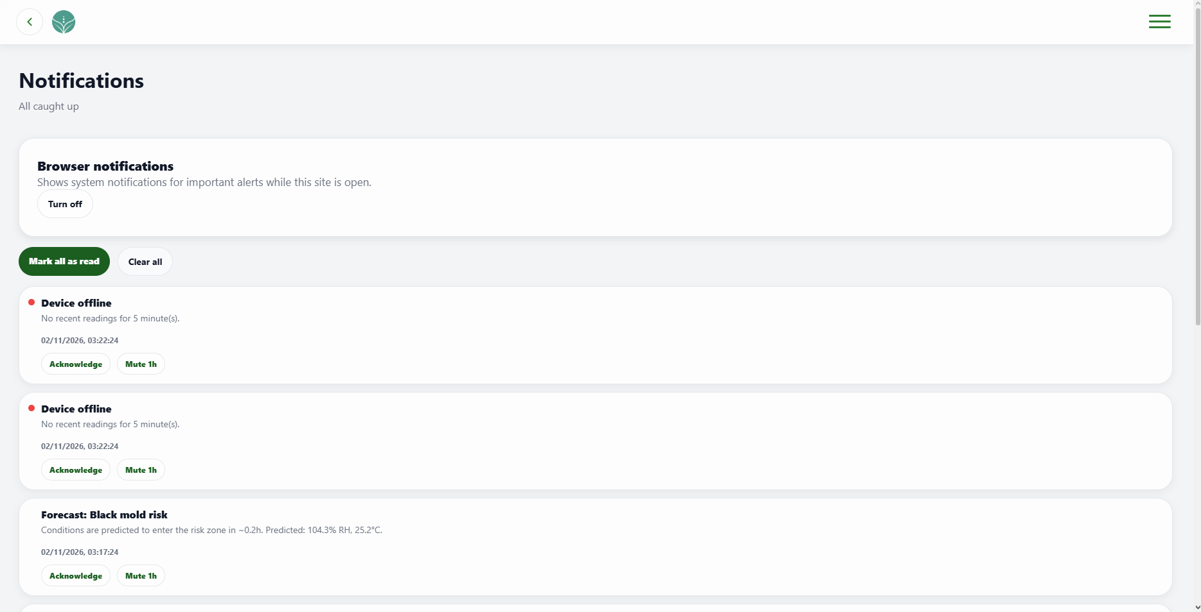 | PASSED
5 | Select Acknowledge on an unread notification. |  | The notification is marked as read and displays an Acknowledged badge. |  | 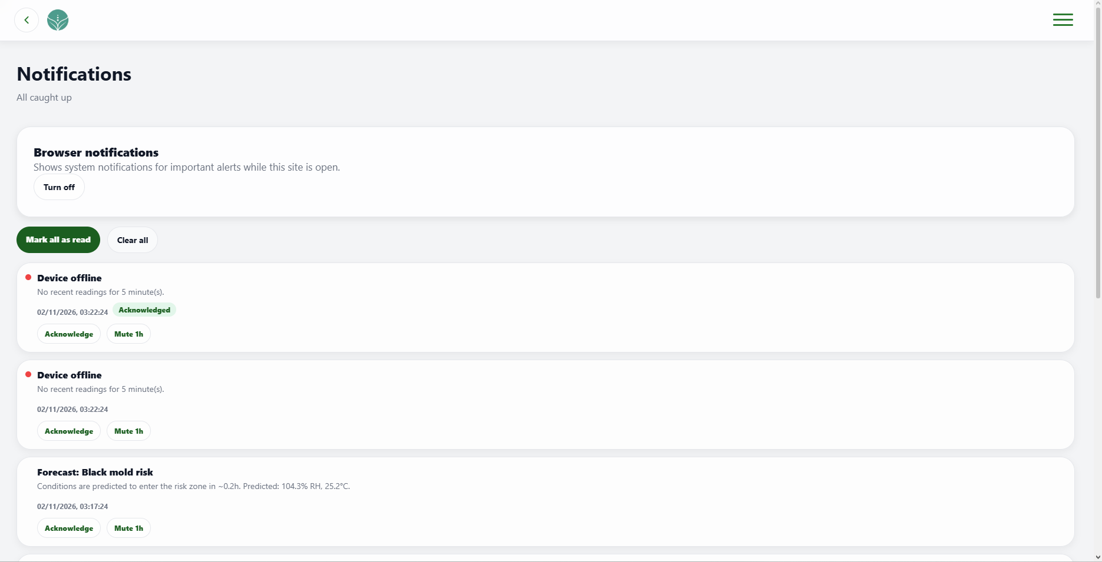 | PASSED
6 | Select Mute 1h on a notification category. |  | The item shows a muted-until time and the control changes to Unmute. |  | 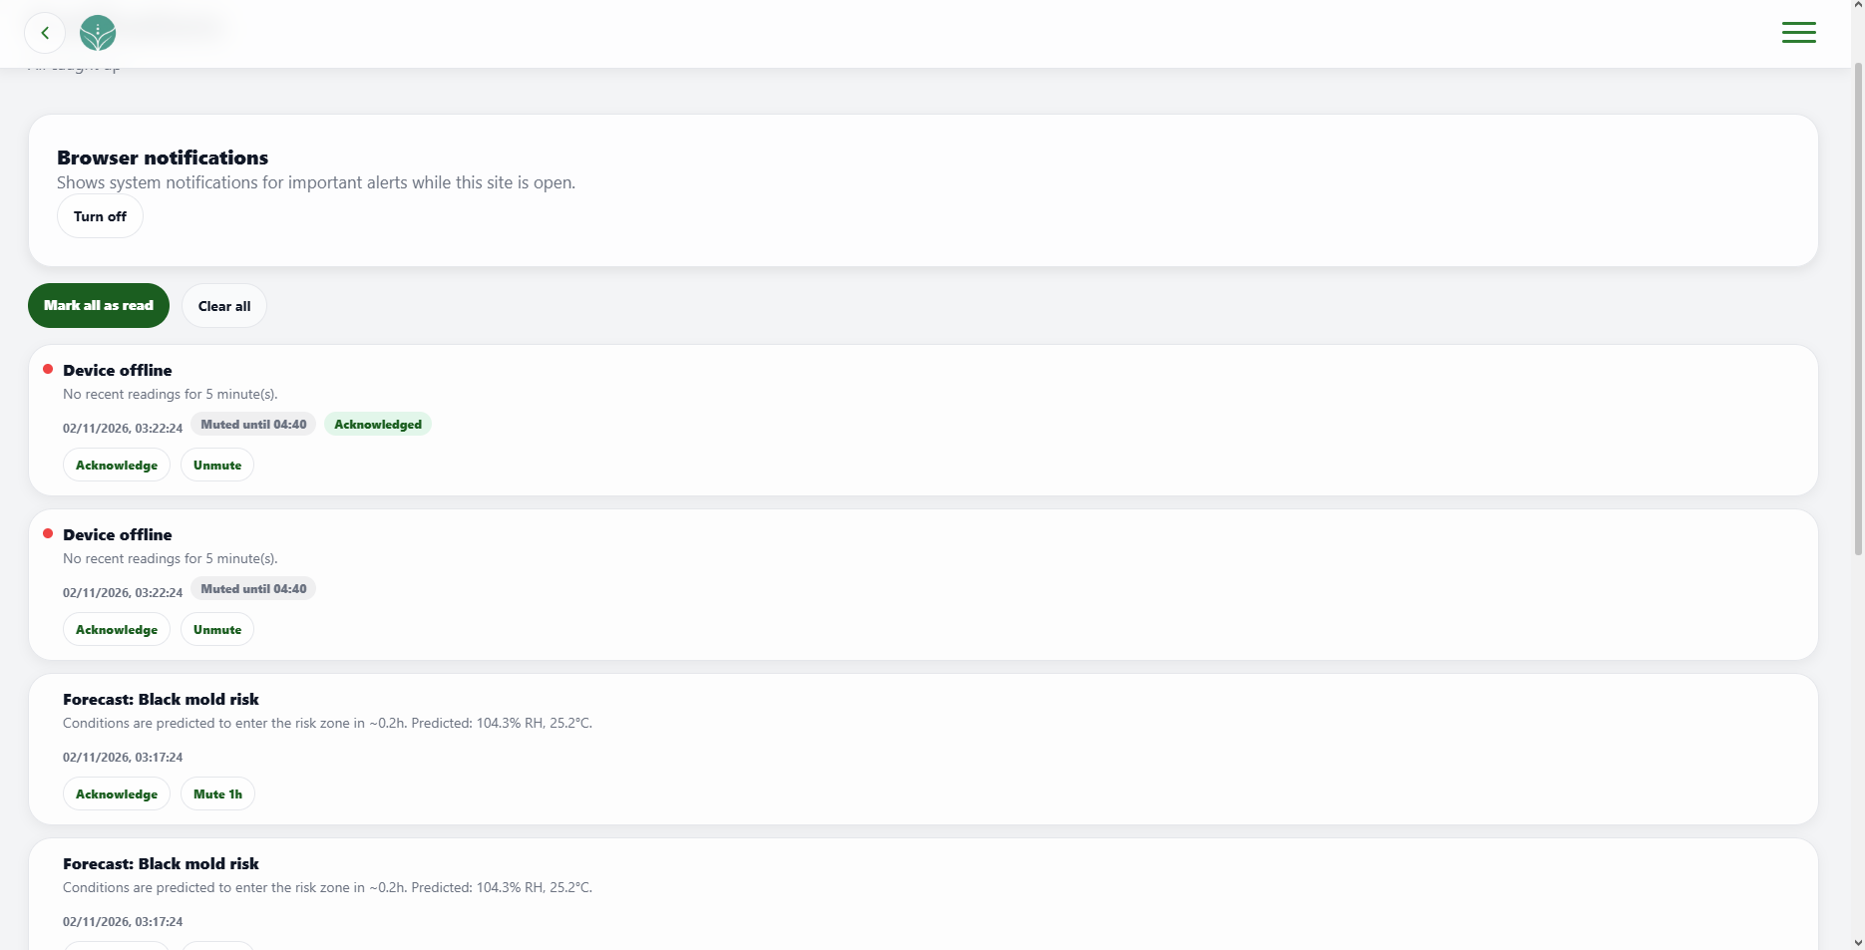 | PASSED
7 | Select Clear all while notifications are listed. |  | The notification list is cleared and the No updates, yet message appears. |  |  | PASSED
8 | Select Turn on and allow browser notifications then show the browser’s notification |  | Browser notifications are enabled and the control changes to Turn off. |  | 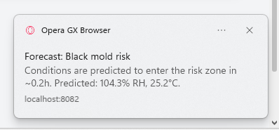 | PASSED
9 | Select Turn off after browser notifications have been enabled. |  | Browser notifications are disabled in AgriX and the control changes to Turn on. |  | 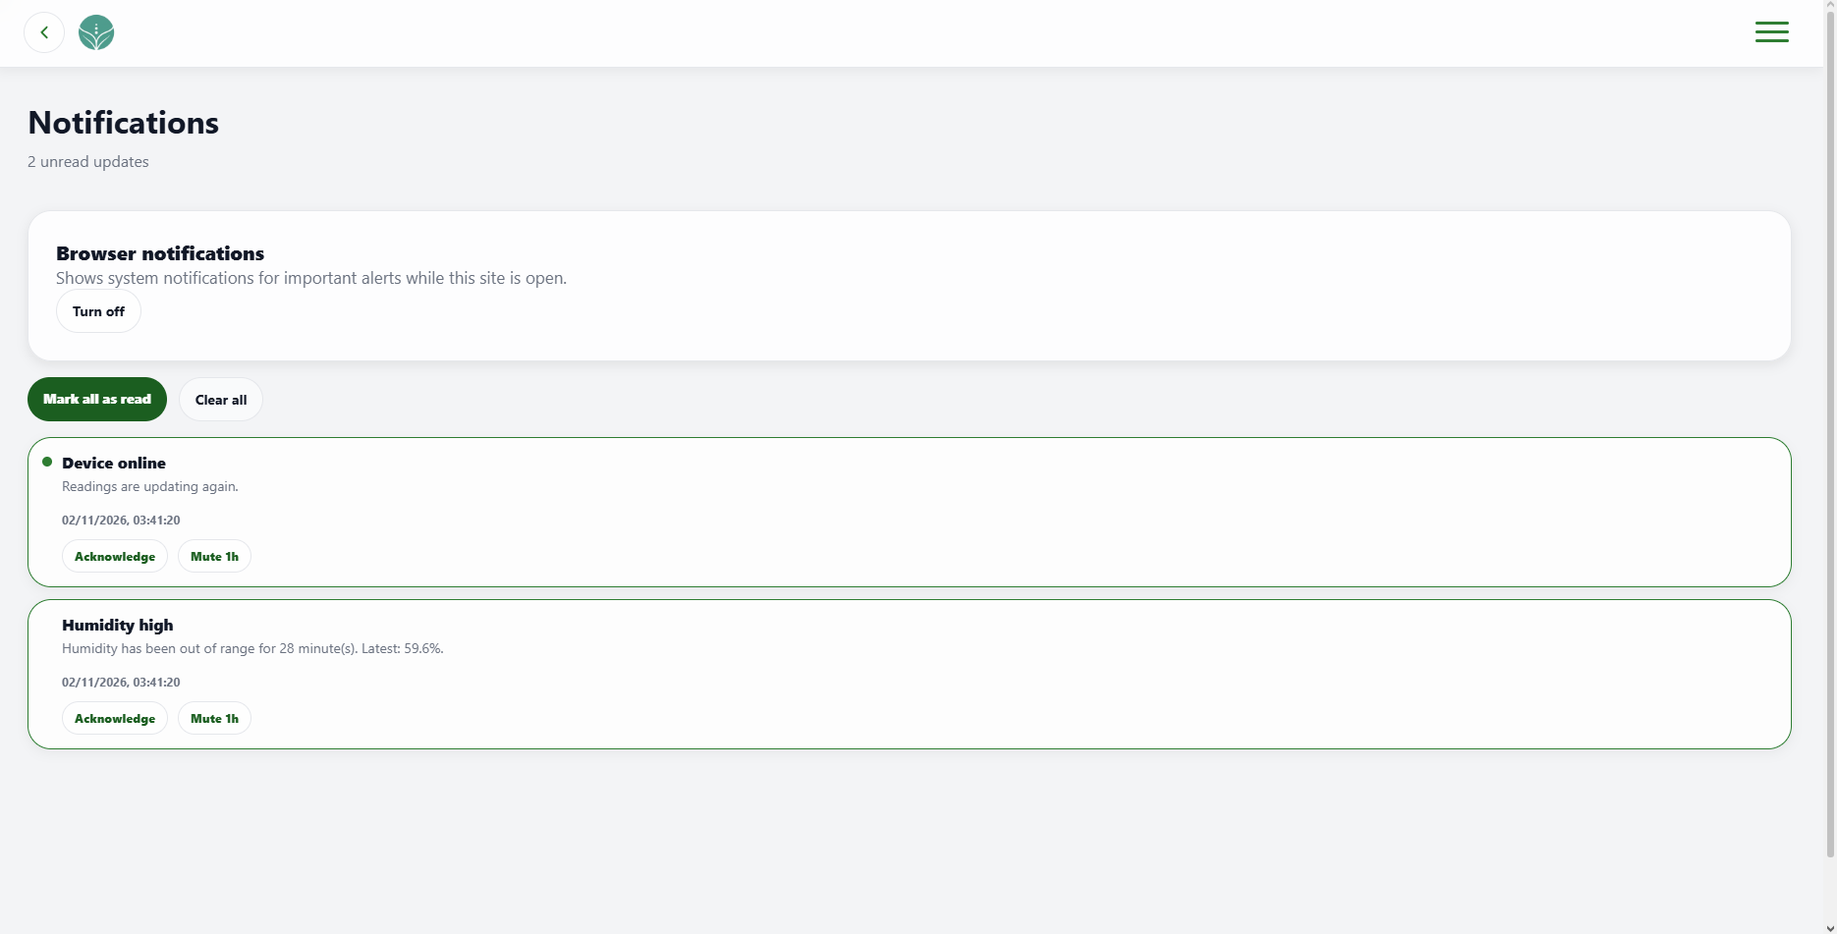 | PASSED
10 | Select the back arrow in the page header. |  | The previous page opens; if no previous page exists, the appropriate home page opens. |  | 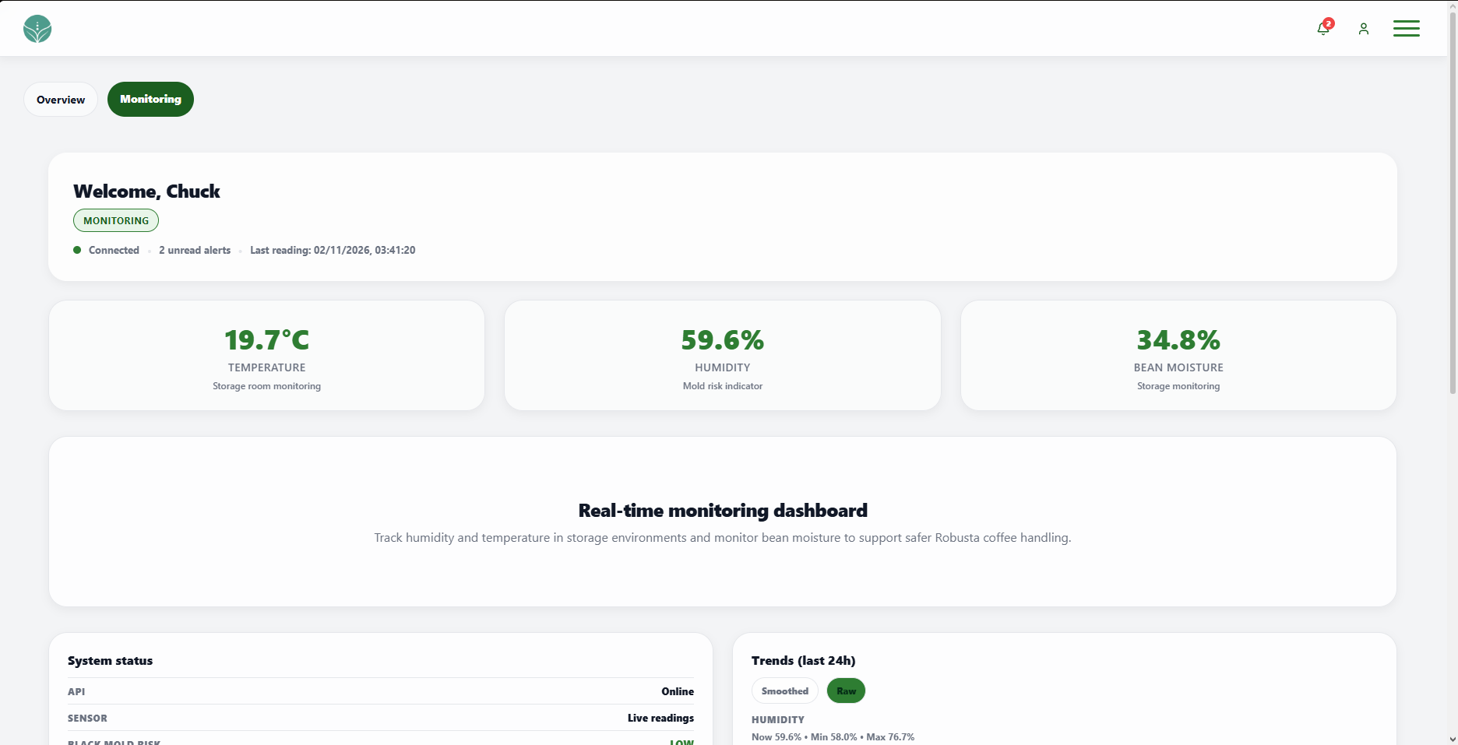 | PASSED
11 | Select the AgriX logo in the page header. |  | The client Dashboard opens. |  | 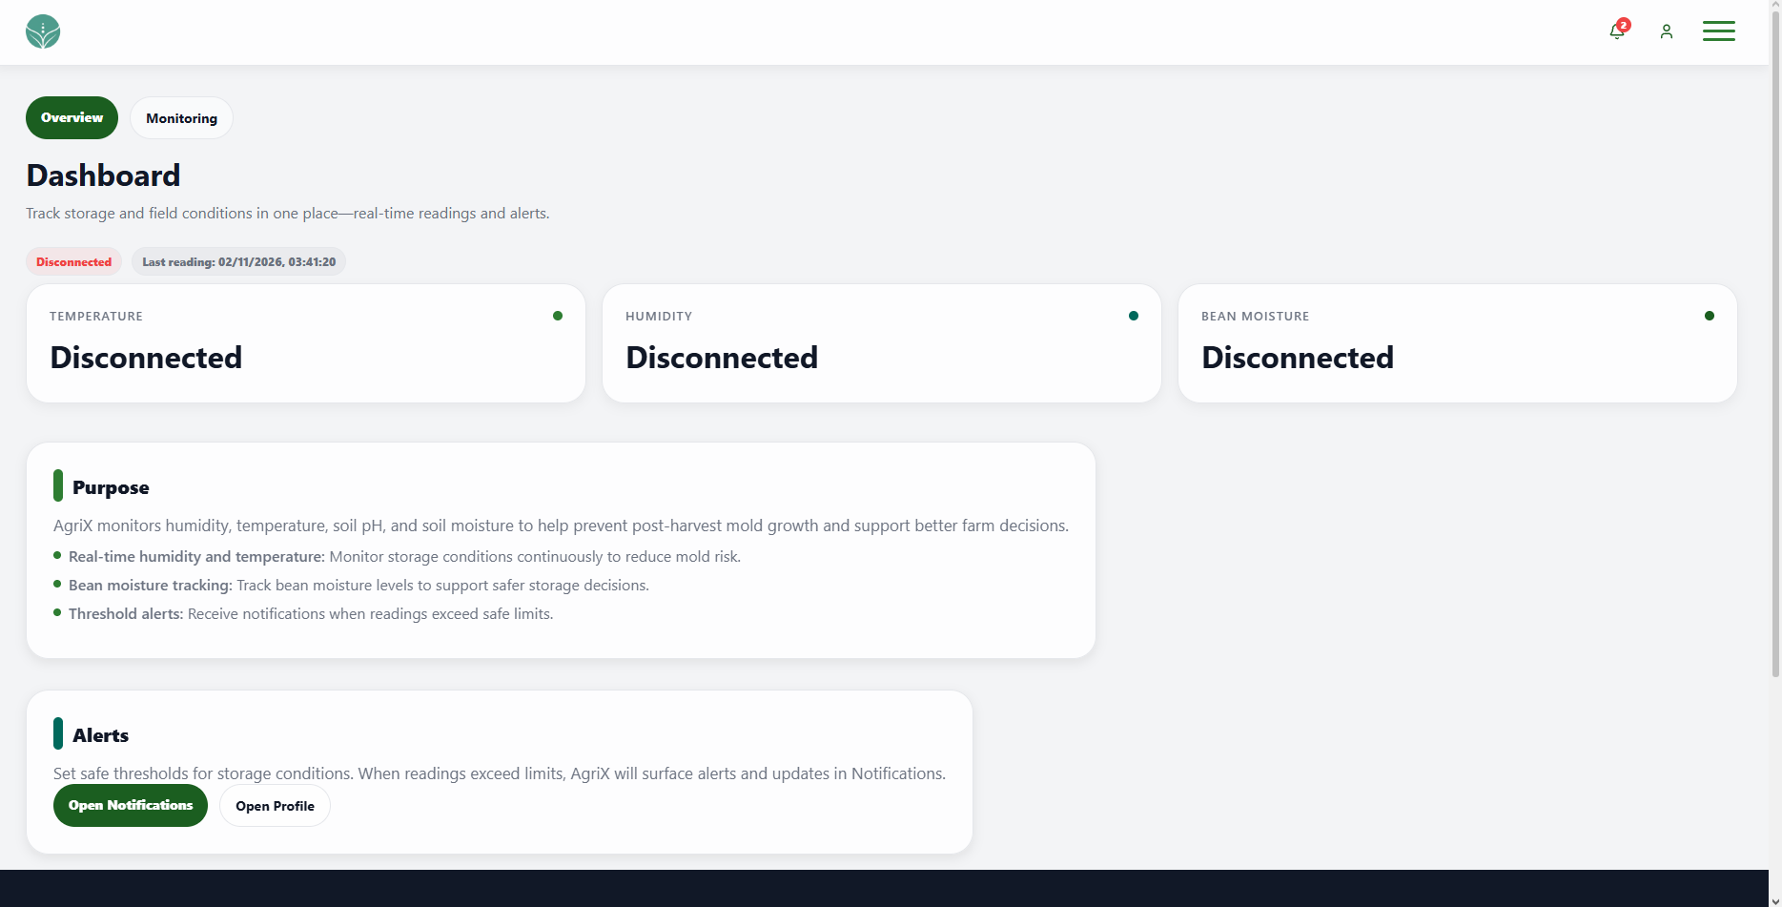 | PASSED
12 | Select the menu icon in the page header. |  | The navigation menu opens and displays its available options. |  | 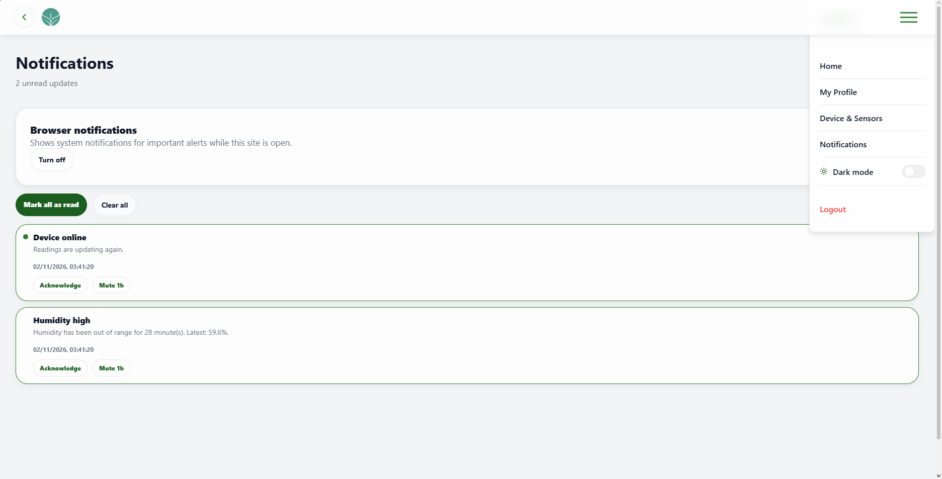 | PASSED

UNIT TEST DOCUMENT |  | Module Name |  | PROFILE MODULE
Test Cycle No. | 1
Test Cycle No. | 1 | Component Name |  | PROFILE PAGE
Date Tested |  | Type of System |  | Web Application
Pre-conditions | A signed-in client test account is available with access to the current email inbox and phone. A separate unused email address and phone number are available for update checks. Test images smaller and larger than 5 MB are available.
Action Description | Open the client Profile page and review personal details, profile editing, contact verification, photo upload, and page navigation.
Verification Steps | Confirm profile details load for the signed-in user, editable fields validate correctly, changes save or cancel as expected, email and phone changes require OTP verification, and the page controls open their intended destinations.
Test Scenario | Data  (Input Values) |  | Expected Results |  | Actual Results | Remarks
1 | Open the Profile page. |  | The signed-in user details appear, and the password is masked. |  | 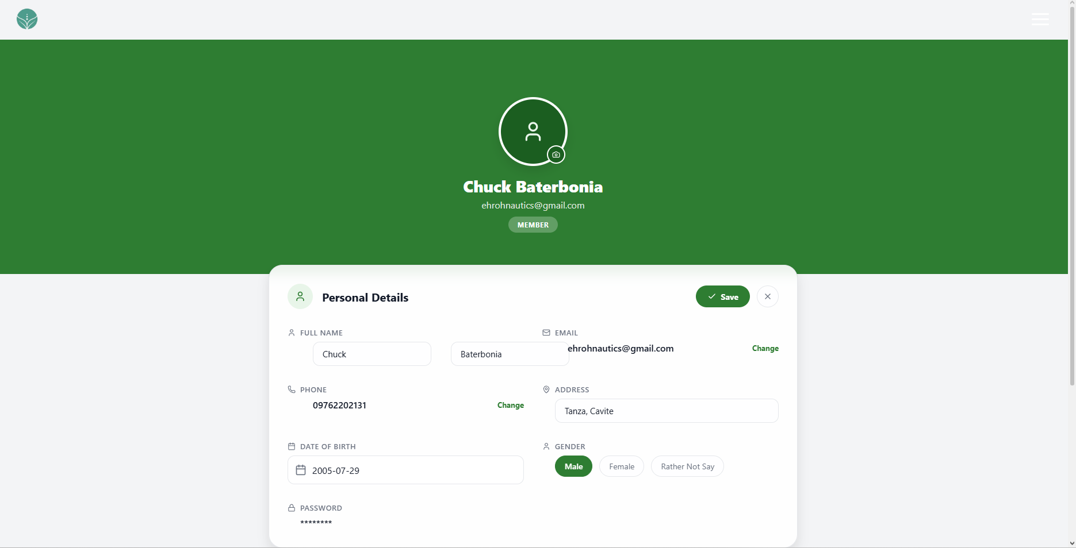 | PASSED
2 | Select the AgriX logo in the header. |  | The client Dashboard opens. |  | 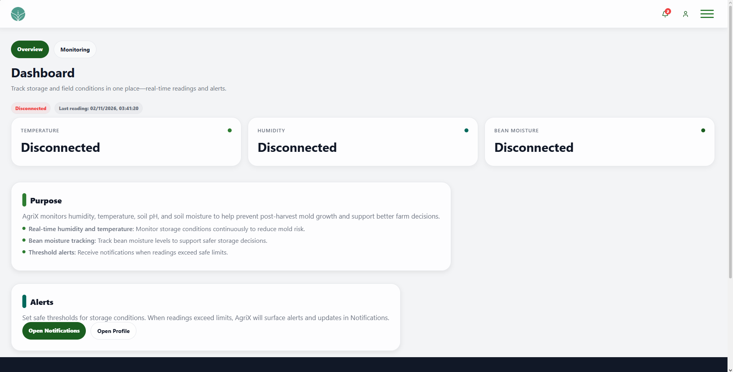 | PASSED
3 | Select the menu icon in the header. |  | The navigation menu opens and shows its available options. |  | 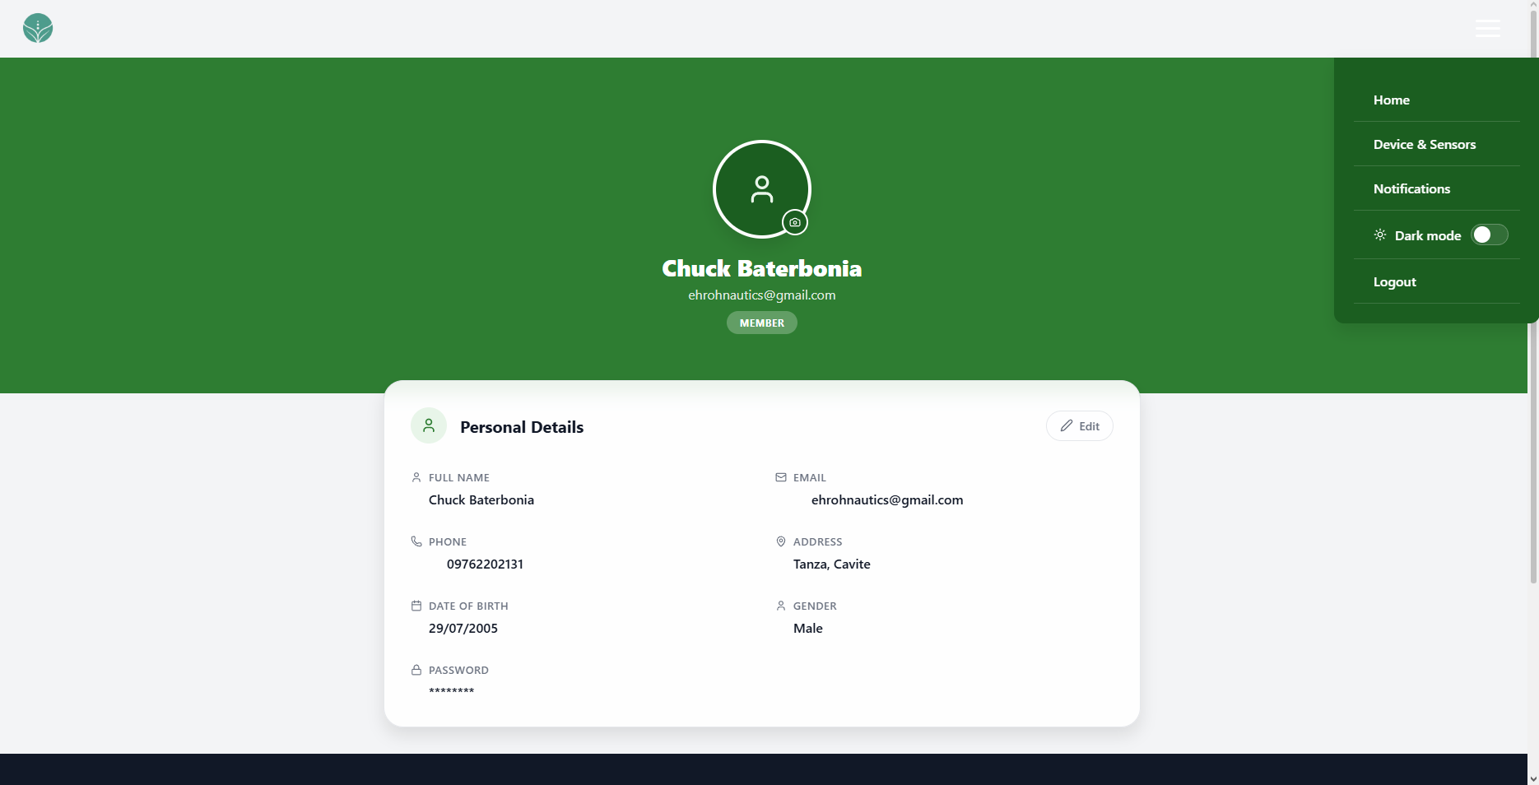 | PASSED
4 | Open the navigation menu and select Dark mode. |  | The page change’s theme and profile text and controls remain readable. |  | 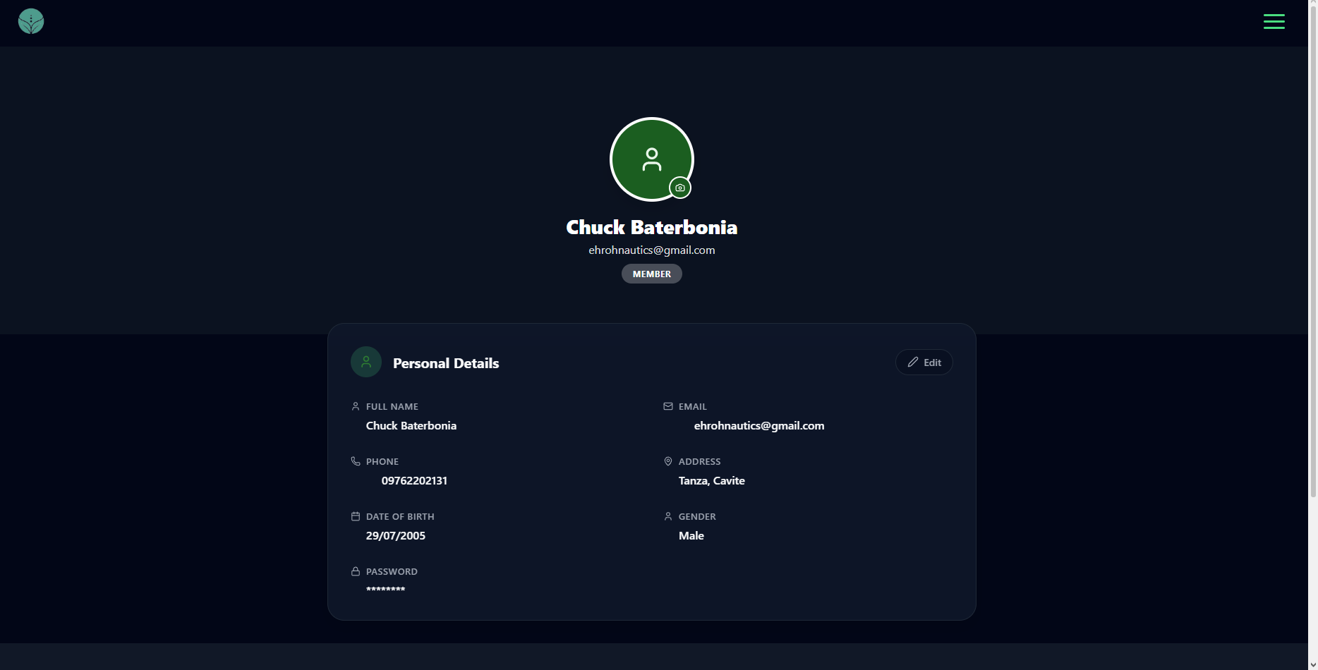 | PASSED
5 | Select Edit in Personal Details. |  | First Name, Last Name, Address, Date of Birth, and Gender become editable, and Save and Cancel controls appear. |  | 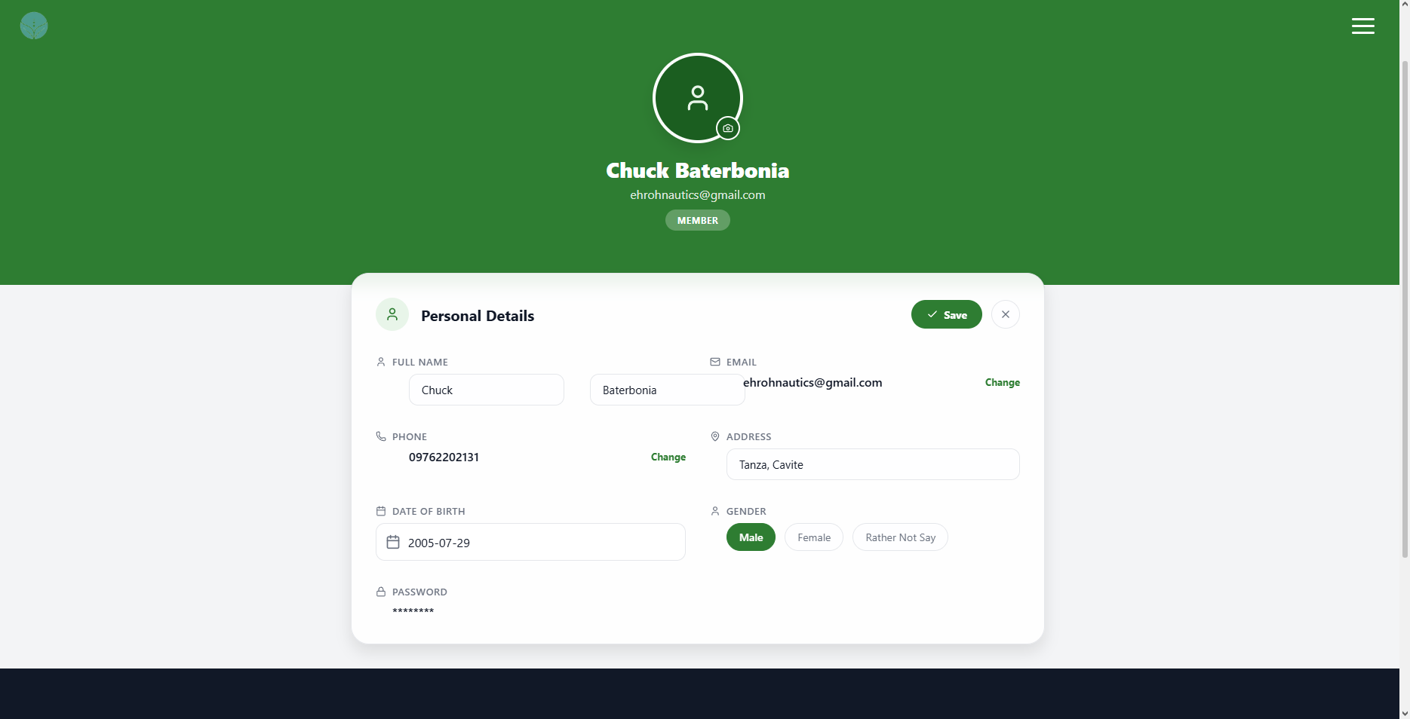 | PASSED
6 | Leave the First Name field blank and select Save. |  | The profile is not saved, and a First Name required message appears. |  | 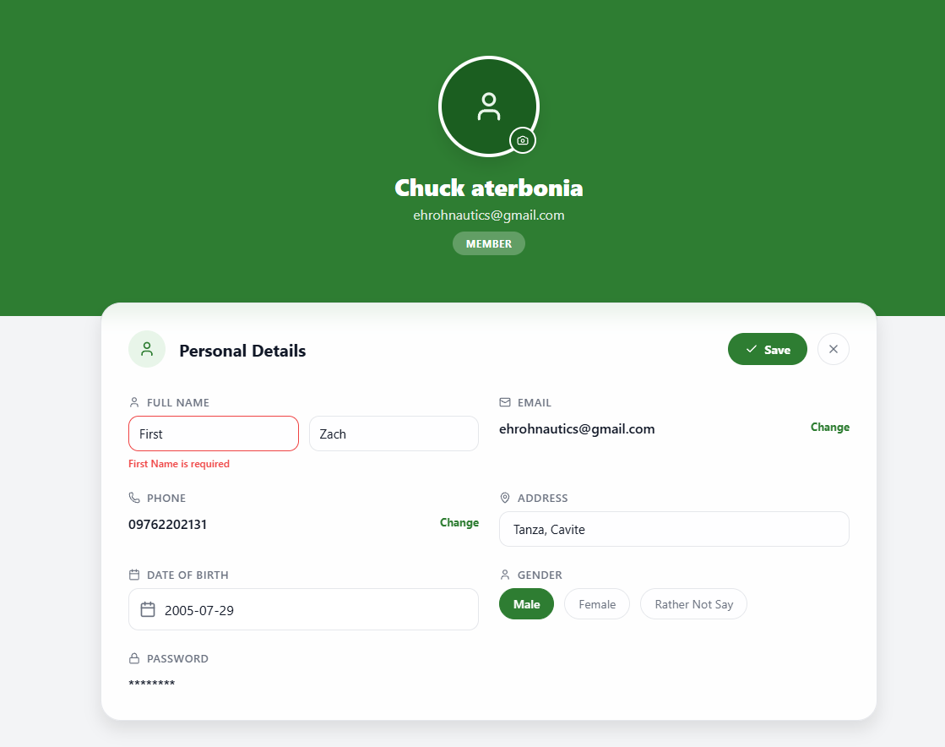 | PASSED
7 | Enter one character in the First Name field and select Save. |  | The profile is not saved, and a minimum length message appears. |  | 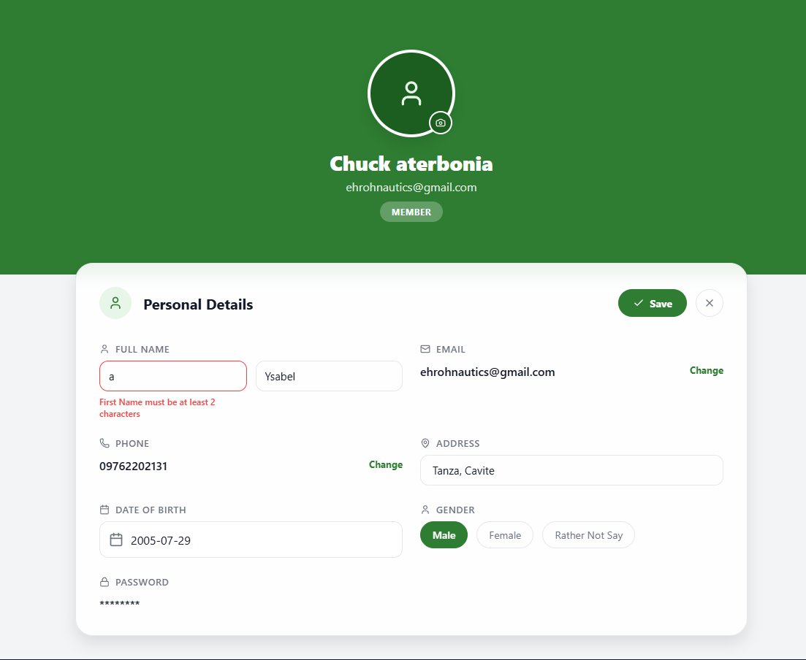 | PASSED
8 | Enter 36 characters in the First Name field. |  | The field keeps no more than 35 characters. |  | 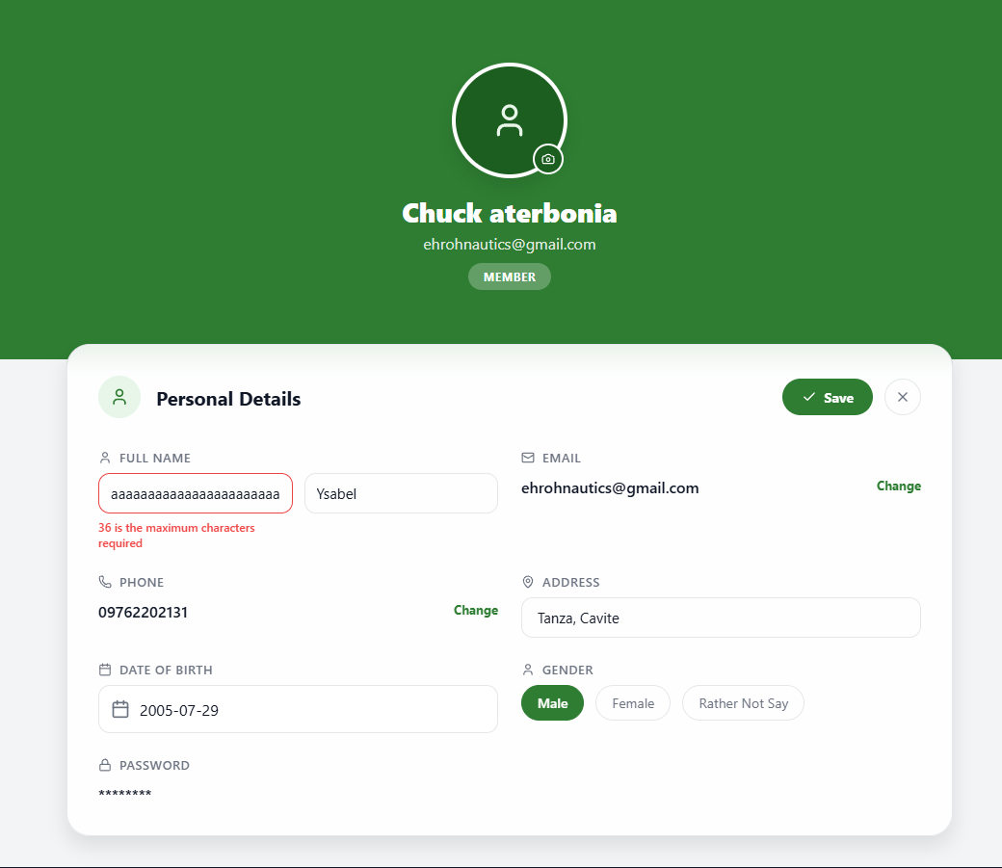 | PASSED
9 | Leave the Last Name field blank and select Save. |  | The profile is not saved, and a Last Name required message appears. |  | 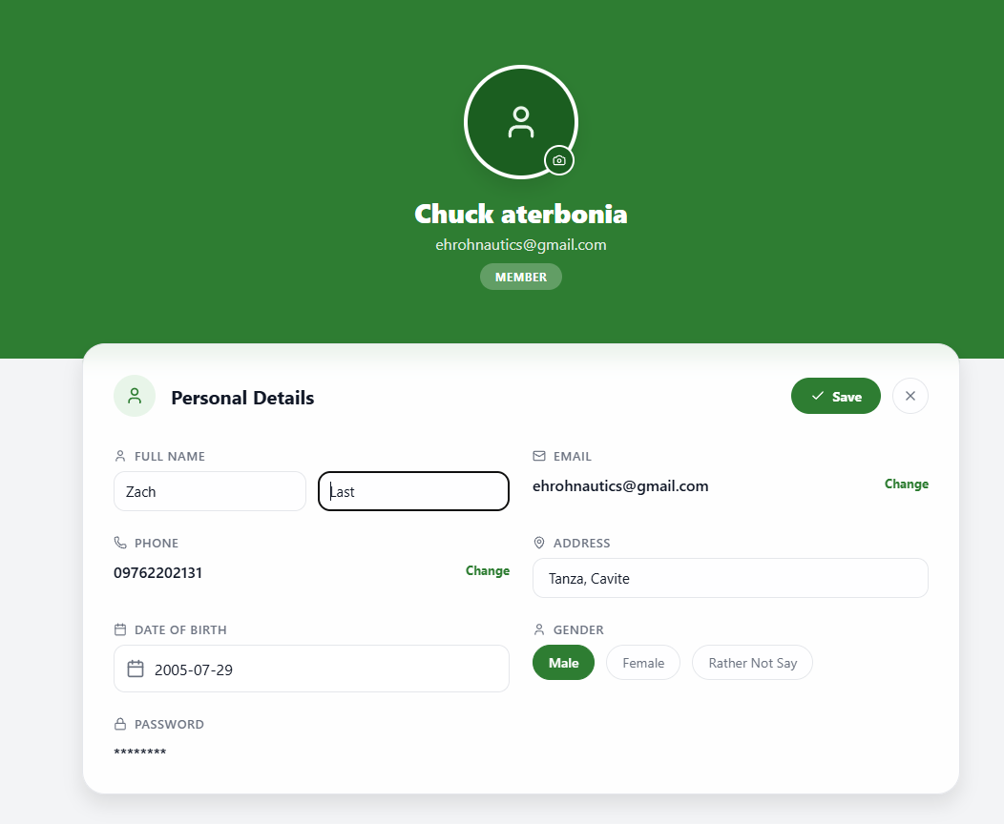 | PASSED
10 | Enter one character in the Last Name field and select Save. |  | The profile is not saved, and a minimum length message appears. |  | 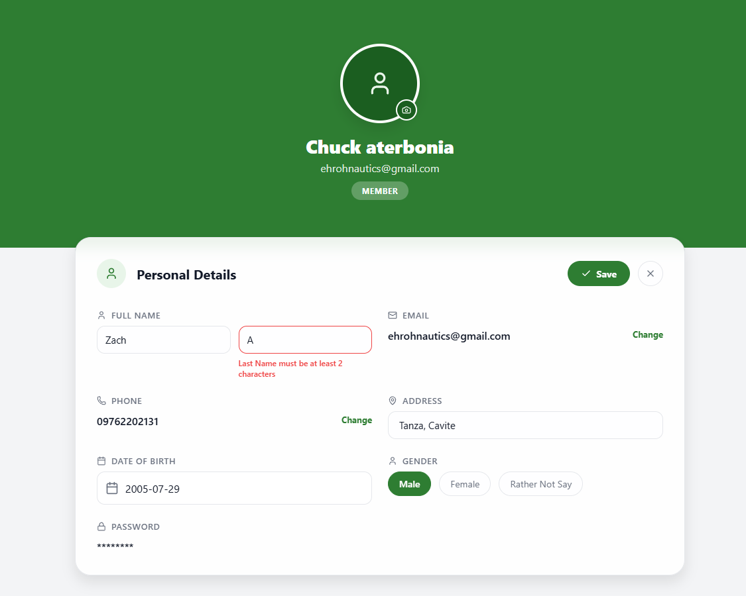 | PASSED
11 | Enter 36 characters in the Last Name field. |  | The field keeps no more than 35 characters. |  | 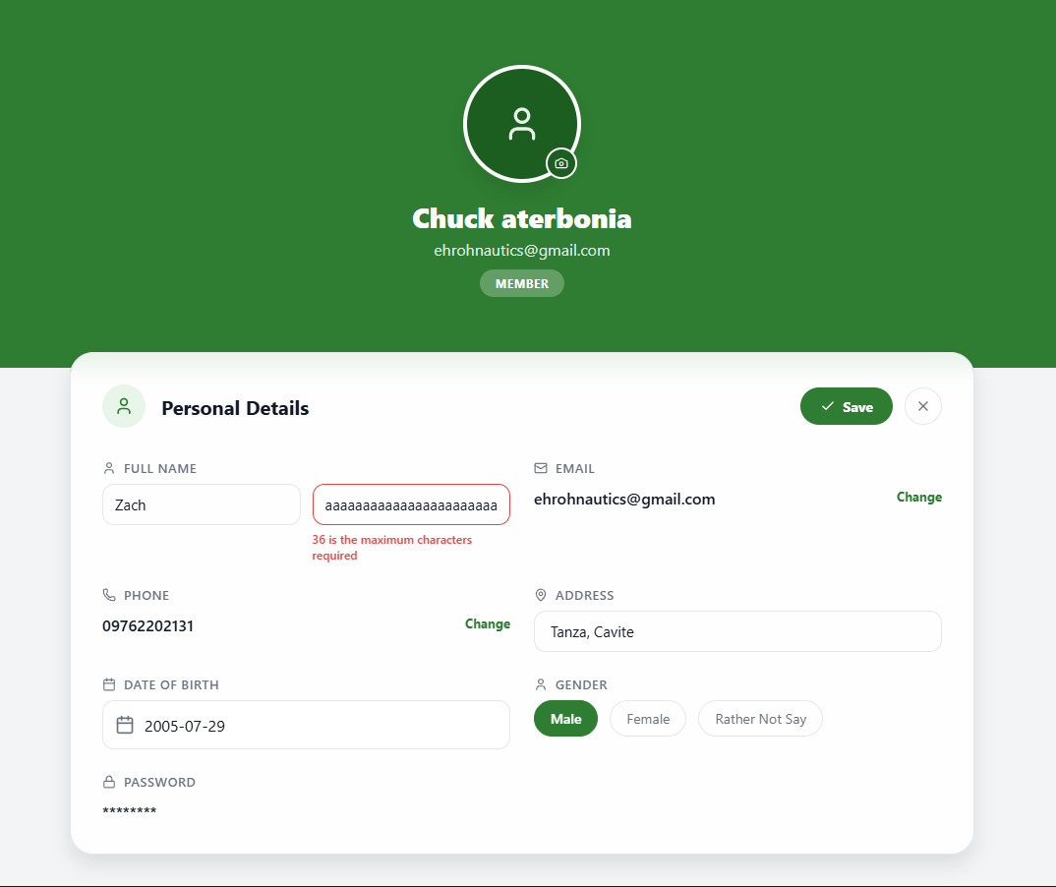 | PASSED
12 | Leave the Address field blank and select Save. |  | The profile is not saved, and an Address required message appears. |  | 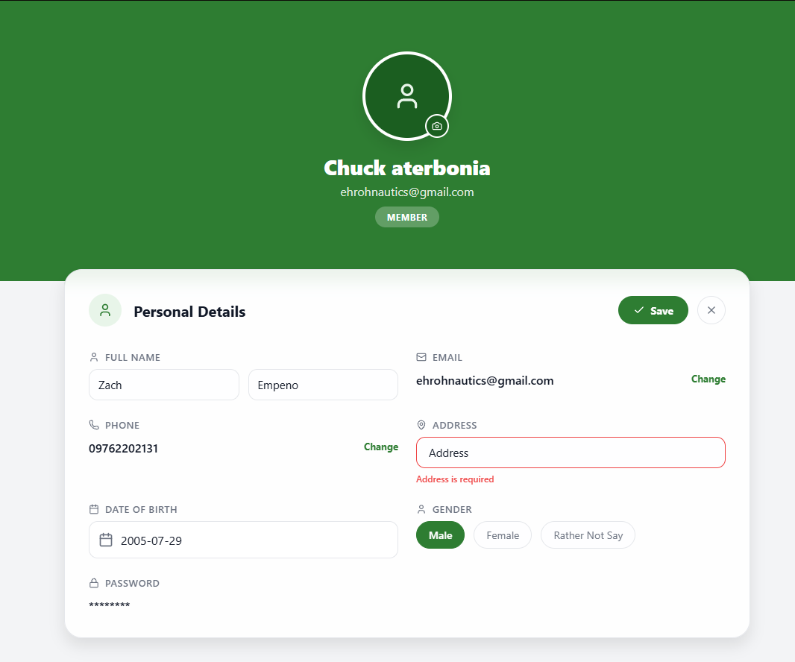 | PASSED
13 | Enter 4 characters in the Address field and select Save. |  | The profile is not saved, and a minimum length message appears. |  | 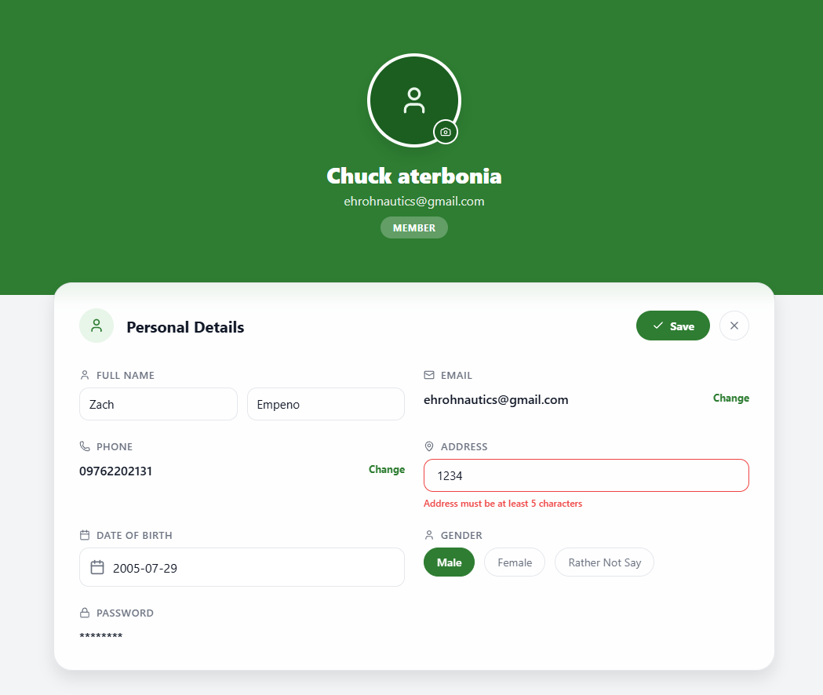 | PASSED
14 | Enter 5 characters in the Address field and select Save with other values valid. |  | The minimum-length address is accepted. |  | 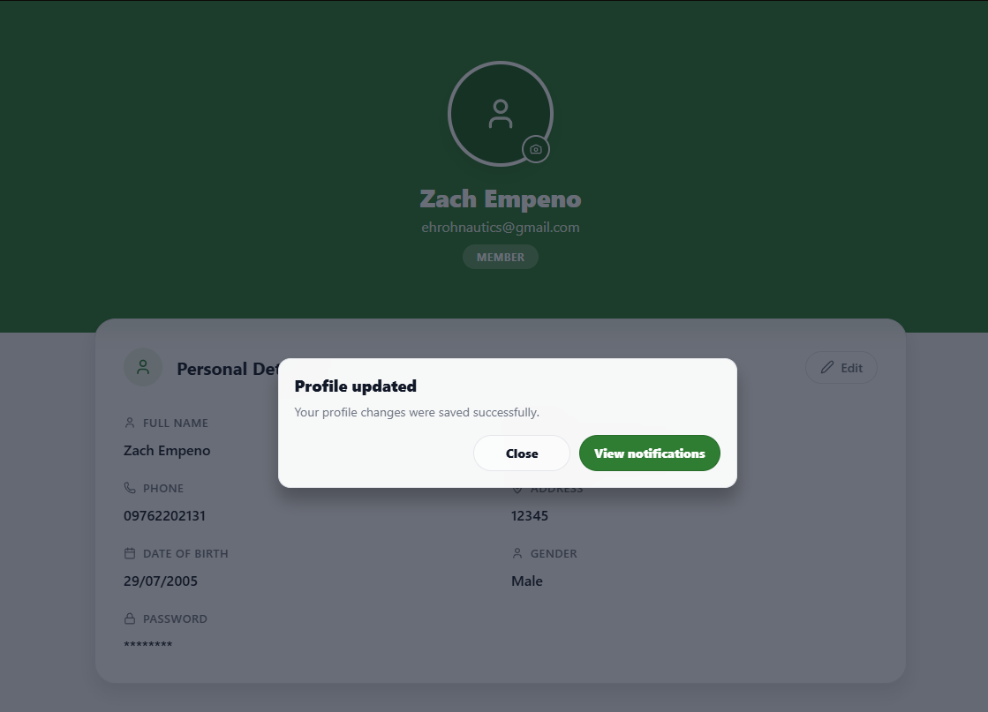 | PASSED
15 | Enter 161 characters in the Address field and select Save. |  | The profile is not saved, and a maximum length message appears. |  | 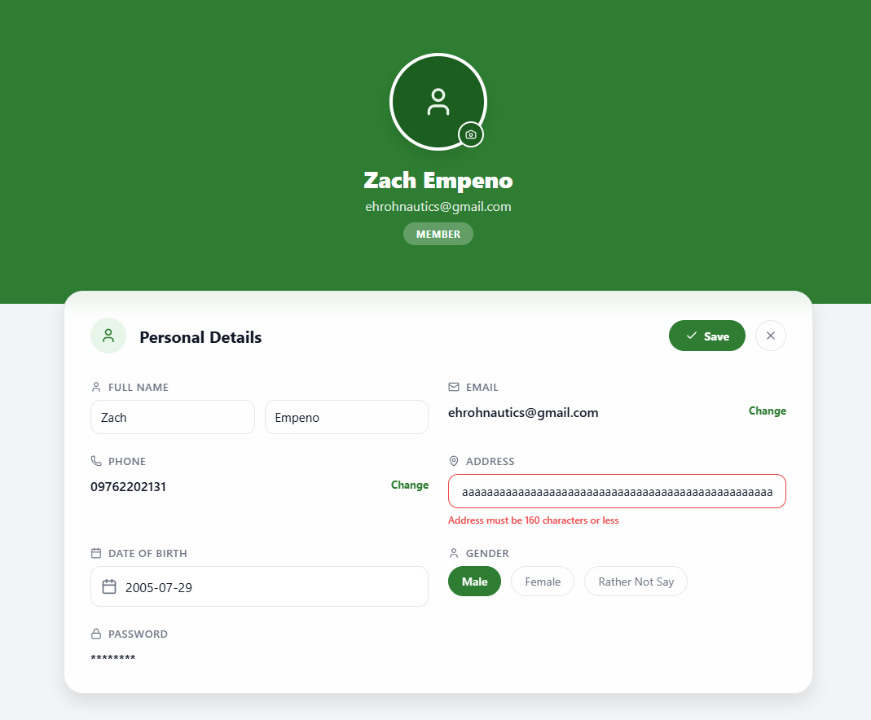 | PASSED
16 | Enter a date that makes the user under 18 and select Save. |  | The profile is not saved, and an age requirement message appears. |  | 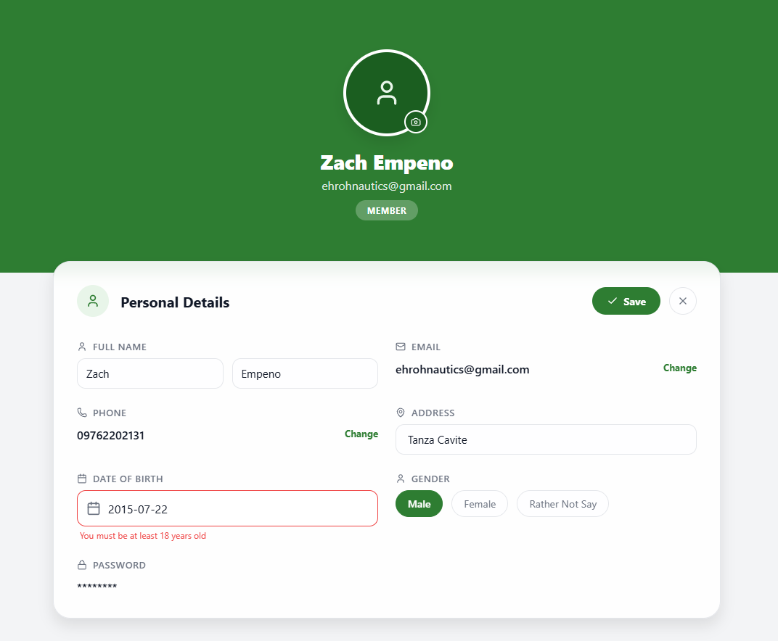 | PASSED
17 | Enter a future date of birth and select Save. |  | The profile is not saved, and a future date message appears. |  | 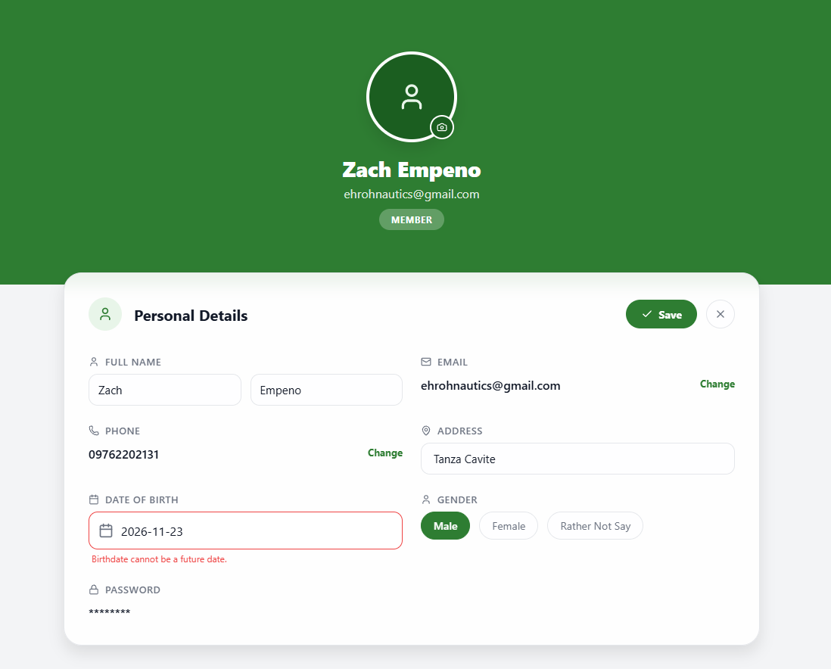 | PASSED
18 | Enter 2000-01-01 as the Date of Birth and select Save with other values valid. |  | The adult date of birth is accepted. |  | 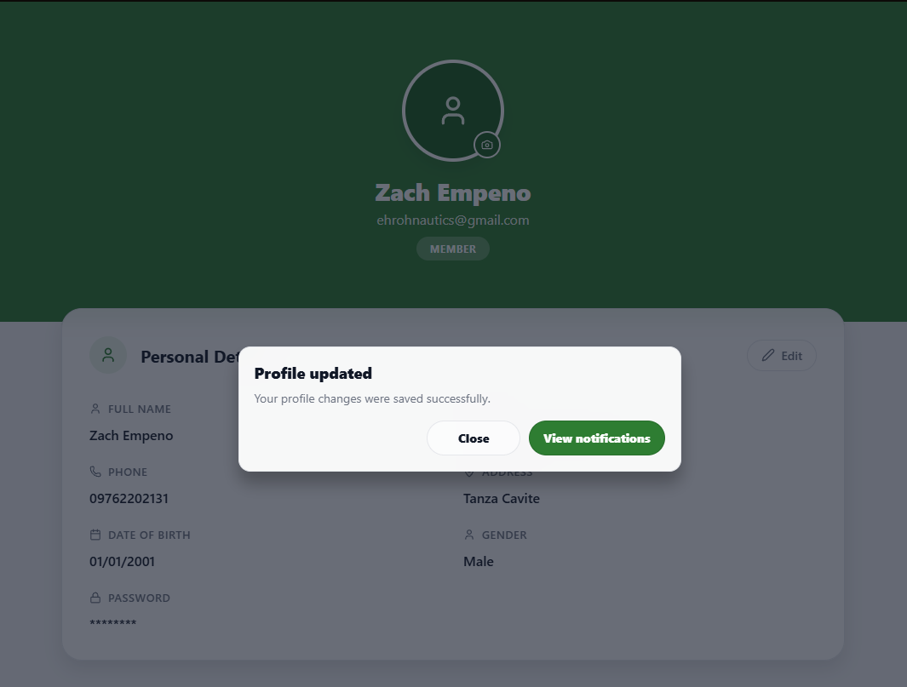 | PASSED
19 | Select Male |  | Male is Selected |  | 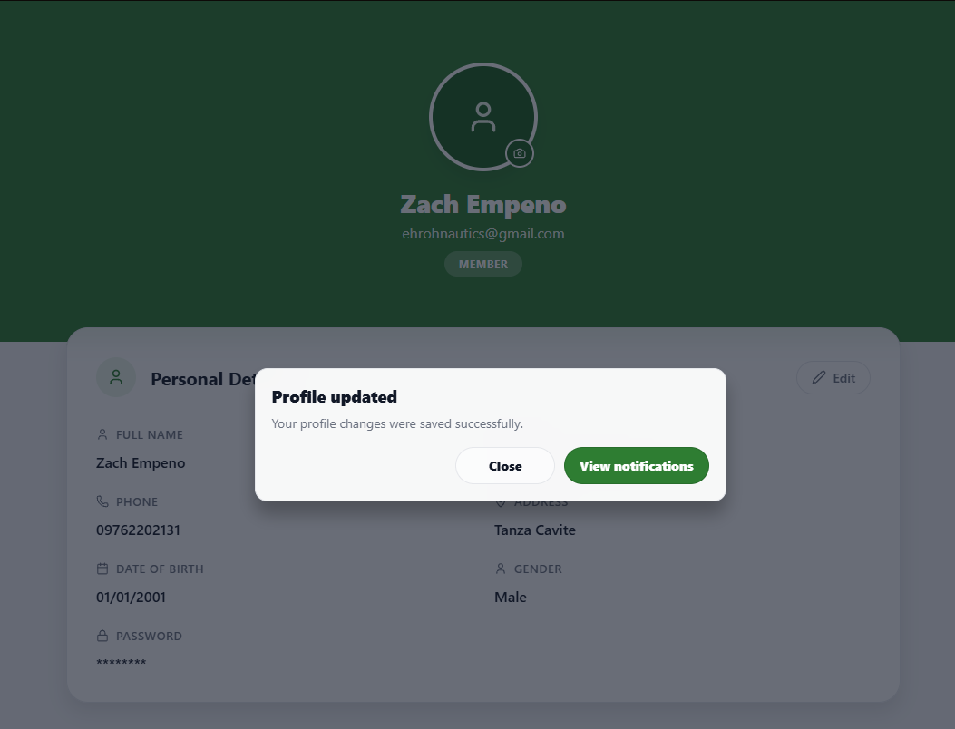 | PASSED
20 | Select Female |  | Female is Selected |  | 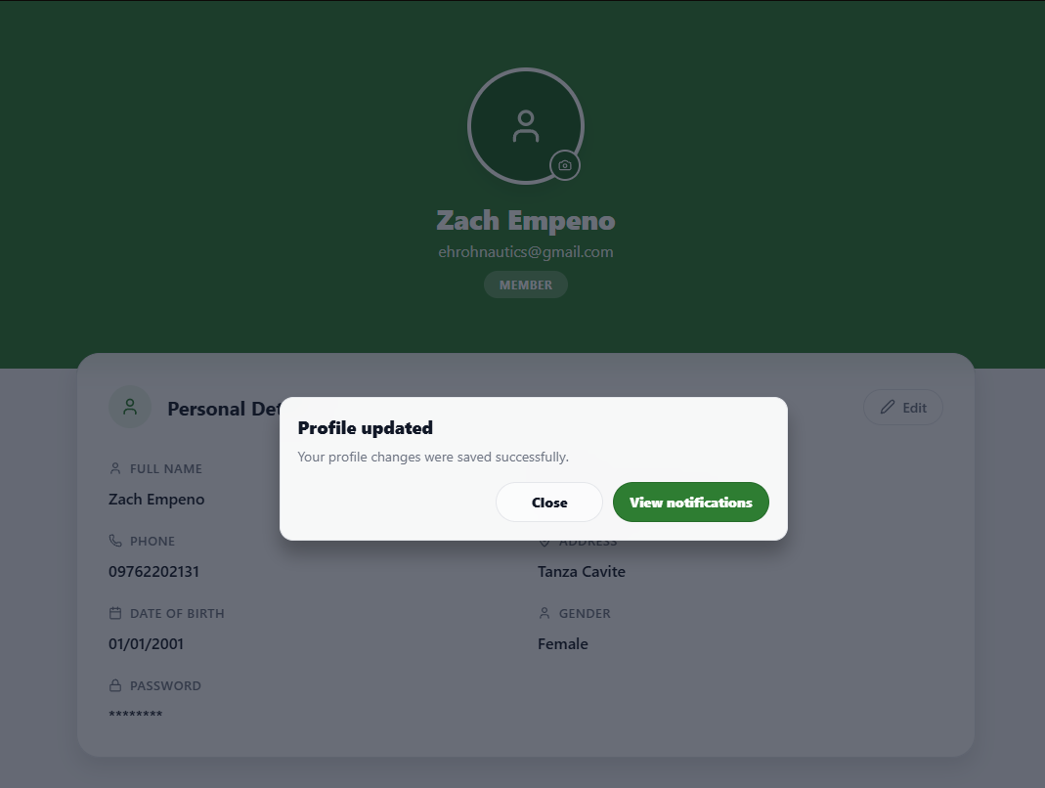 | PASSED
21 | Select Rather not to say |  | Rather not to say is Selected |  | 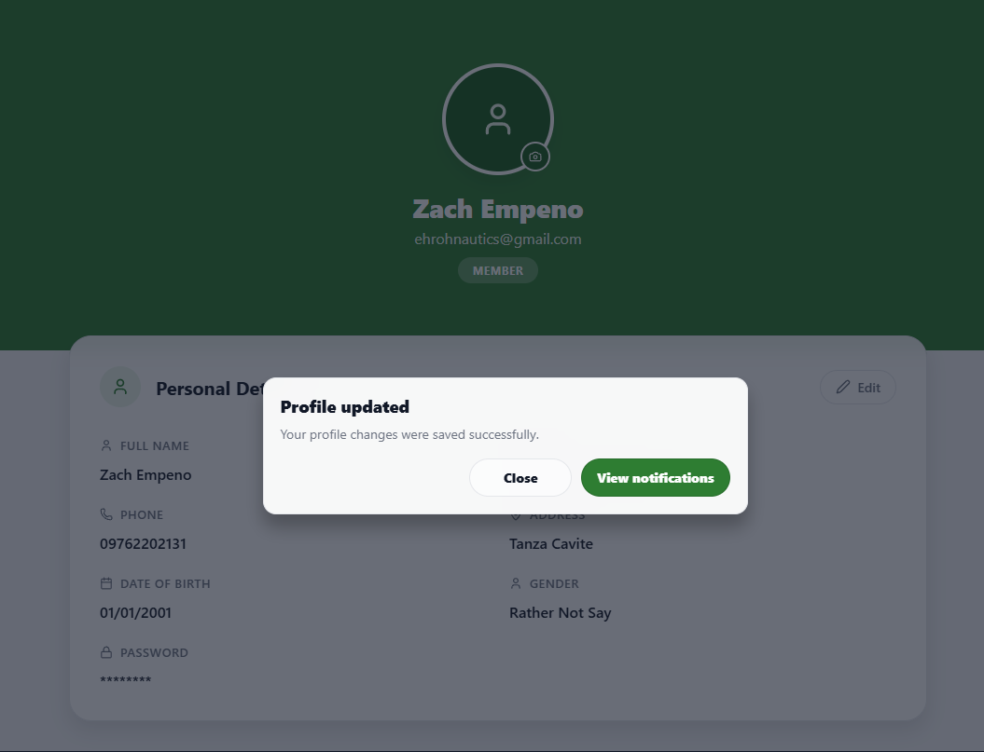 | PASSED
22 | Enter valid changes in the editable profile fields and select Save. |  | The changes are saved, the view returns to read mode, and a success notification appears. |  | 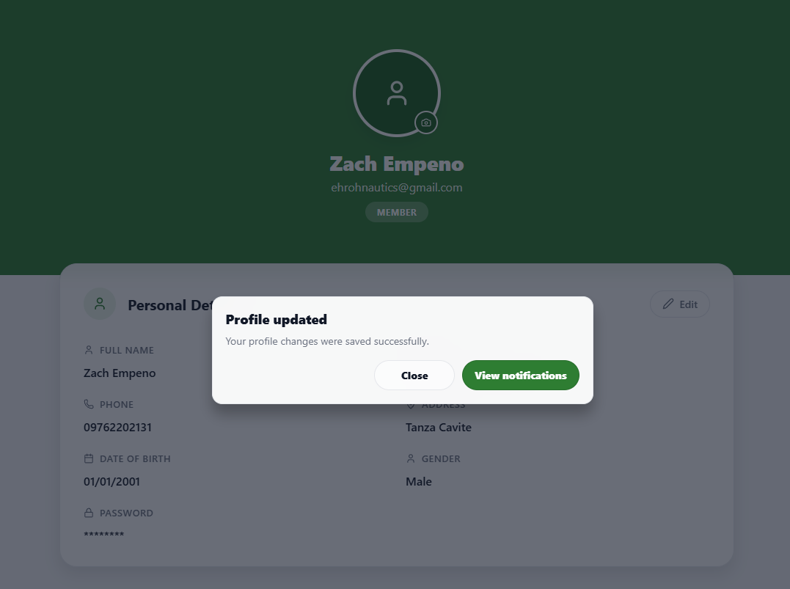 | PASSED
23 | Change profile fields and select Cancel. |  | Editing ends and the original profile details are restored. |  | 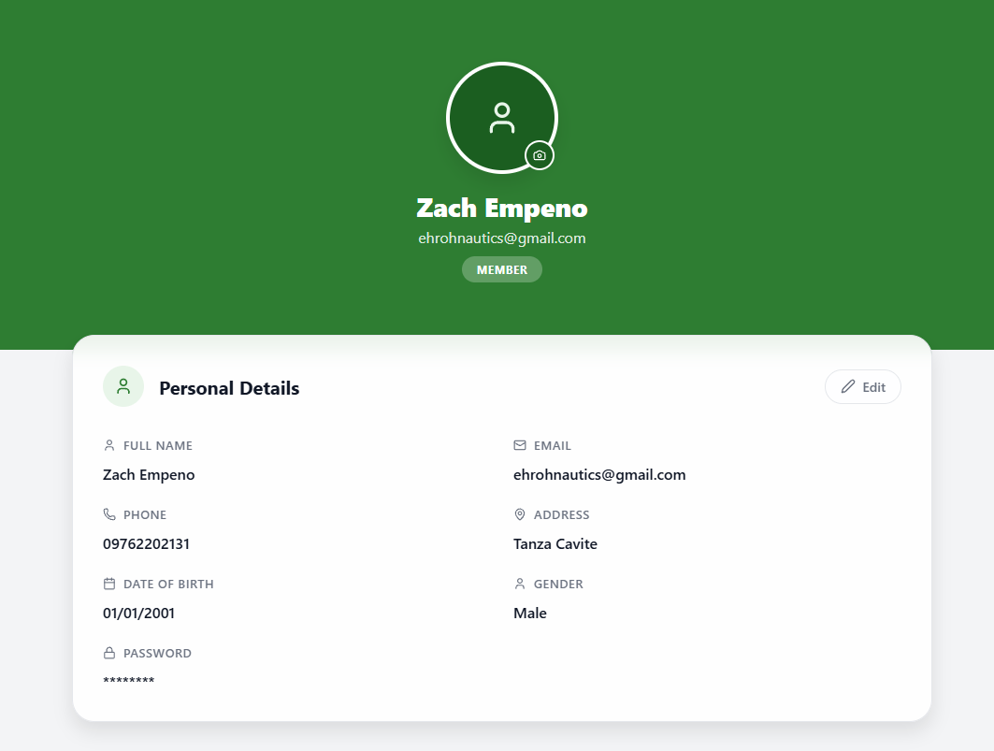 | PASSED
24 | Make an unsaved change and navigate away, then select Stay and try again with Discard & leave. |  | Stay keeps the user on the Profile page; Discard & leave completes navigation without saving the changes. |  | 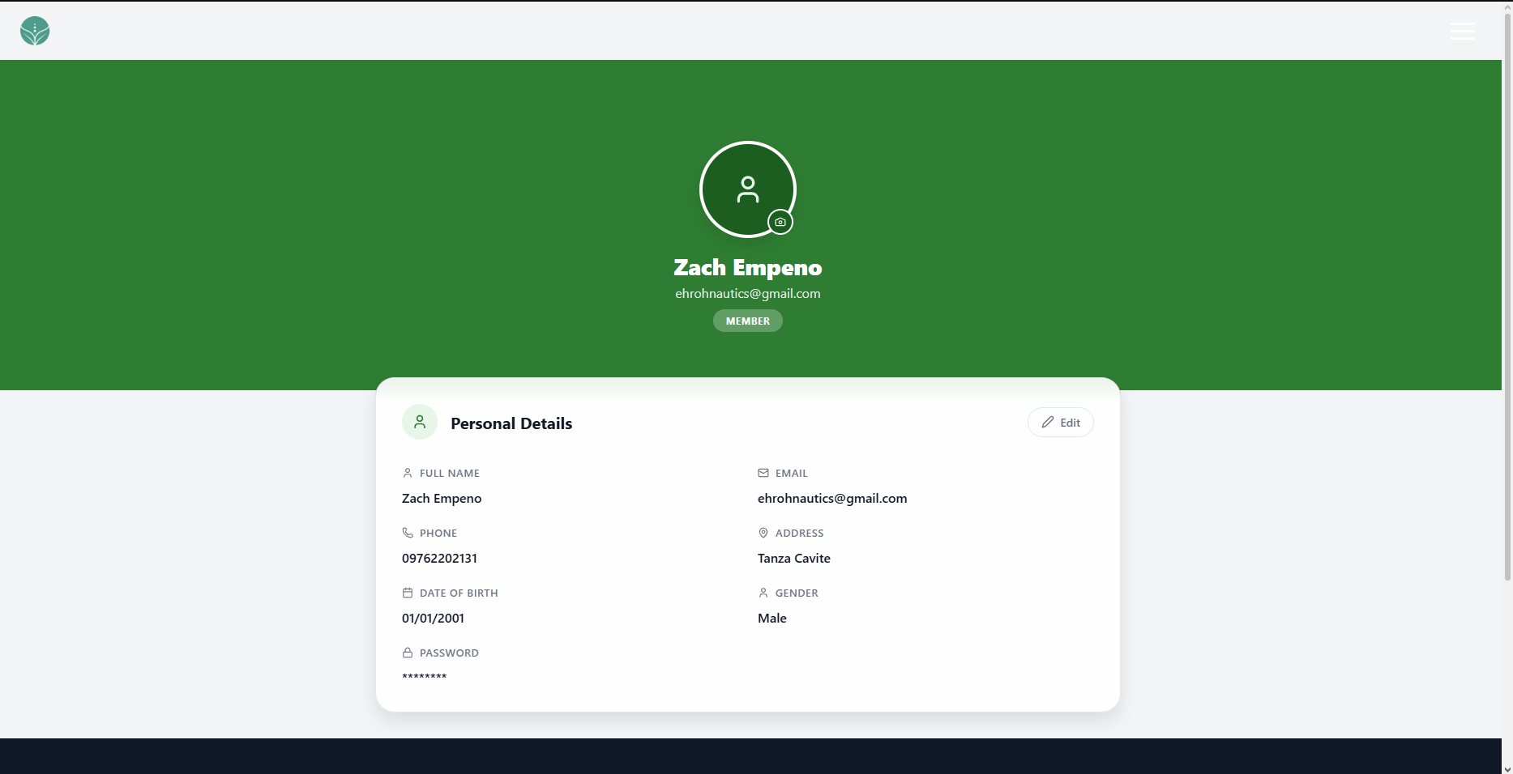 | PASSED
25 | Open Change for Email and enter an invalid email address. |  | The email update is rejected with a clear validation message. |  | 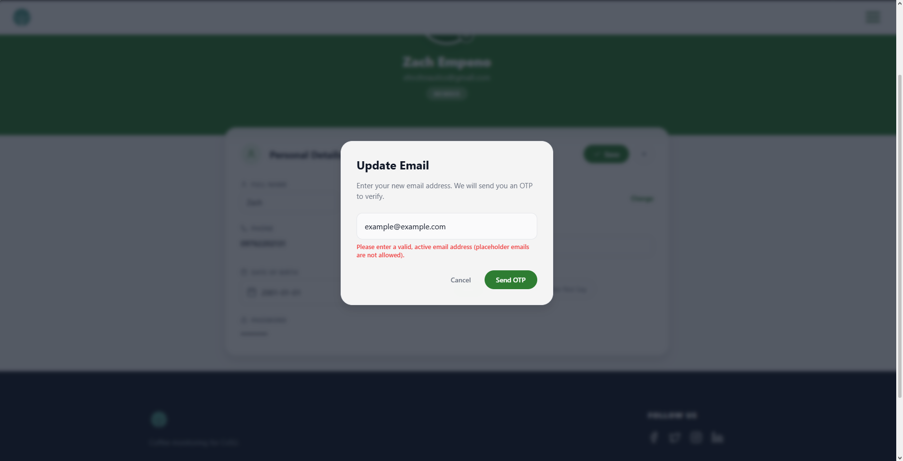 | PASSED
26 | Open Change for Email and enter an email address already in use. |  | The email update is rejected with an already-in-use message. |  | 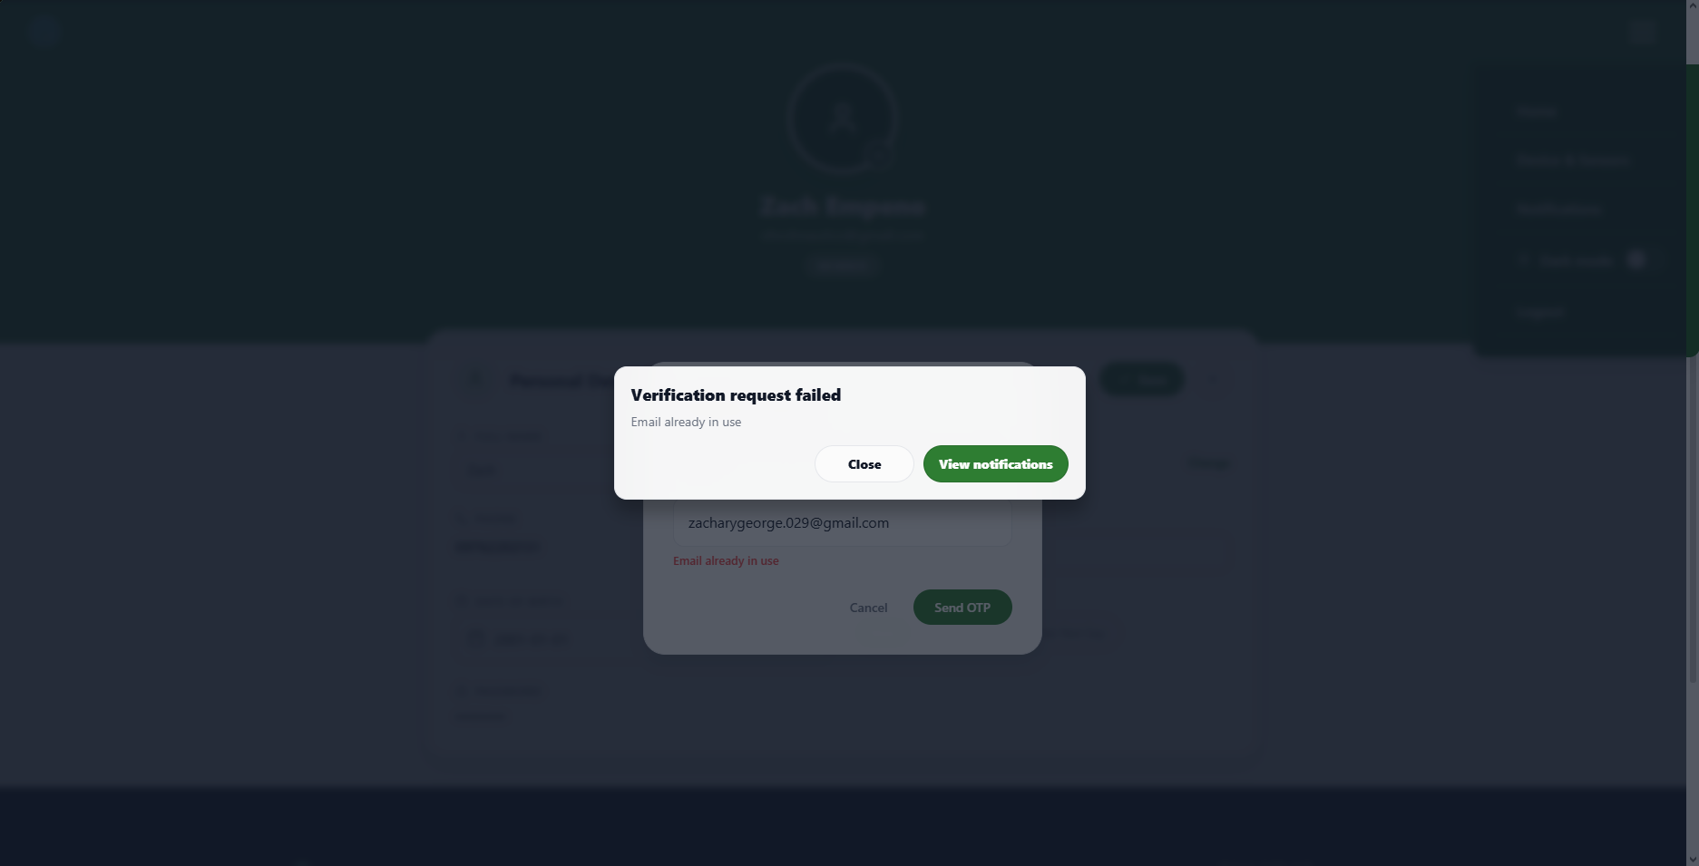 | PASSED
27 | Open Change for Email and enter a valid unused email address, then select Send OTP. |  | A verification code is sent and the modal changes to the OTP step. |  | 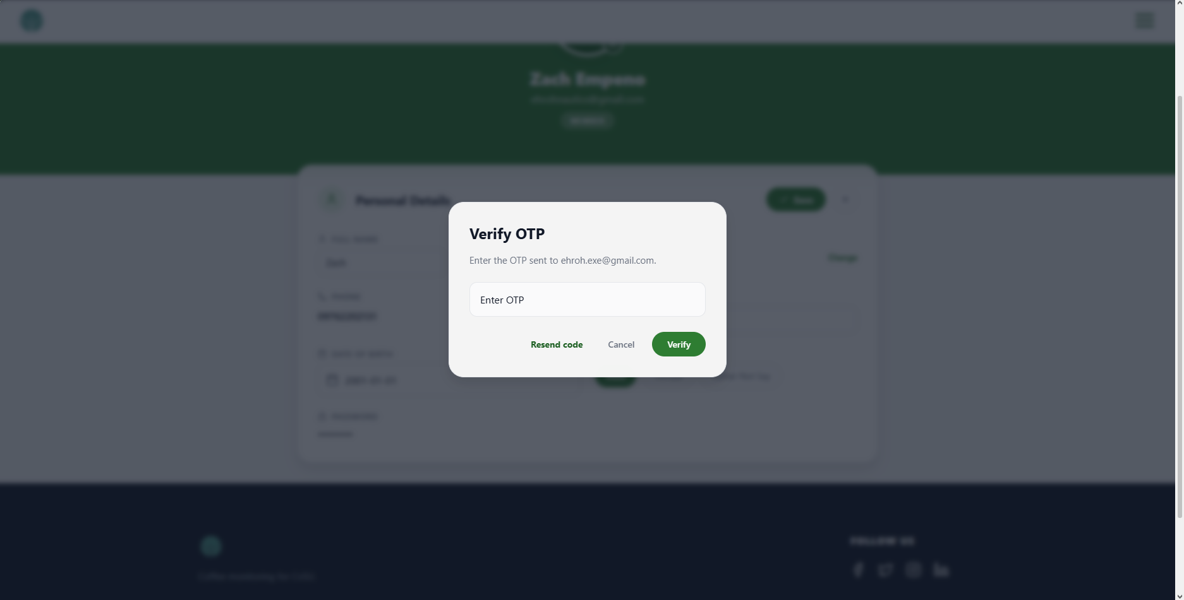 | PASSED
28 | Enter an incorrect email verification code and select Verify. |  | The email remains unchanged, and an invalid-code message appears. |  | 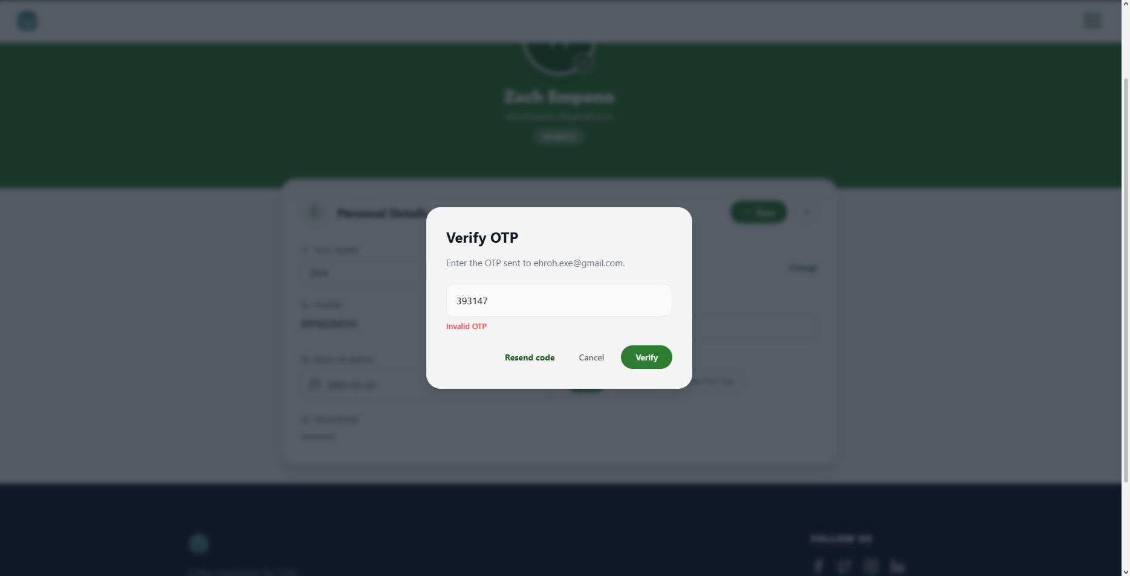 | PASSED
29 | Enter the current email verification code and select Verify. |  | The new email is saved, the modal closes, and the new email appears in the profile. |  | 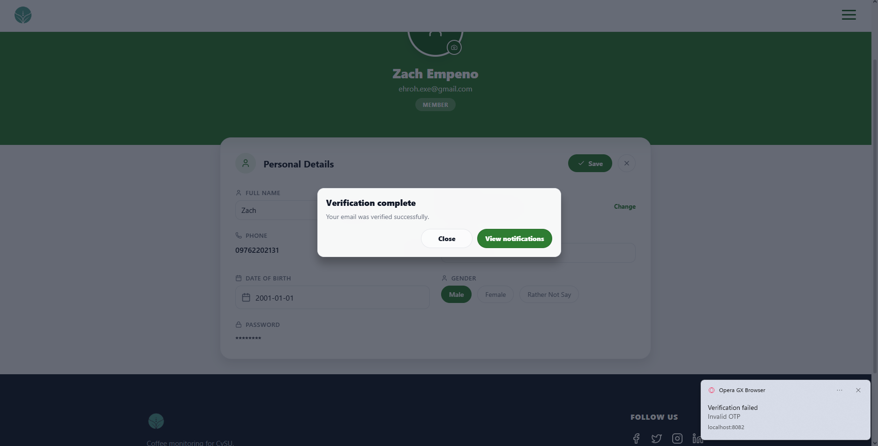 | PASSED
30 | Open Change for Phone and enter fewer than 11 digits for the +63-country code, then select Send OTP. |  | The phone update is rejected with a message that the number is incomplete or invalid. |  | 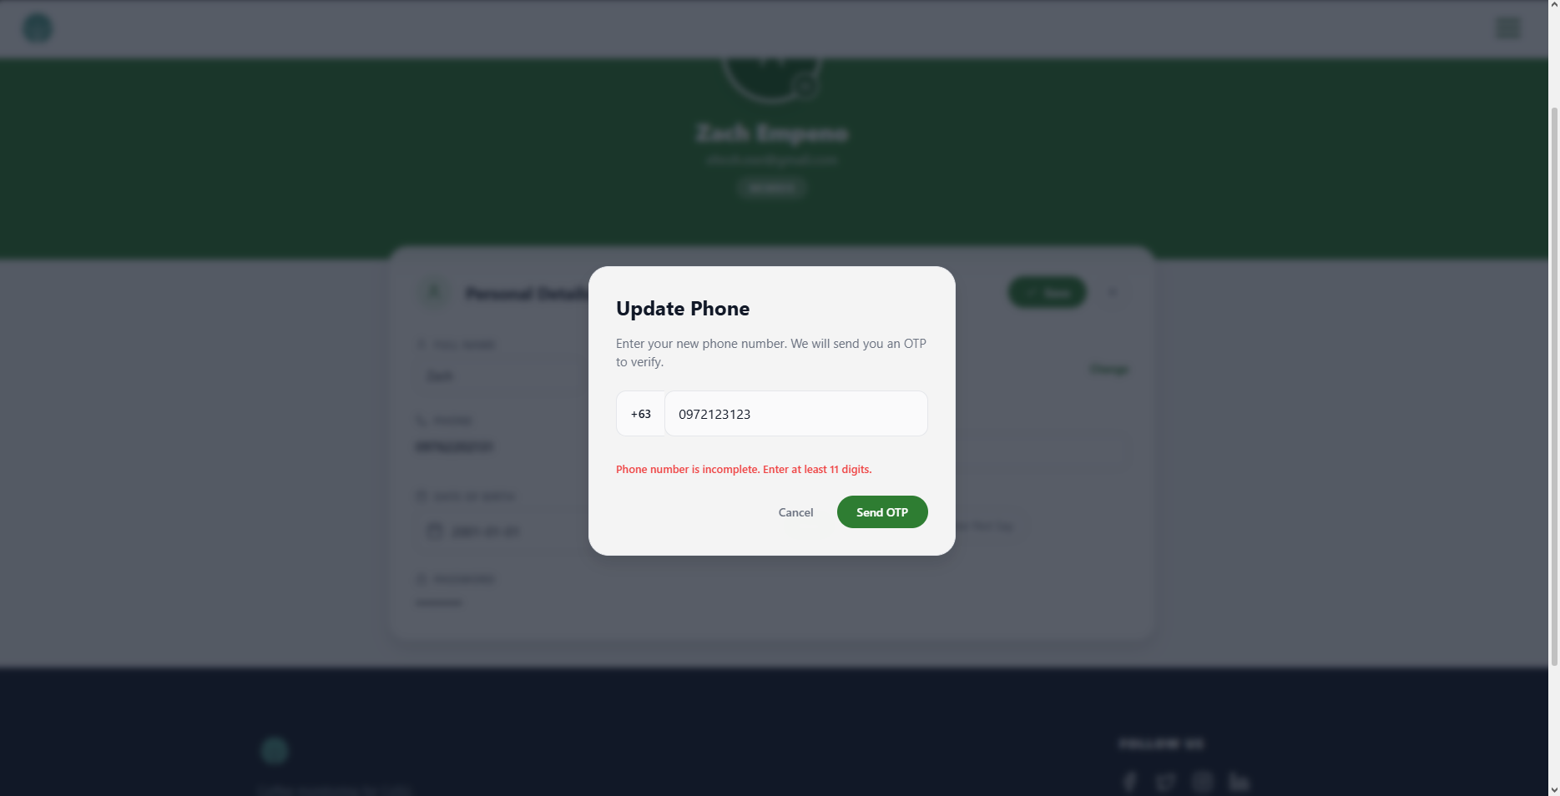 | PASSED
31 | Select +1 in the country-code list. |  | The phone field clears and shows the input length and example format for +1. |  | 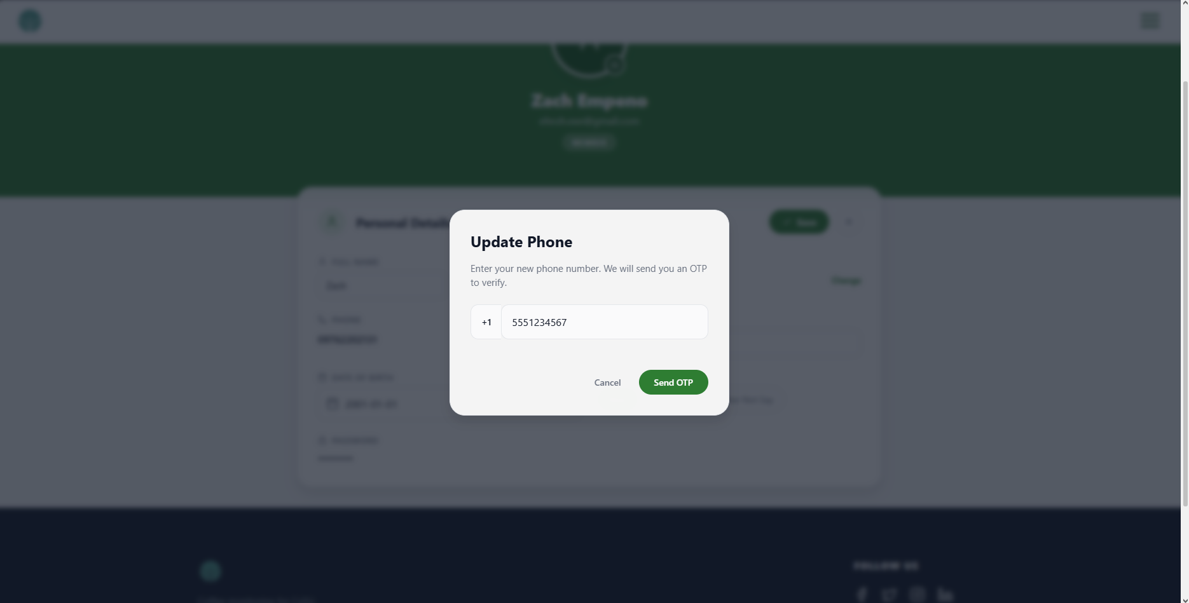 | PASSED
32 | Choose an image larger than 5 MB for the profile photo. |  | The upload is blocked, and a maximum file size message appears. |  | 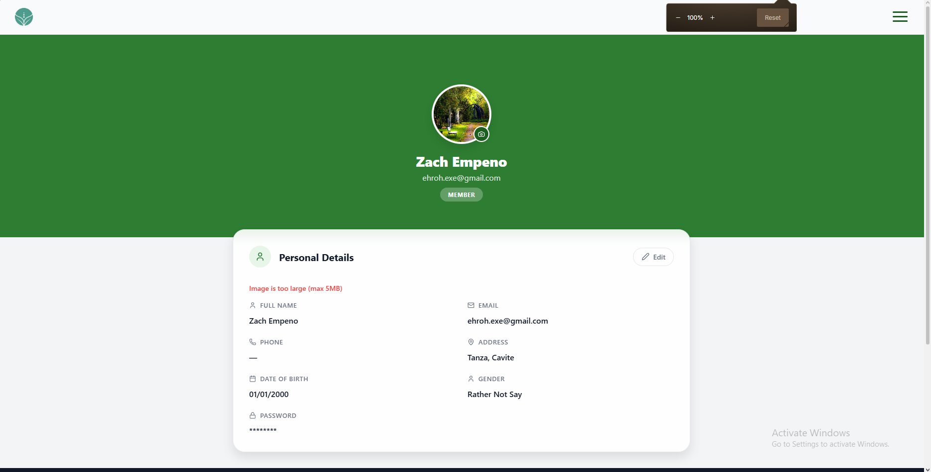 | PASSED
33 | Choose a valid image smaller than 5 MB for the profile photo. |  | The profile photo uploads, and the new image appears on the Profile page. |  | 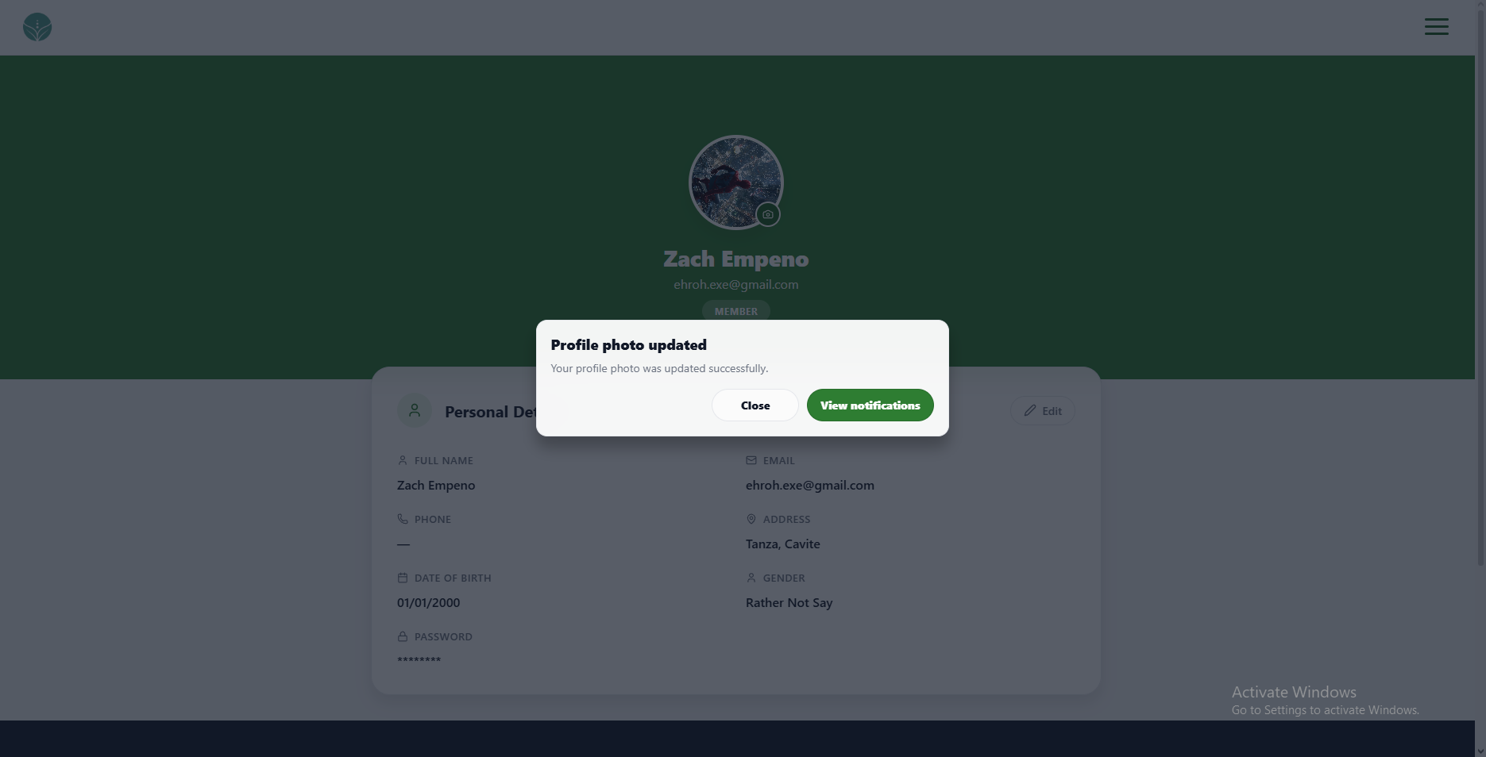 | PASSED

UNIT TEST DOCUMENT |  | Module Name |  | PROFILE MODULE
Test Cycle No. | 1
Test Cycle No. | 1 | Component Name |  | PROFILE PAGE
Date Tested |  | Type of System |  | Web Application
Pre-conditions | A signed-in client test account is available with access to the current email inbox and phone. A separate unused email address and phone number are available for update checks. Test images smaller and larger than 5 MB are available.
Action Description | Open the client Profile page and review personal details, profile editing, contact verification, photo upload, and page navigation.
Verification Steps | Confirm profile details load for the signed-in user, editable fields validate correctly, changes save or cancel as expected, email and phone changes require OTP verification, and the page controls open their intended destinations.
Test Scenario | Data  (Input Values) |  | Expected Results |  | Actual Results | Remarks
1 | Open the Profile page. |  | The signed-in user details appear, and the password is masked. |  |  | PASSED

UNIT TEST DOCUMENT |  | Module Name |  | DEVICE AND SENSORS MODULE
Test Cycle No. | 1
Test Cycle No. | 1 | Component Name |  | DEVICE & SENSORS
Date Tested |  | Type of System |  | Web Application
Pre-conditions
Action Description
Verification Steps
Test Scenario | Data  (Input Values) |  | Expected Results |  | Actual Results | Remarks
1 | Open Device & Sensors from the client navigation menu. |  | The Device & Sensors page opens with Status and Shortcuts visible. |  |  | PASSED
2 | Open the page when a fresh sensor reading is available. |  | Connection shows Online and Last seen displays the latest reading time. |  |  | PASSED
3 | Open the page when the latest reading is older than the saved offline timeout. |  | Connection shows Offline. |  |  | PASSED
4 | Open the page when no sensor readings are saved. |  | Last seen shows No readings yet and risk values show an unknown state. |  |  | PASSED
5 | Select Readings timeline in Shortcuts. |  | The Readings Timeline page opens. |  |  | PASSED
6 | Select Graph history in Shortcuts. |  | The Graph History page opens. |  |  | PASSED
7 | Select Snapshot gallery in Shortcuts. |  | The Snapshot Gallery page opens. |  |  | PASSED
8 | Select Alert history in Shortcuts. |  | The Alert History page opens. |  |  | PASSED
9 | Select Open monitoring in Shortcuts. |  | The Dashboard opens in its Monitoring view. |  |  | PASSED
10 | Enter a reachable IoT server address and select Save connection. |  | The address is saved and remains in the IoT server URL field. |  |  | PASSED
11 | Use a reachable IoT server address and select Test connection. |  | The page reports that the IoT server is reachable. |  |  | PASSED
12 | Use an unreachable IoT server address and select Test connection. |  | The page reports that the server cannot be reached or its health check failed. |  |  | PASSED
13 | Review the Arduino server URL after setting the IoT server address. |  | The generated Arduino URL is displayed and cannot be edited. |  |  | PASSED
14 | Select Copy Arduino URL in a supported web browser. |  | The generated URL is copied and the page confirms the copy. |  |  | PASSED
15 | Enter a device name and select Save device info. |  | The new name appears in Status and remains saved after reopening the page. |  |  | PASSED
16 | Enter a firmware version and select Save device info. |  | The firmware version is saved with the device information. |  |  | PASSED
17 | Enter a Wi-Fi strength percentage and select Save device info. |  | The Wi-Fi strength is saved with the device information. |  |  | PASSED
18 | Change Humidity high (minutes) to a valid number and select Save rules. |  | The humidity alert duration is saved and remains after reopening the page. |  |  | PASSED
19 | Change Temperature high (minutes) to a valid number and select Save rules. |  | The temperature alert duration is saved and remains after reopening the page. |  |  | PASSED
20 | Change Black mold risk (minutes) to a valid number and select Save rules. |  | The black mold risk duration is saved and remains after reopening the page. |  |  | PASSED
21 | Change Forecast horizon (hours) to a valid number and select Save rules. |  | The forecast horizon is saved and the Status forecast uses the saved hour limit. |  |  | PASSED
22 | Change Escalation (minutes) to a valid number and select Save rules. |  | The escalation duration is saved and remains after reopening the page. |  |  | PASSED
23 | Change Offline timeout (minutes) to a valid number and select Save rules. |  | The timeout is saved and the connection status uses the saved duration. |  |  | PASSED
UNIT TEST DOCUMENT |  | Module Name |  | DEVICE AND SENSORS - READING TIMELINE MODULE
Test Cycle No. | 1
Test Cycle No. | 1 | Component Name |  | READING TIMELINE
Date Tested |  | Type of System |  | Web Application
Pre-conditions
Action Description
Verification Steps
Test Scenario | Data  (Input Values) |  | Expected Results |  | Actual Results | Remarks
1 | Open Readings Timeline and select 24h. |  | Only readings from the last 24 hours are shown. |  |  | PASSED
2 | Select 7d in Readings Timeline. |  | Readings from the last seven days are shown. |  |  | PASSED
3 | Select All in Readings Timeline. |  | All available readings are shown. |  |  | PASSED
4 | Select Humidity in the metric filters. |  | The timeline shows humidity values for each matching reading. |  |  | PASSED
5 | Select Temperature in the metric filters. |  | The timeline shows temperature values for each matching reading. |  |  | PASSED
6 | Select Bean moisture in the metric filters. |  | The timeline shows bean moisture values for each matching reading. |  |  | PASSED
7 | Open the timeline when no readings match the selected range and metric. |  | The page displays No readings for this filter. |  |  | PASSED
UNIT TEST DOCUMENT |  | Module Name |  | DEVICE AND SENSORS - GRAPH HISTORY MODULE
Test Cycle No. | 1
Test Cycle No. | 1 | Component Name |  | GRAPH HISTORY
Date Tested |  | Type of System |  | Web Application
Pre-conditions
Action Description
Verification Steps
Test Scenario | Data  (Input Values) |  | Expected Results |  | Actual Results | Remarks
1 | Open Graph History with All metrics selected. |  | Humidity, temperature, and bean moisture graphs appear for the selected time range. |  |  | PASSED
2 | Select one sensor metric in Graph History. |  | Only the graph for the selected metric appears. |  |  | PASSED
3 | Select Refresh history in Graph History. |  | The selected range reloads and a loading state appears while data is retrieved. |  |  | PASSED
4 | Export a graph as a CSV file in a web browser. |  | A CSV file downloads for the selected metric and date range. |  |  | PASSED
UNIT TEST DOCUMENT |  | Module Name |  | DEVICE AND SENSORS - SNAPSHOT GALLERY MODULE
Test Cycle No. | 1
Test Cycle No. | 1 | Component Name |  | SNAPSHOT GALLERY
Date Tested |  | Type of System |  | Web Application
Pre-conditions
Action Description
Verification Steps
Test Scenario | Data  (Input Values) |  | Expected Results |  | Actual Results | Remarks
1 | Open Snapshot Gallery when no snapshots have been uploaded. |  | The page displays No snapshots yet. |  |  | PASSED
2 | Select Upload snapshot and choose an image file. |  | The image is added to the gallery with its upload time. |  |  | PASSED
3 | Select one snapshot in the gallery. |  | The snapshot is marked as selected without a comparison. |  |  | PASSED
4 | Select two different snapshots in the gallery. |  | A comparison area displays both selected images and their times. |  |  | PASSED
5 | Select Clear selection after choosing snapshots. |  | No snapshots remain selected and the comparison area closes. |  |  | PASSED
UNIT TEST DOCUMENT |  | Module Name |  | DEVICE AND SENSORS - ALERT HISTORY MODULE
Test Cycle No. | 1
Test Cycle No. | 1 | Component Name |  | ALERT HISTORY
Date Tested |  | Type of System |  | Web Application
Pre-conditions
Action Description
Verification Steps
Test Scenario | Data  (Input Values) |  | Expected Results |  | Actual Results | Remarks
1 | Open Alert History with alerts in different acknowledgement states. |  | All displays available alerts with their titles, messages, and times. |  |  | PASSED
2 | Select Unacknowledged in Alert History. |  | Only alerts that have not been acknowledged are displayed. |  |  | PASSED
3 | Select Acknowledged in Alert History. |  | Only acknowledged alerts are displayed. |  |  | PASSED
4 | Select Acknowledge on an unacknowledged alert. |  | The alert shows an Acknowledged badge and appears under the Acknowledged filter. |  |  | PASSED
5 | Select Open Notifications in Alert History. |  | The Notifications page opens. |  |  | PASSED
UNIT TEST DOCUMENT |  | Module Name |  | DEVICE AND SENSORS - OPEN MONITORING MODULE
Test Cycle No. | 1
Test Cycle No. | 1 | Component Name |  | OPEN MONITORING
Date Tested |  | Type of System |  | Web Application
Pre-conditions
Action Description
Verification Steps
Test Scenario | Data  (Input Values) |  | Expected Results |  | Actual Results | Remarks
1 | Open the Dashboard in its Monitoring view when a fresh sensor reading is available. |  | The Monitoring view opens and displays the latest sensor readings and connection status. |  |  | PASSED
2 | Select the back arrow from a Device Sensors subpage. |  | The Monitoring view opens. |  |  | PASSED
Prepared By | Administered/Performed By
____________________________  Signature over Printed Name | ____________________________  Signature over Printed Name

